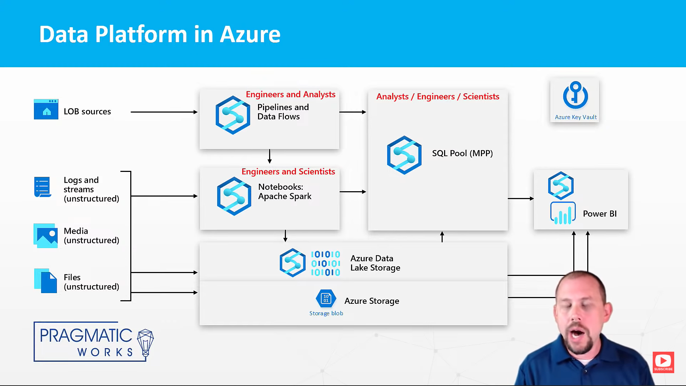

Asa workspace require a datalake configured(should have 1 primary data lake by default)

Azure data lake – general purpose storage account.

Azure SQL pools(formerly known as SQL Data Warehouse or Parallel Data Warehouse) – helps in doing analysis on big data, relational database(works well on star schema), leverages Masively parallel processing, quickly run complex queries across petabytes of data

Notebooks – Apache spark pools

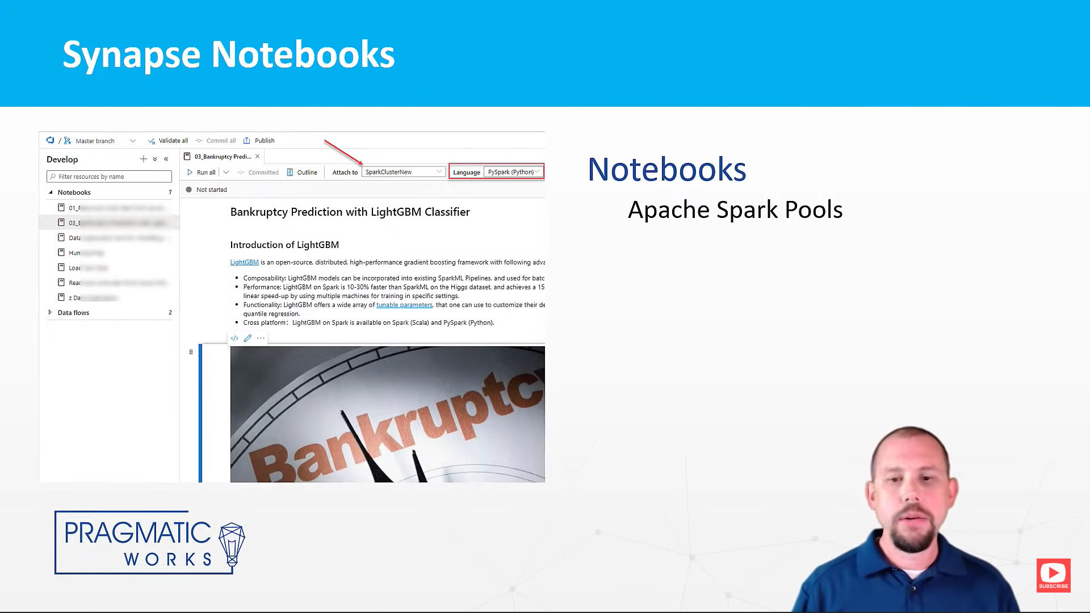

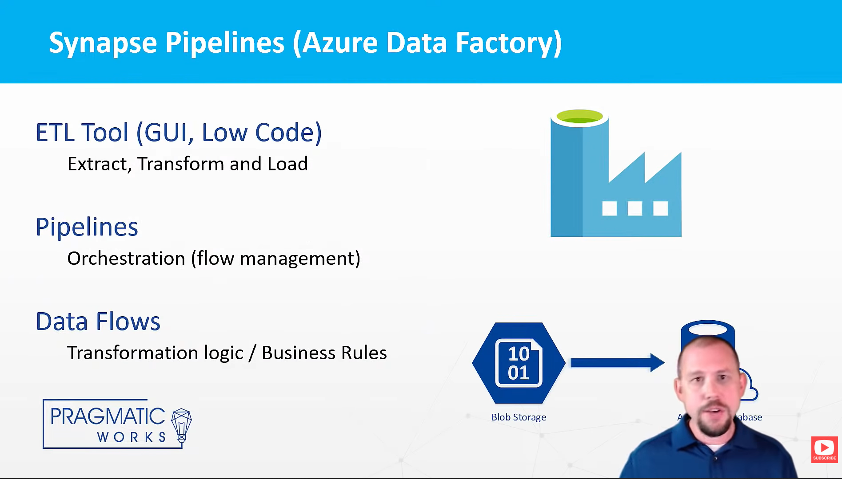

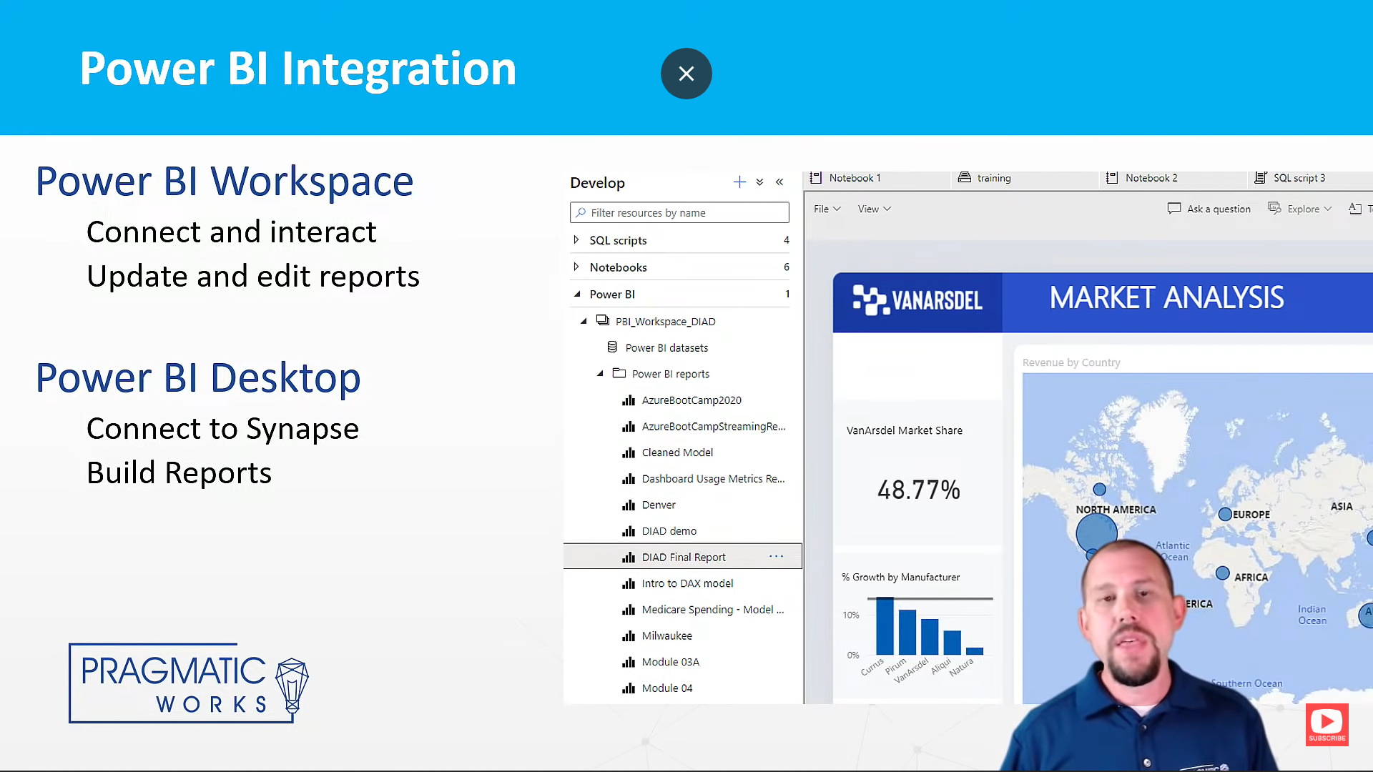

Reason

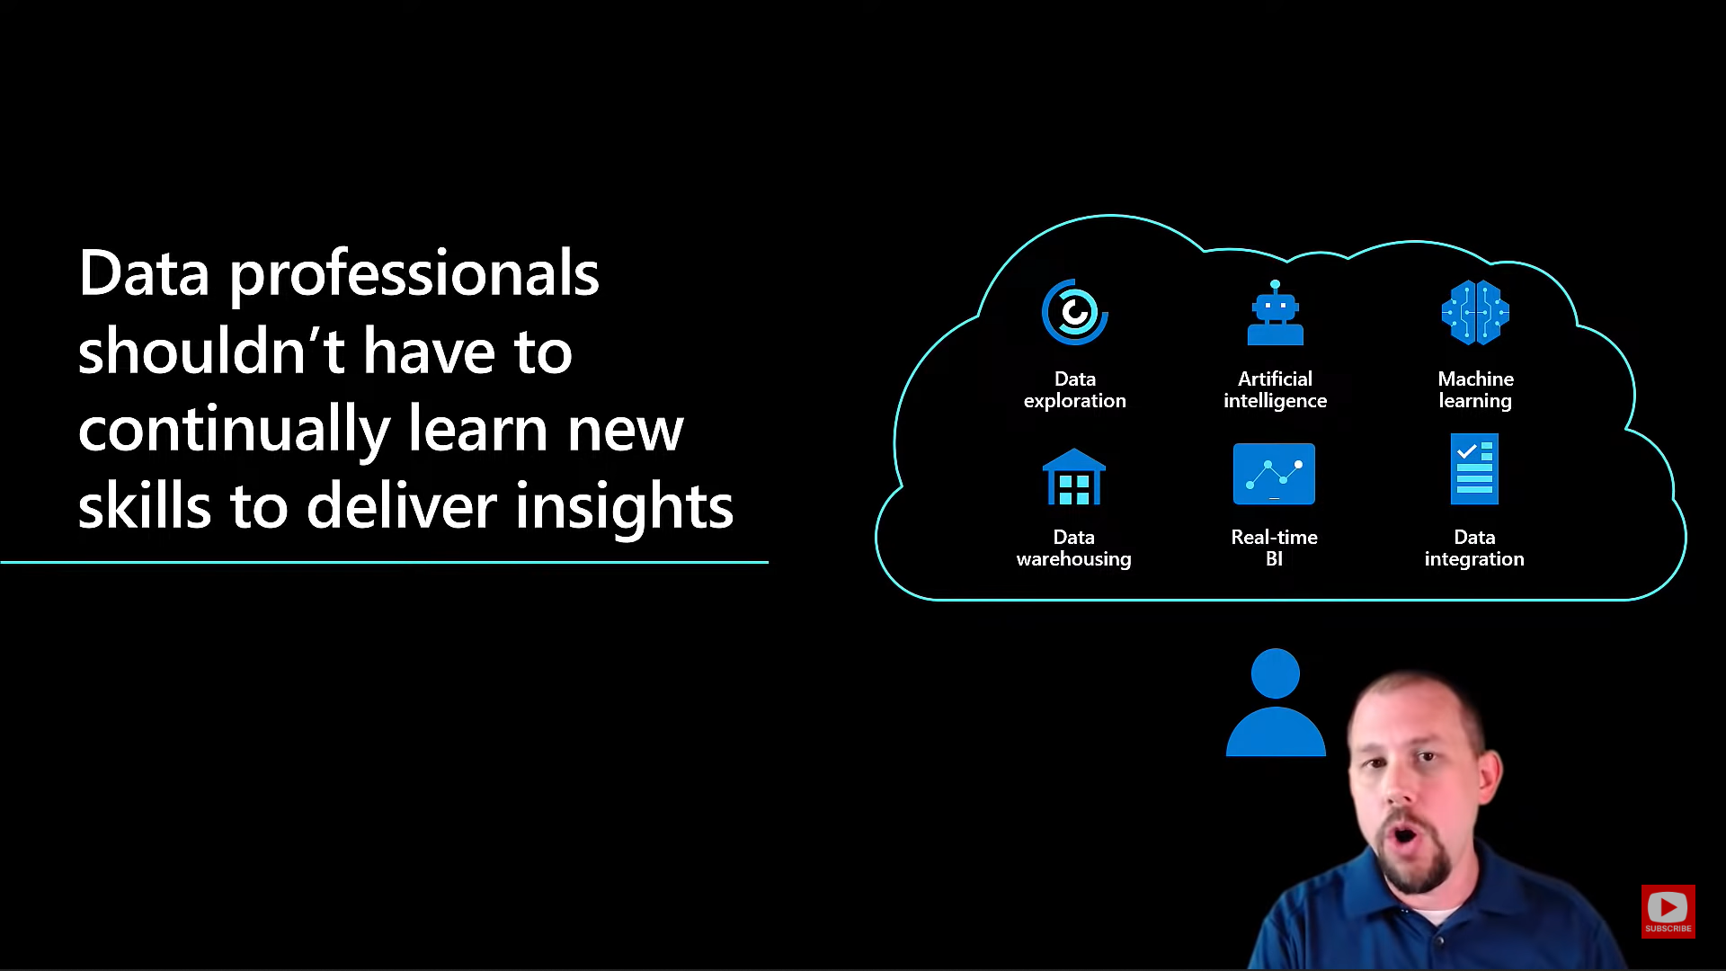

A **resource group** is a collection of resources that share the same lifecycle, premissions, and policies.

**Managed resource group** is a container that holds ancillary resources created by Azure Synapse Analytics for your workspace. By default, a managed resource group is created for you when your workspace is created. Optionally, you can specify the name of the resource group that will be created by Azure Synapse Analytics to satisfy your organization’s resource group name policies.

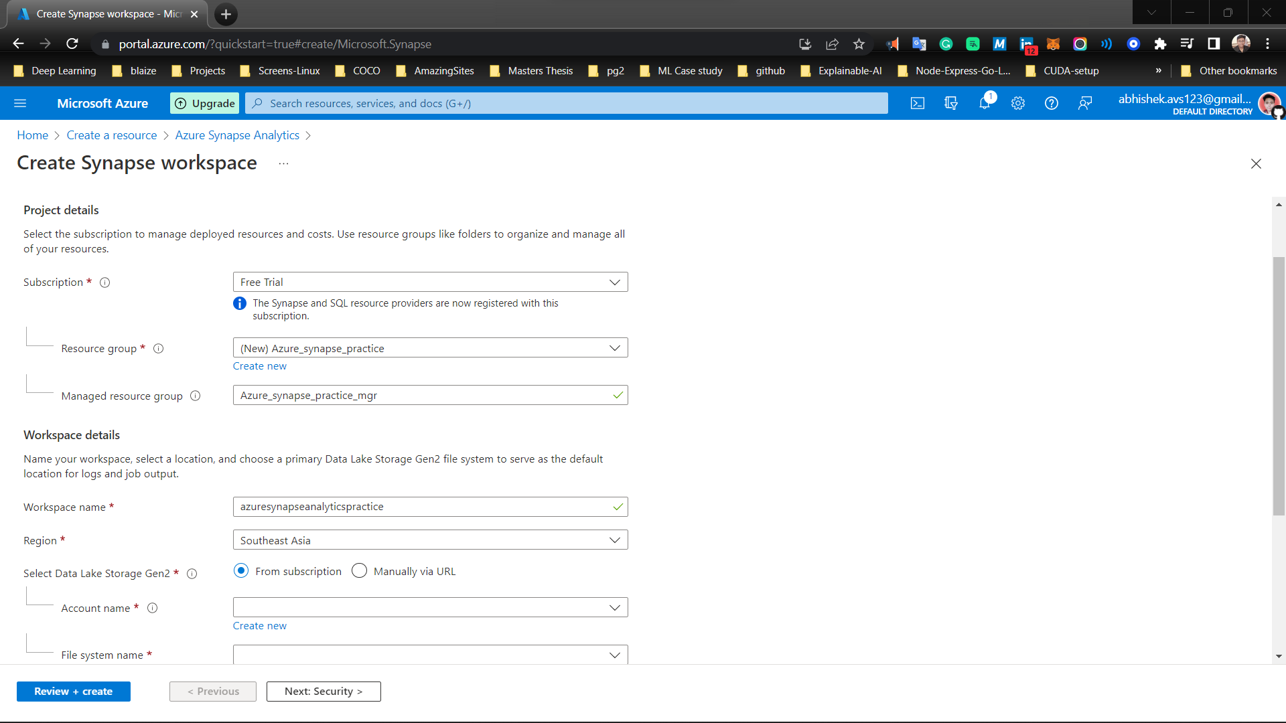

* Workspace name must be between 1 and 50 characters long.
* Workspace name must contain only lowercase letters or numbers or hyphens.
* Workspace name must start with a letter or a number.
* Workspace name must end with a letter or a number.
* Workspace name must not contain '-ondemand' word.
* Workspace name must be unique

We need to setup a primary datalake  
This account will be the primary storage account for the workspace, holding catalog data and metadata associated with the workspace.

**Only Data Lake Storage Gen2 accounts with Hierarchical Name Space (HNS) enabled are listed.**

first demo i want to do i'm ready we're going to jump right into the first demo here is going to be using serverless pools

serverless on demand - exploration of our data without requiring a dedicated pool

Why serverless pools?

so this dedicated pool that i've provisioned right here for this workshop this is costing me right now 1.50 an hour it's not a lot of money it's the the lowest tier you can absolutely go with but it's going to cost me every hour that it runs i can pause it and i can turn it off but if i do anything that I was using any scripts any you know power bi reports whatever anything that was using that dedicated p1 database is not going to work until it's turned back on so i'm saving money but it's highly inconvenient so instead the way we can kind of work around that problem is we can use serverless

(5$/TB od data processed)

serverlesspools is where we are essentially going to be saying look i want to query data that's in my data

lake using sql and i want to be able to scale that out i want to get great performance even if it's big data but i don't want

to have to go spin up a dedicated pool and so companies shouldn't have to spin

up and leave a dedicated pool running all the time and so if the pool's paused and it's not running and i want to run a

query then i have to go and turn the pool on and that pool is going to be running and it's going to charge me x number of dollars per hour for me just

to go and run a couple of ad hoc queries right that's not very flexible not very helpful and so serverless

sql on demand gives us the capability of kind of just in time reporting it gives

us the capability of running a lot of ad hocs and interacting with our data and doing some you know just it kind of

exploration of our data without requiring a dedicated pool this is game changing in a lot of ways because before

this you would have had to you know had your dedicated pool running which does can cost quite a bit of money per hour

that it runs right so this dedicated pool that i've provisioned right here for this workshop this is costing me

right now 1.50 an hour it's not a lot of money it's the the lowest tier you can absolutely go with

but it's going to cost me every hour that it runs i can pause it and i can turn it off but if i do anything that i

was using any scripts any you know power bi reports whatever anything that was using that dedicated p1 database is not

going to work until it's turned back on so i'm saving money but it's highly

inconvenient so instead the way we can kind of work around that problem is we can use serverless let me show you what

this is every asa environment by default has serverless pools available to you it's

there you can use it if you want don't use it if you don't want serverless pools cost you five dollars

per terabyte of data processed that's can be pretty inexpensive and i'm going to show you that here in a minute

when we go back and look at monitoring okay so five dollars per data per terabyte of data that is processed

so let's do this let's go out to our data lake and just query some data and take a look at it so i'm going to go

back over to the data hub under the data hub i have some data that i've already uploaded to my data lake right so i'm

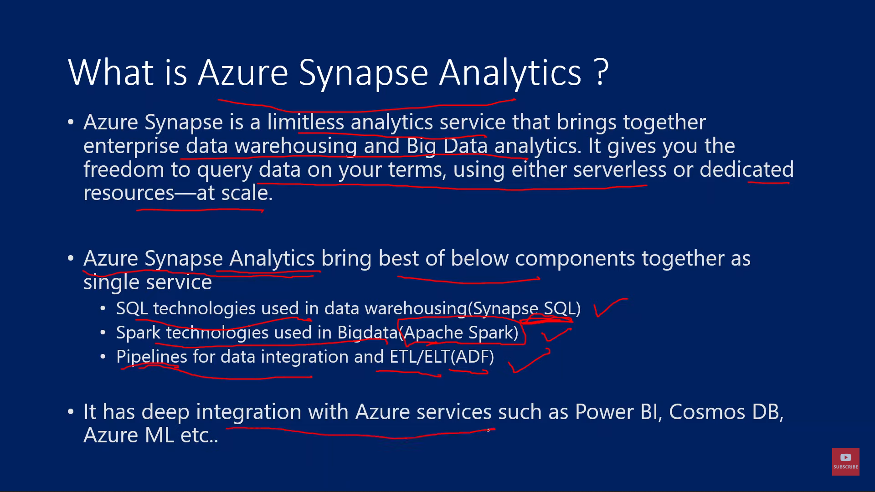

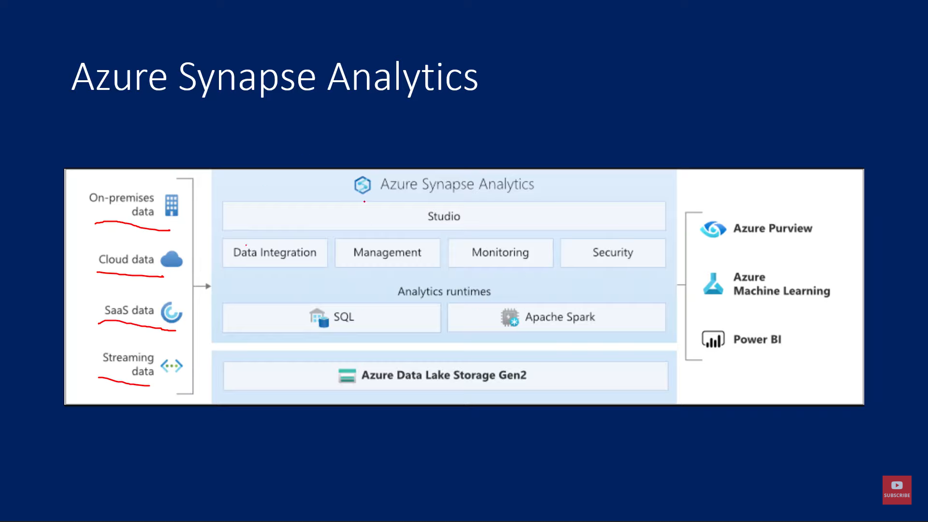

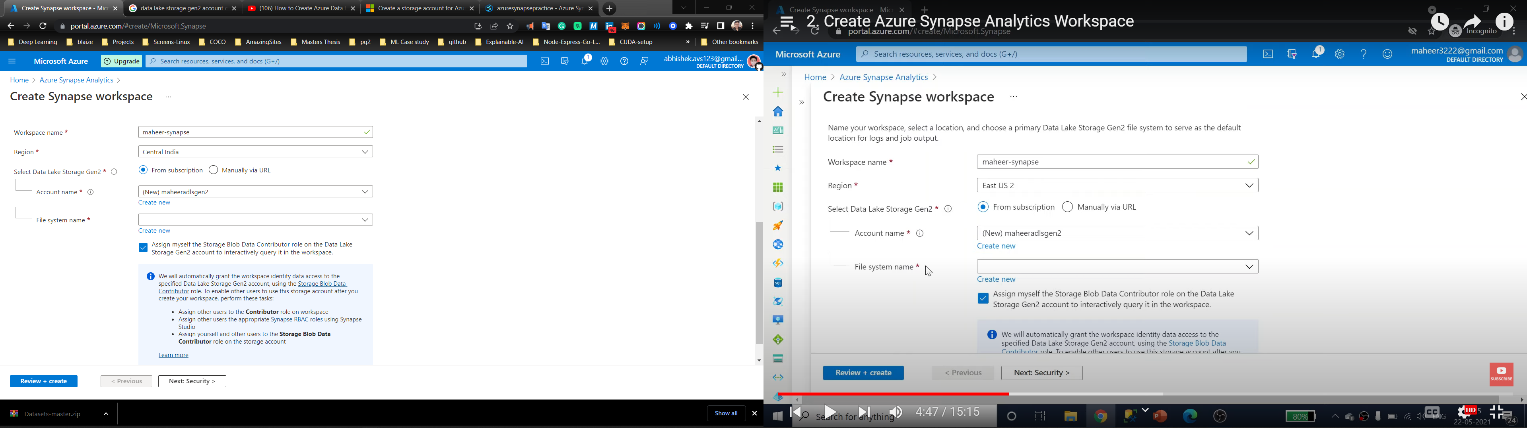

Filesystem name – inside datalake storage gen 2 we have containers that has folders and files. We give a name to the container

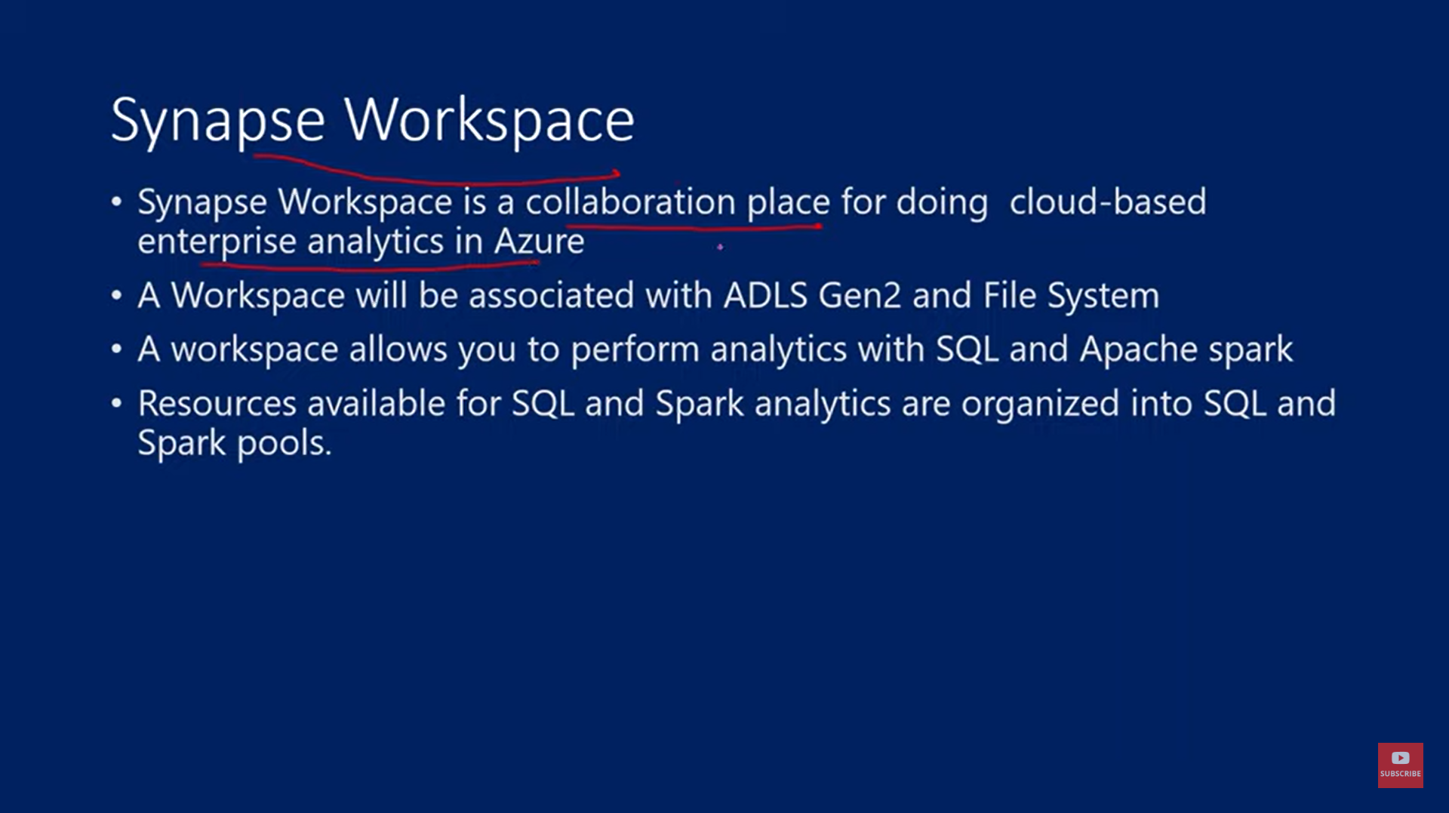

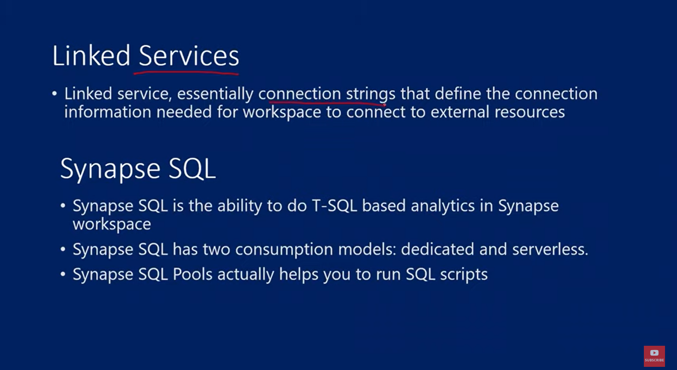

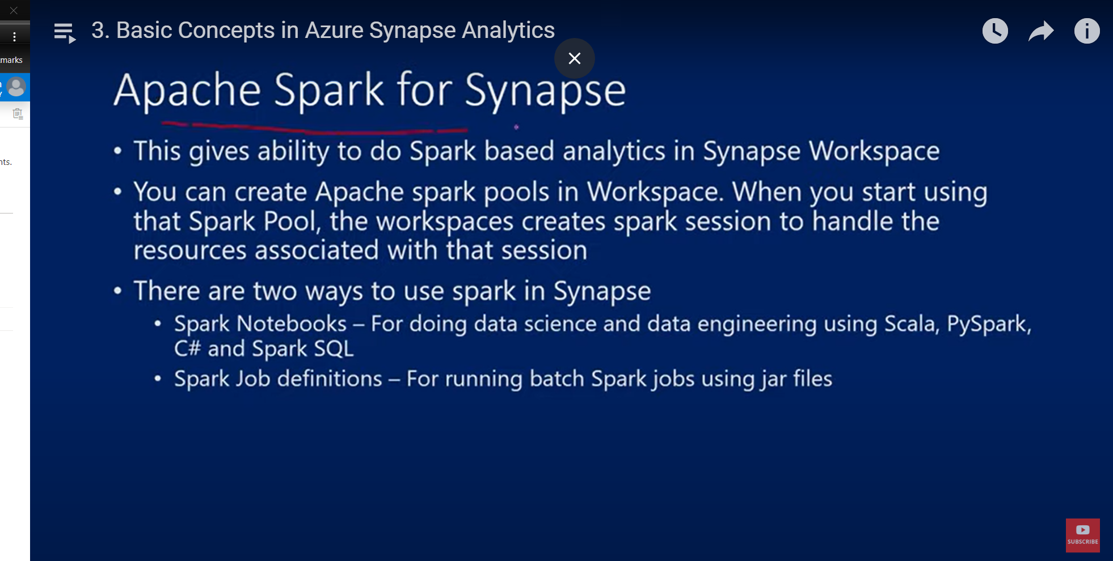

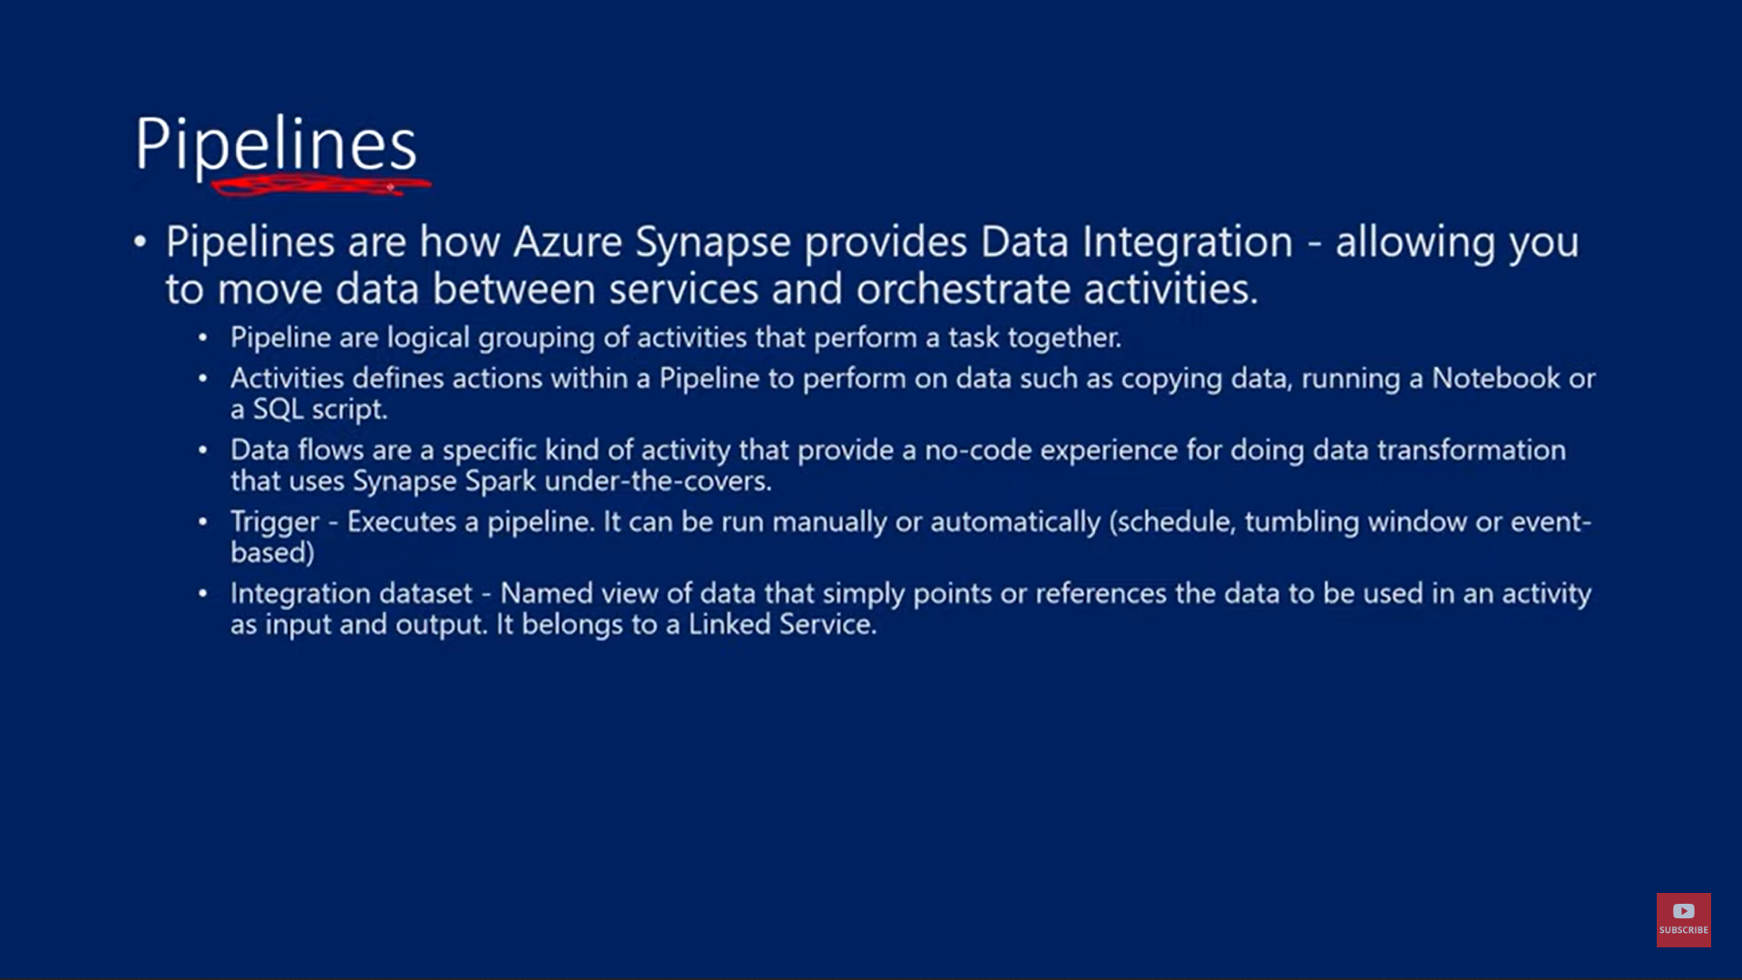

SQL SERVERLESS POOL

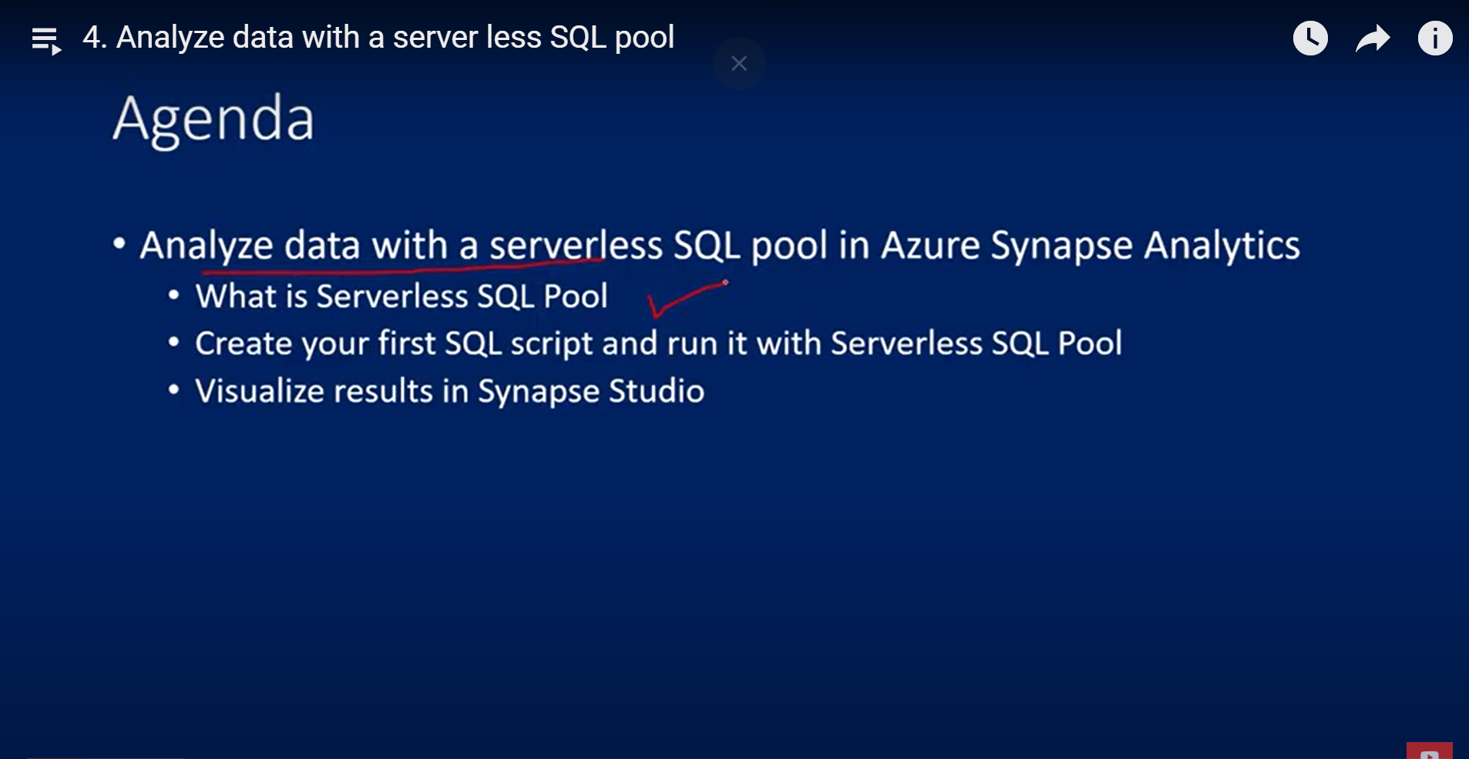

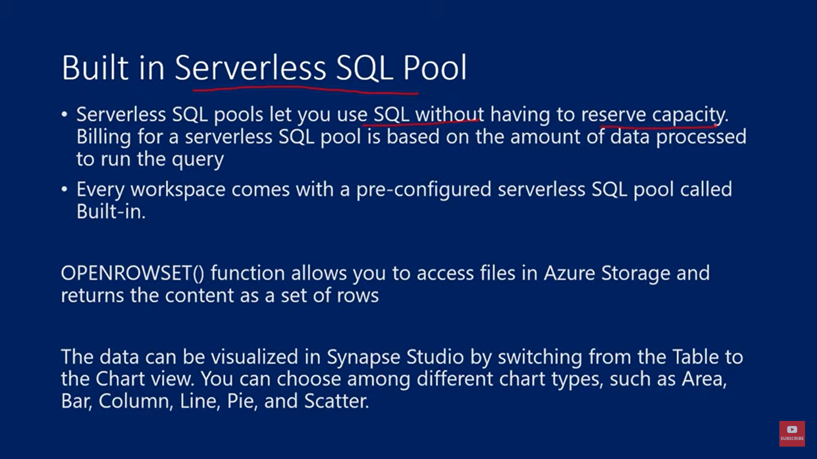

Synapse workspace>pverview tab> scroll down> open in synapse studio> web.azuresynapse.net will open> manage menu left> sql pool> built-in => comes with pre configured sql pool

In data tab upload some data in linked tab inside the gen2 a container is there, make a data folder and add a data

Then to add sql script, go to develop and add sql script

To add autogenerated one => go to data> new sql script> se;lect top 100 rows

Dedicated SQL pool

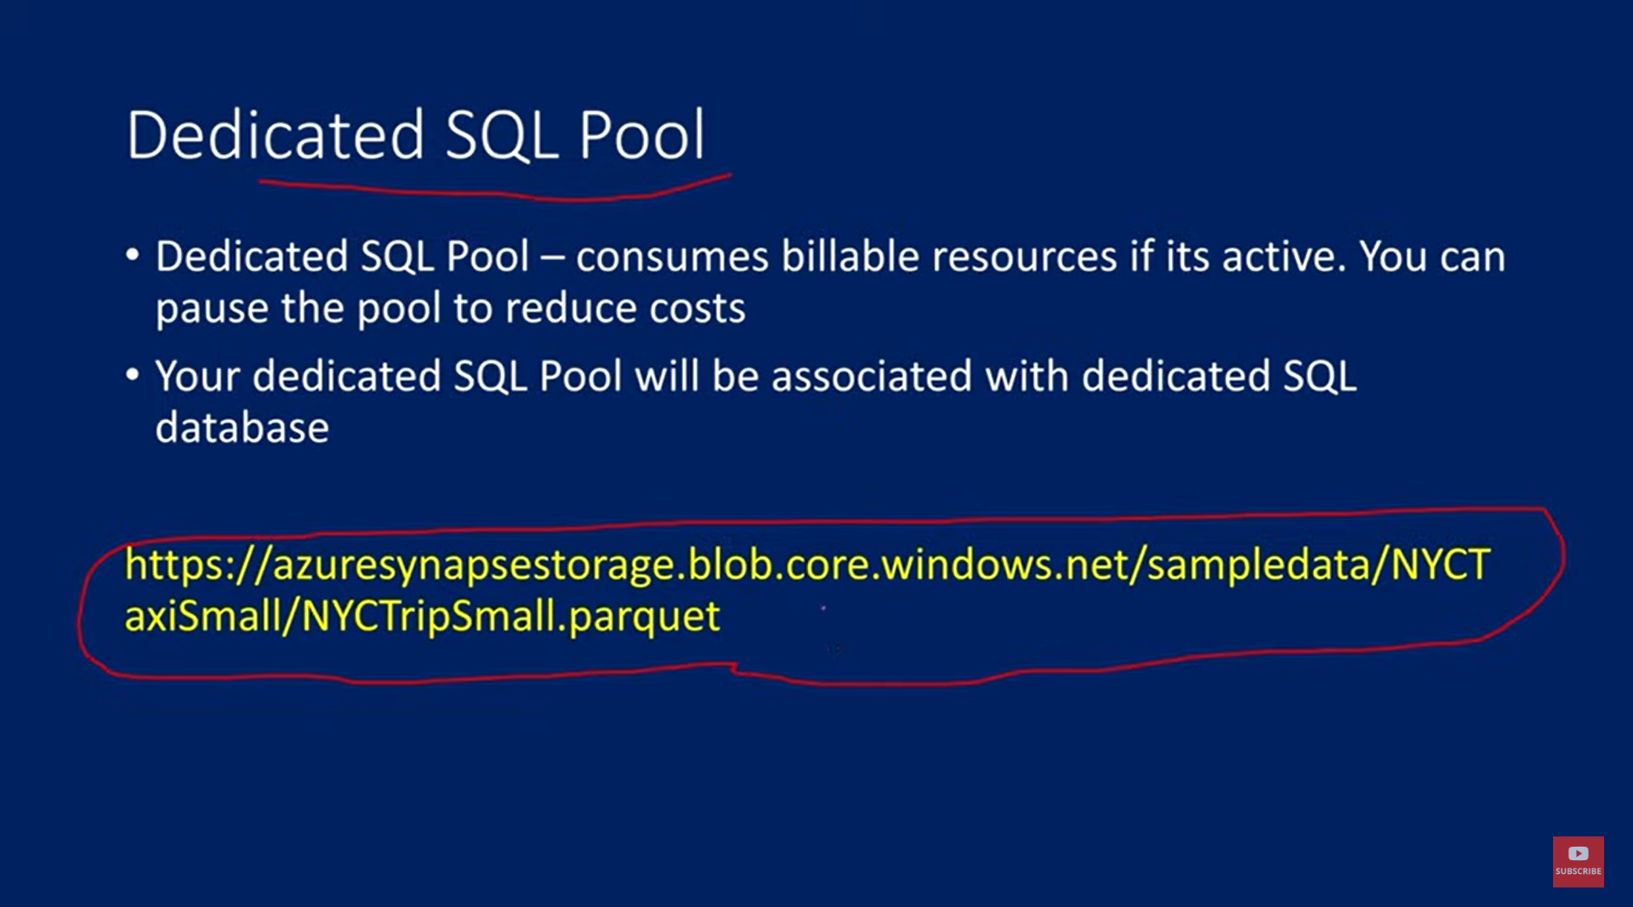

Manage>sql pool> +new>choose performance and create

Synapse works superfast

IF NOT EXISTS (SELECT * FROM sys.objects O JOIN sys.schemas S ON O.schema_id = S.schema_id WHERE O.NAME = 'NYCTaxiTripSmall' AND O.TYPE = 'U' AND S.NAME = 'dbo')

CREATE TABLE dbo.NYCTaxiTripSmall

    (

     [DateID] int,

     [MedallionID] int,

     [HackneyLicenseID] int,

     [PickupTimeID] int,

     [DropoffTimeID] int,

     [PickupGeographyID] int,

     [DropoffGeographyID] int,

     [PickupLatitude] float,

     [PickupLongitude] float,

     [PickupLatLong] nvarchar(4000),

     [DropoffLatitude] float,

     [DropoffLongitude] float,

     [DropoffLatLong] nvarchar(4000),

     [PassengerCount] int,

     [TripDurationSeconds] int,

     [TripDistanceMiles] float,

     [PaymentType] nvarchar(4000),

     [FareAmount] numeric(19,4),

     [SurchargeAmount] numeric(19,4),

     [TaxAmount] numeric(19,4),

     [TipAmount] numeric(19,4),

     [TollsAmount] numeric(19,4),

     [TotalAmount] numeric(19,4)

    )

WITH

    (

    DISTRIBUTION = ROUND_ROBIN,

     CLUSTERED COLUMNSTORE INDEX

     -- HEAP

    )

GO

COPY INTO dbo.NYCTaxiTripSmall

(DateID 1, MedallionID 2, HackneyLicenseID 3, PickupTimeID 4, DropoffTimeID 5,

PickupGeographyID 6, DropoffGeographyID 7, PickupLatitude 8, PickupLongitude 9,

PickupLatLong 10, DropoffLatitude 11, DropoffLongitude 12, DropoffLatLong 13,

PassengerCount 14, TripDurationSeconds 15, TripDistanceMiles 16, PaymentType 17,

FareAmount 18, SurchargeAmount 19, TaxAmount 20, TipAmount 21, TollsAmount 22,

TotalAmount 23)

FROM 'https://maheeradlsgen2.dfs.core.windows.net/synapsedemo/data/NYCTripSmall.parquet'

WITH

(

    FILE_TYPE = 'PARQUET'

    ,MAXERRORS = 0

    ,IDENTITY_INSERT = 'OFF'

)

SELECT COUNT(*) from dbo.NYCTaxiTripSmall

200000 rows in 0.07 sec

We can see the created table in data tab in workspace in tables sub menu in sqlpool and we can use autogenerated script to see the new created table, we can also change the script

SELECT PassengerCount,

SUM(TripDistanceMiles) as SumTripDistance,

AVG(TripDistanceMiles) as AvgTripDistance

FROM dbo.NYCTaxiTripSmall

WHERE TripDistanceMiles > 0 AND PassengerCount > 0

GROUP BY PassengerCount

ORDER BY PassengerCount;

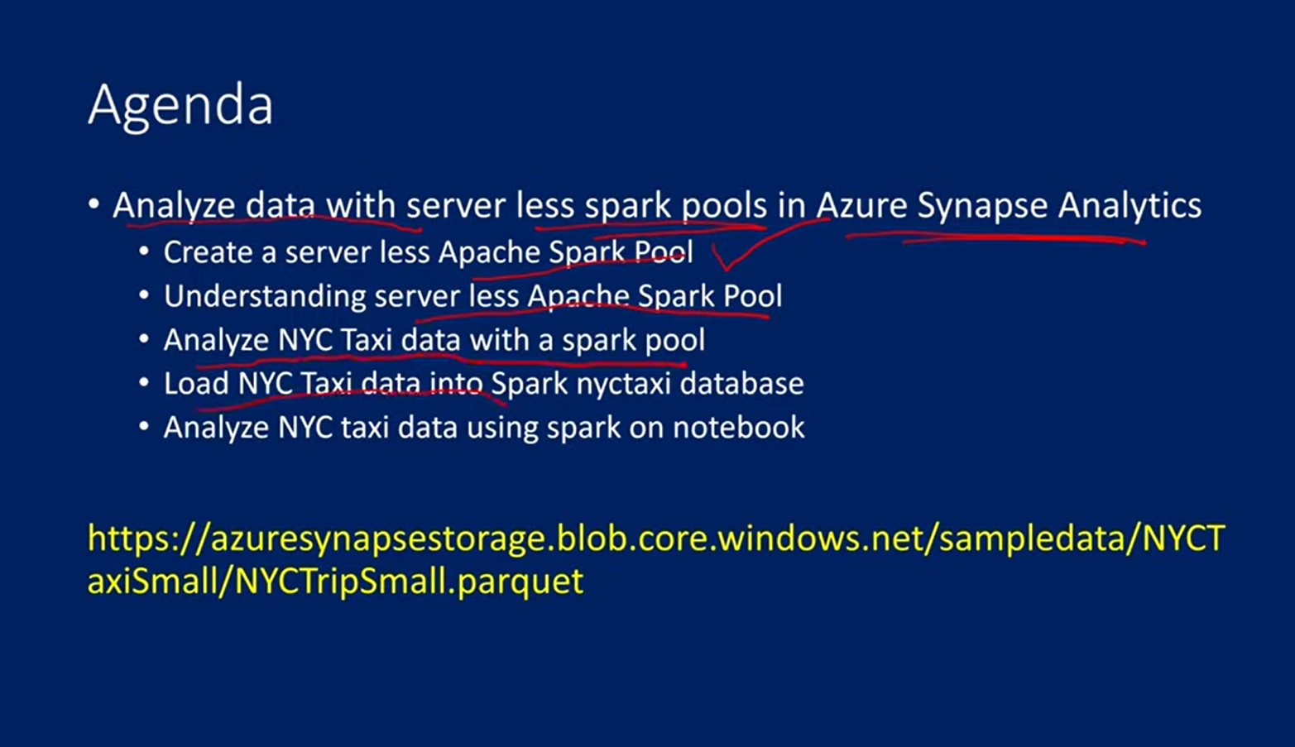

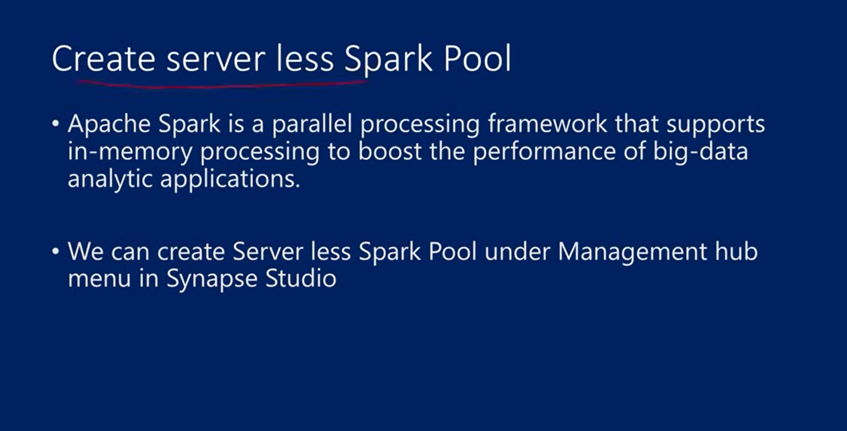

Spark – used for big data processing

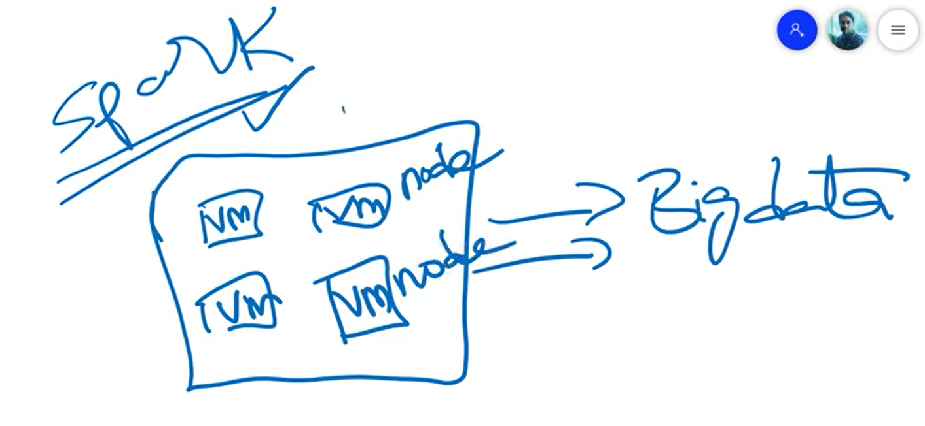

Sparks has clusters, which is group of VMs called nodes. These clusters have capability to understand big data and execute. We write spark code in python or scala. These clusters can understand the spark logic and execute that on the big data to generate meaningful data etc.

In Azure data brick, we create spark cluster and that cluster will be running the notebook **but** in synapse we create spark pool that will execute the notebook. The notebook consists of logic.

In the spark pool we need to define how many nodes we want and size of each node

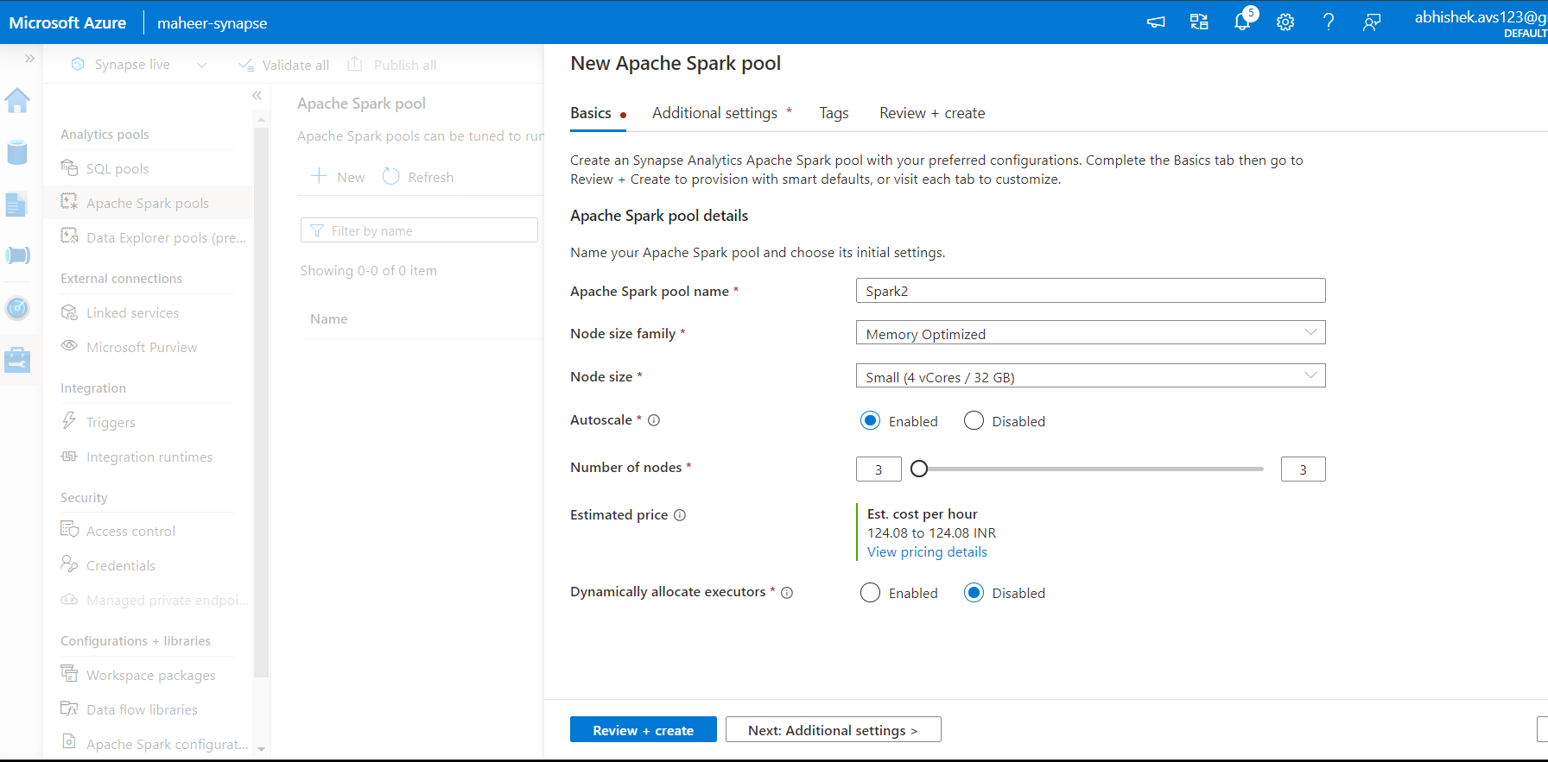

Spark pool decides how many nodes to use based on our data, that is why it asks for min and max number of nodes range.

Serverless spark pools are similar to serverless SQL pool. Whenever we use nodes and we run the logic (notebook), the amount of resources used are only charged for.

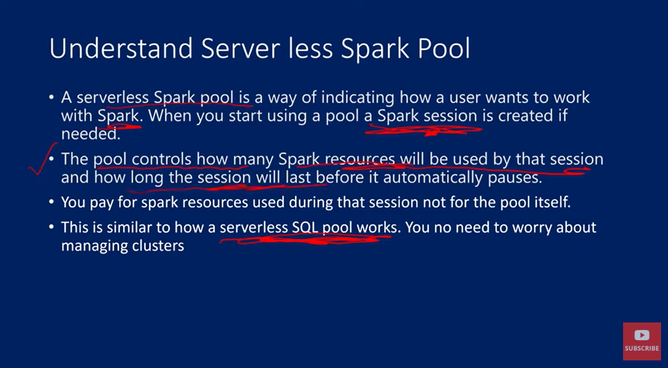

We use the path of ABFSS path – azure blob file system

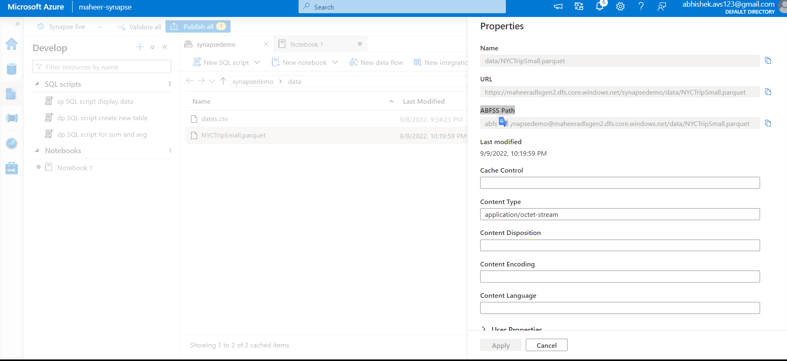

7. Analyze data in Storage Account in Azure Synapse Analytics

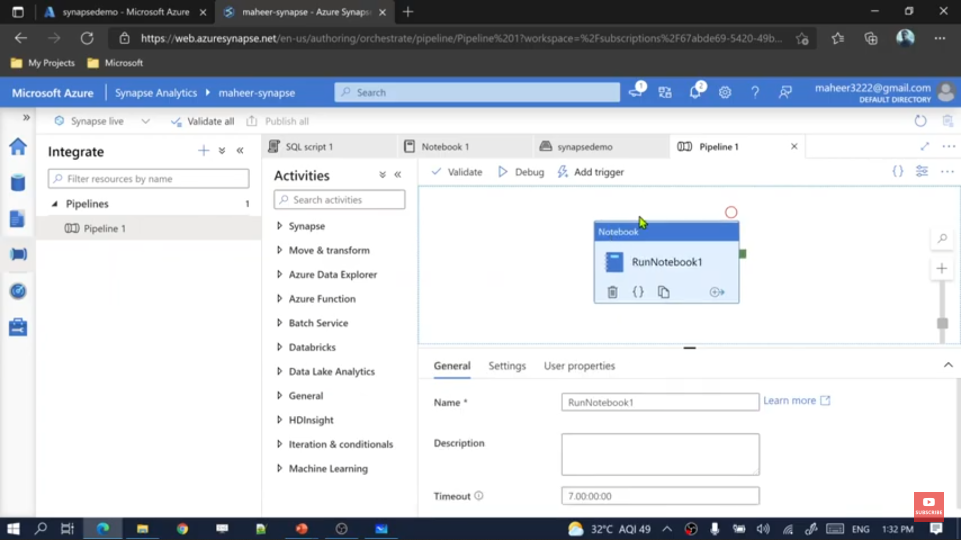  
integrate the notebook and run using the pipeline

To see the triggers u need to go to manage

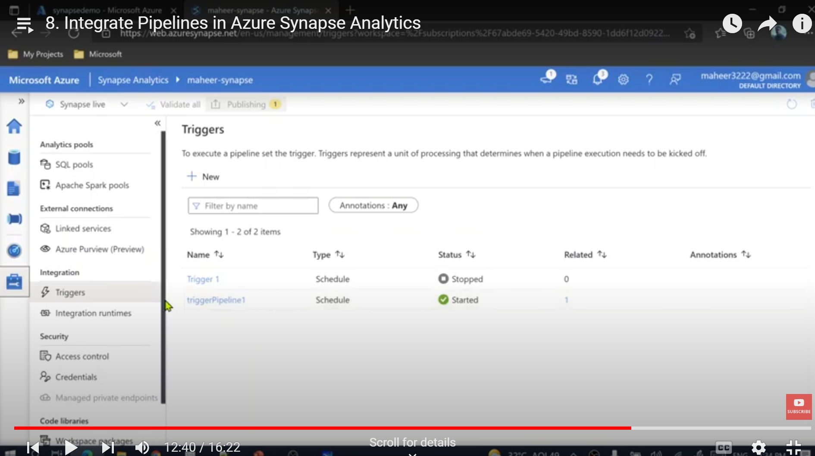

Scheduled trigger, go to manage>triggers> there is a {} symbol on the triogger, if u click it, u can see the json with the trigger schedule etc details

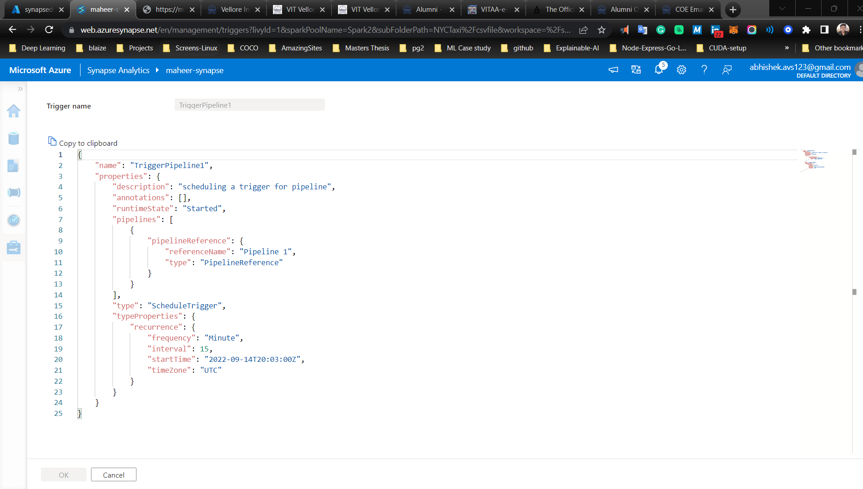

One is the manual trigger, another is a scheduled trigger

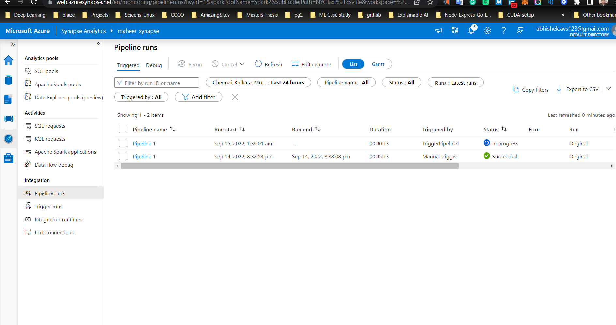

9. Monitor your Azure Synapse Analytics Workspace

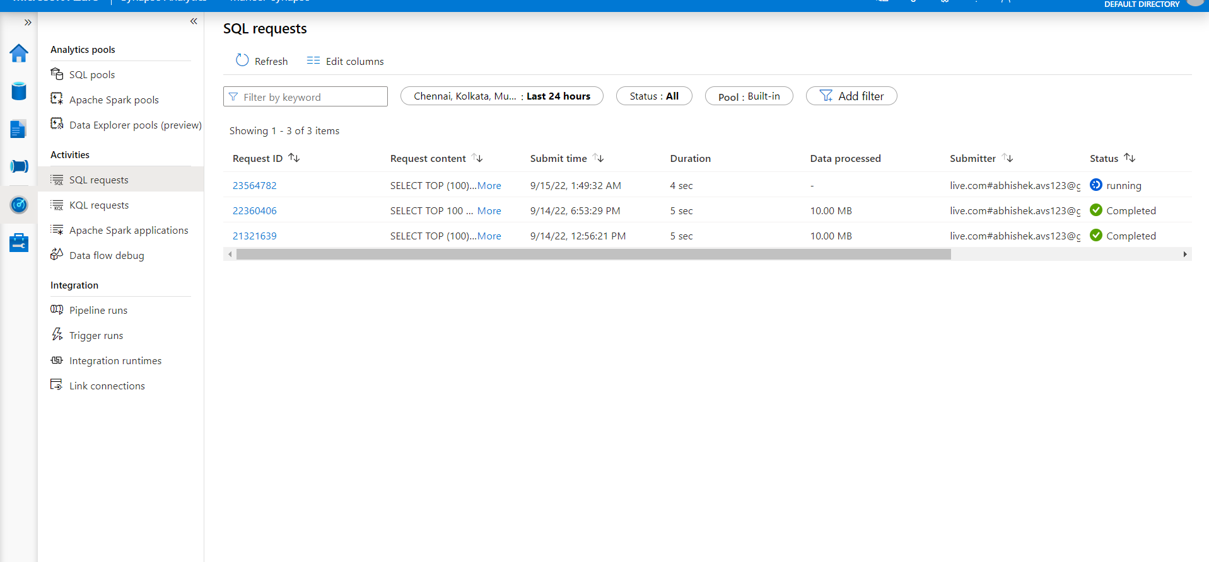’

In monitor tab u can monitor all the sql requests, apache spark application aetc in activities and in integration u can see the pipline runs and trigger runs

And inside the sql request ID u can see who and when it was submitted and the sql query too

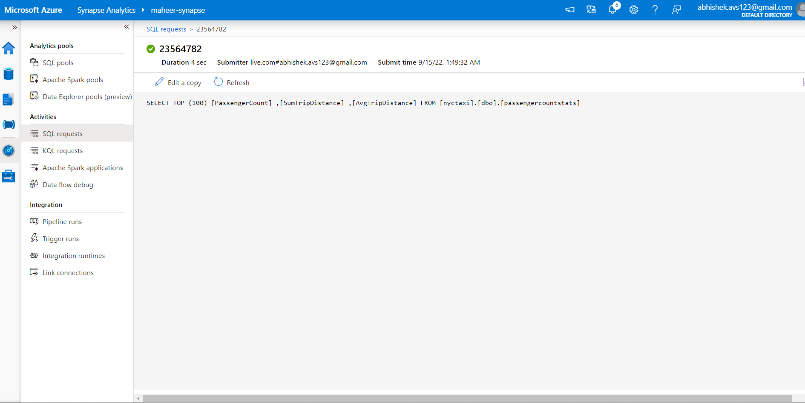

In apache spark application gthere is list of spark session creation from notebooks are here.

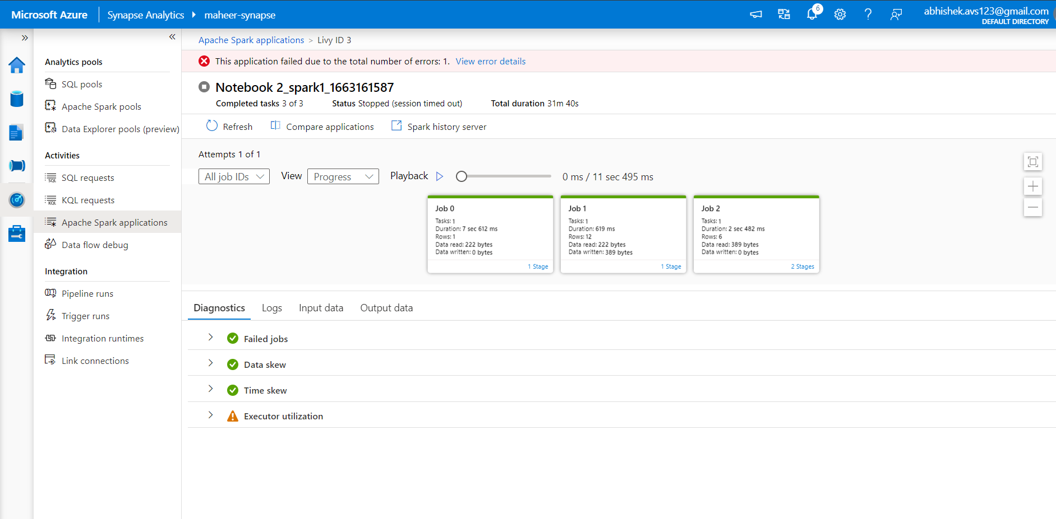

Here logs are available which is beneficial to us

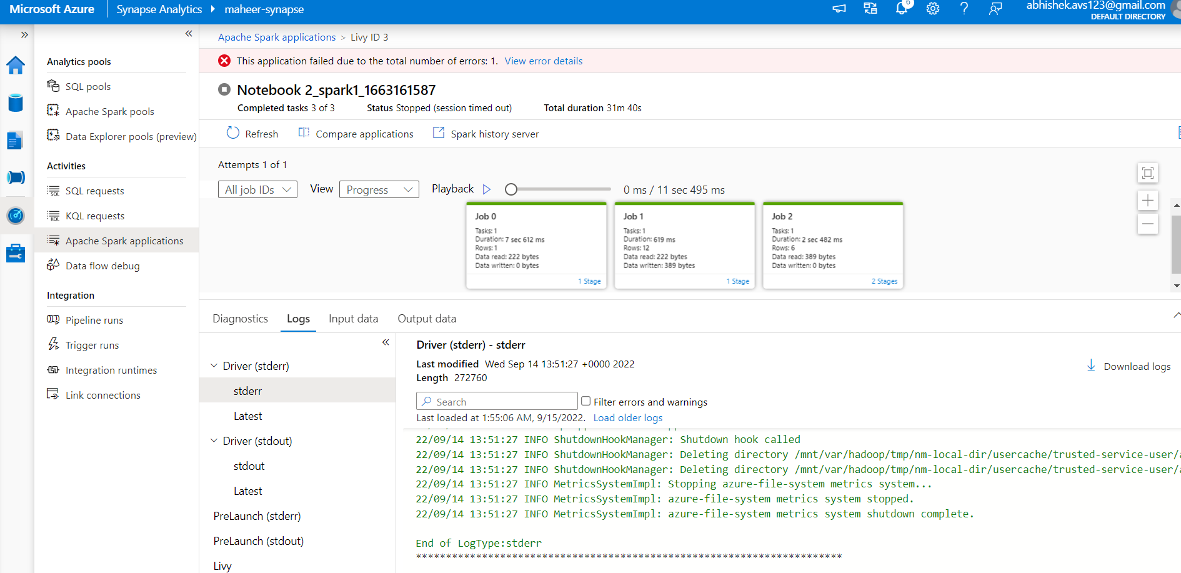

10. Add an Administrator to your Azure Synapse Workspace

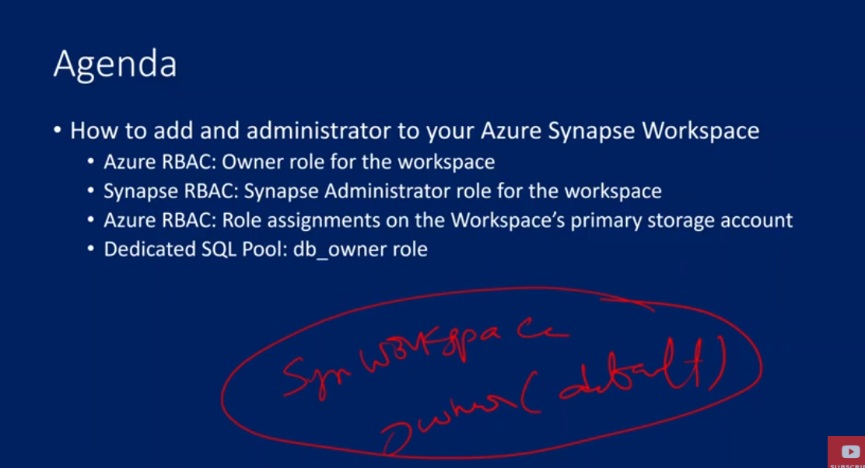  
Azure role based access control system

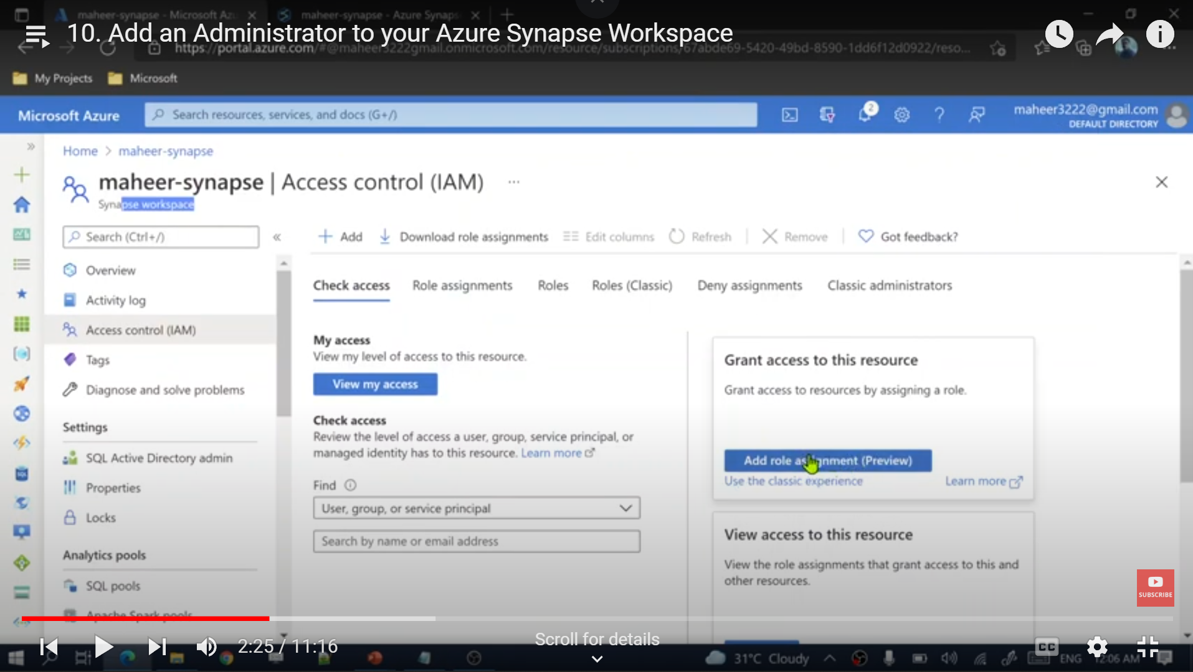

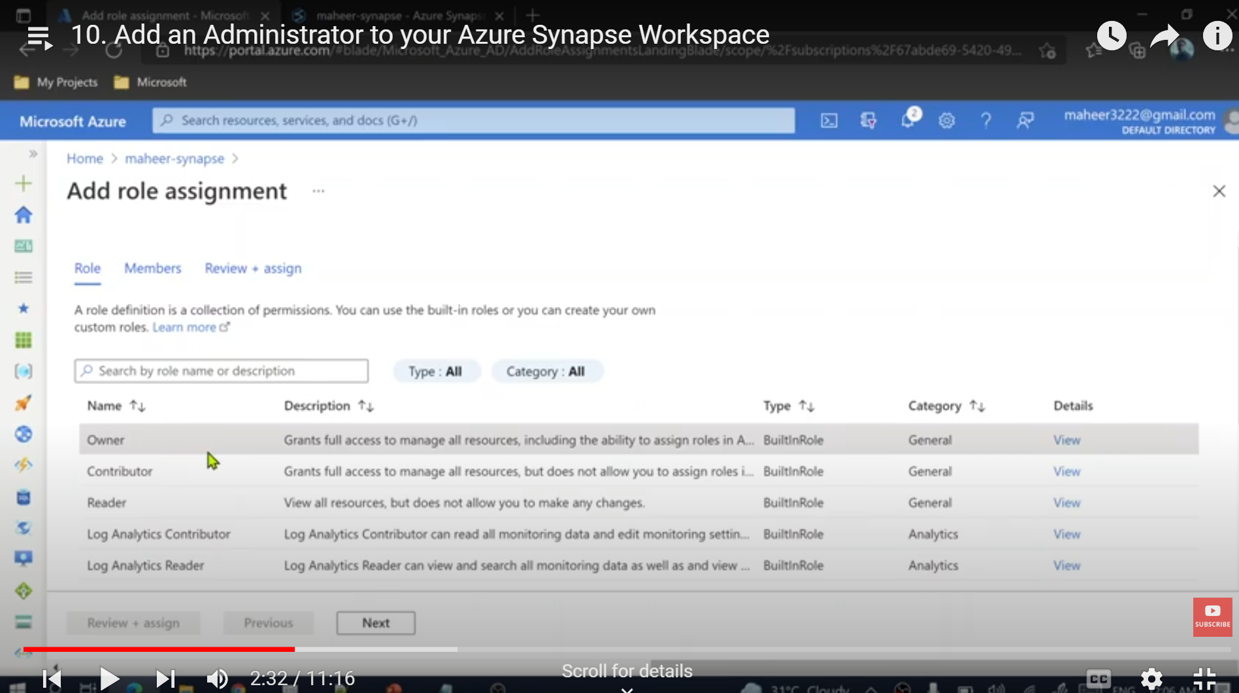

Select owner role

Then click next

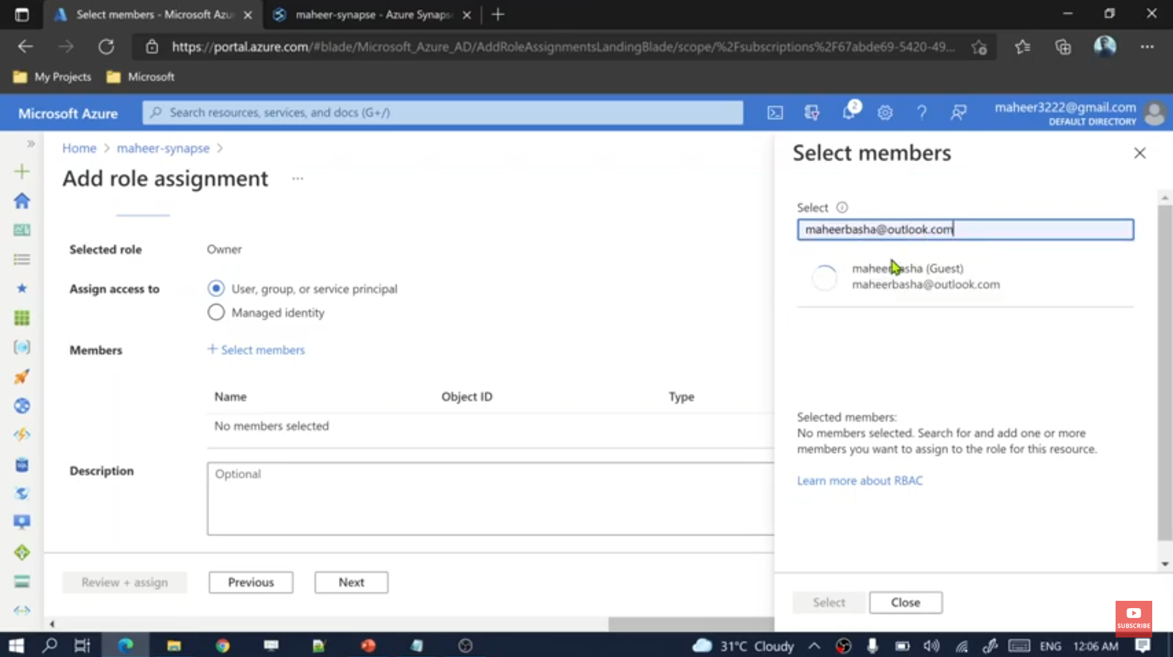

U have added it from the AZURE workspace

Then u have to also add him as owner from spnapse workspace too

So, go to synapse workspace, > manage tab> access control> add> select the role

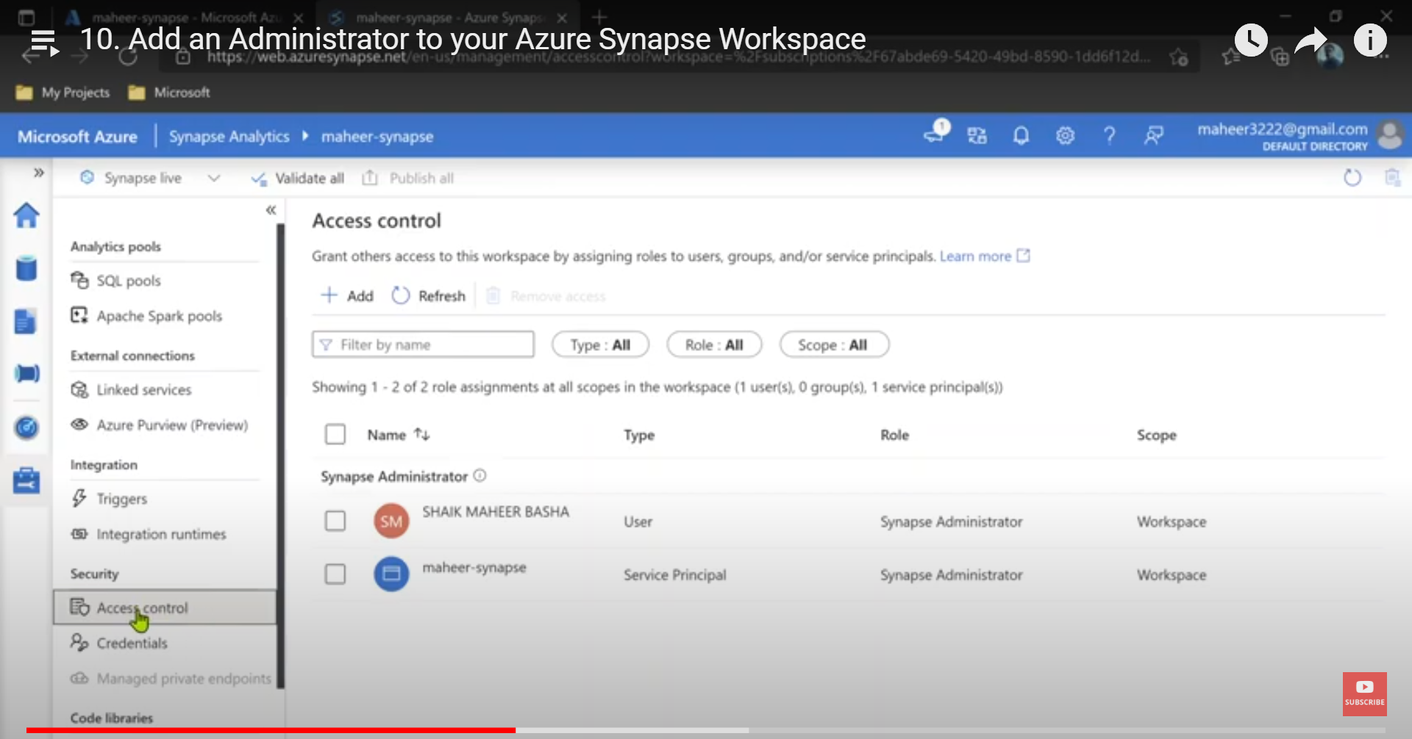

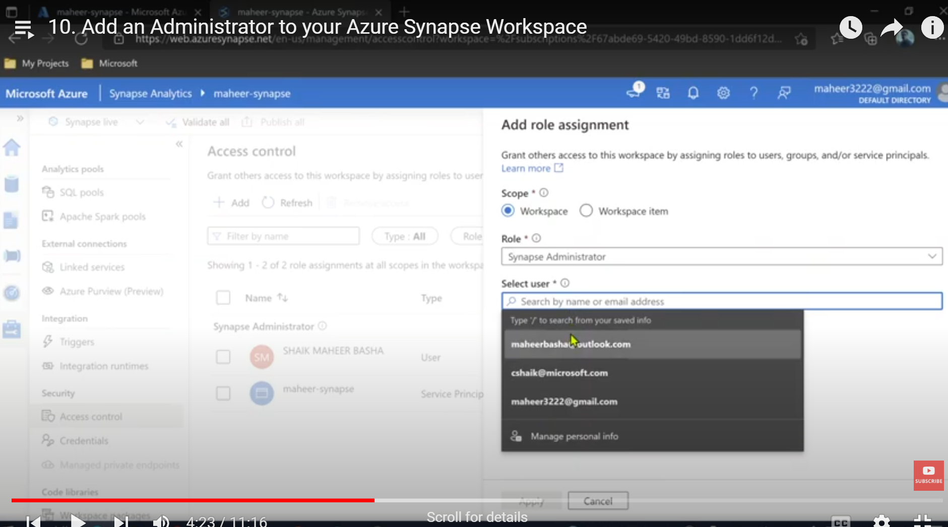

Then we need to give access of gen2 lake

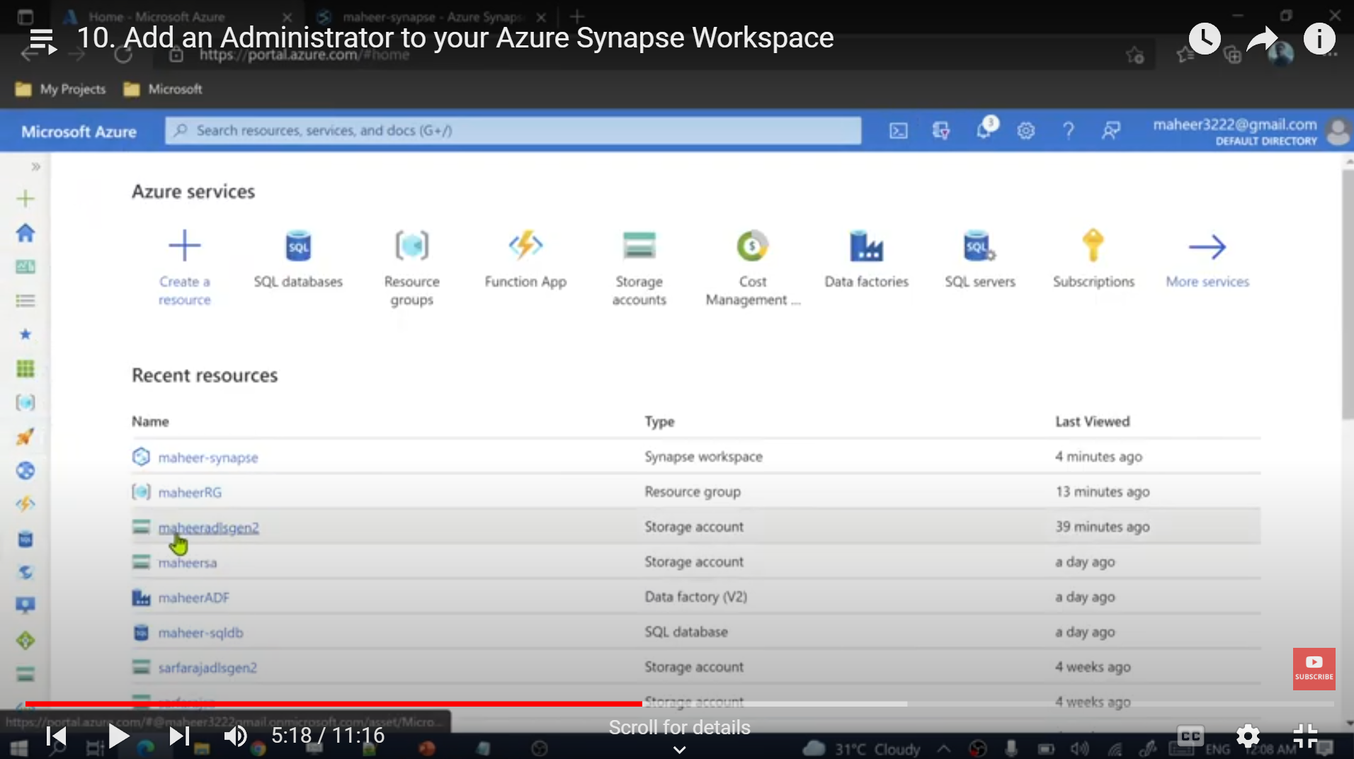

Go to azure portal, open the gen 2 data lake

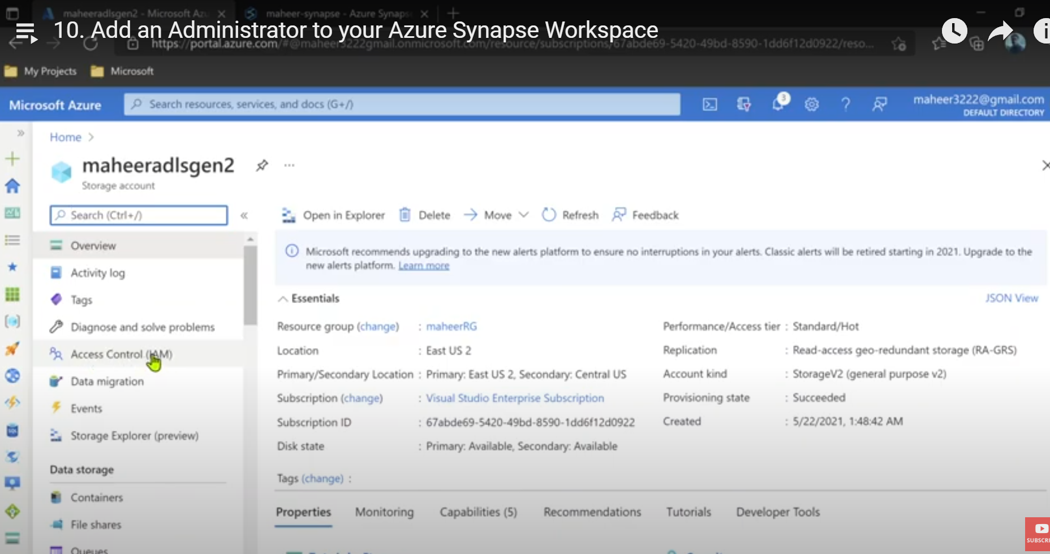

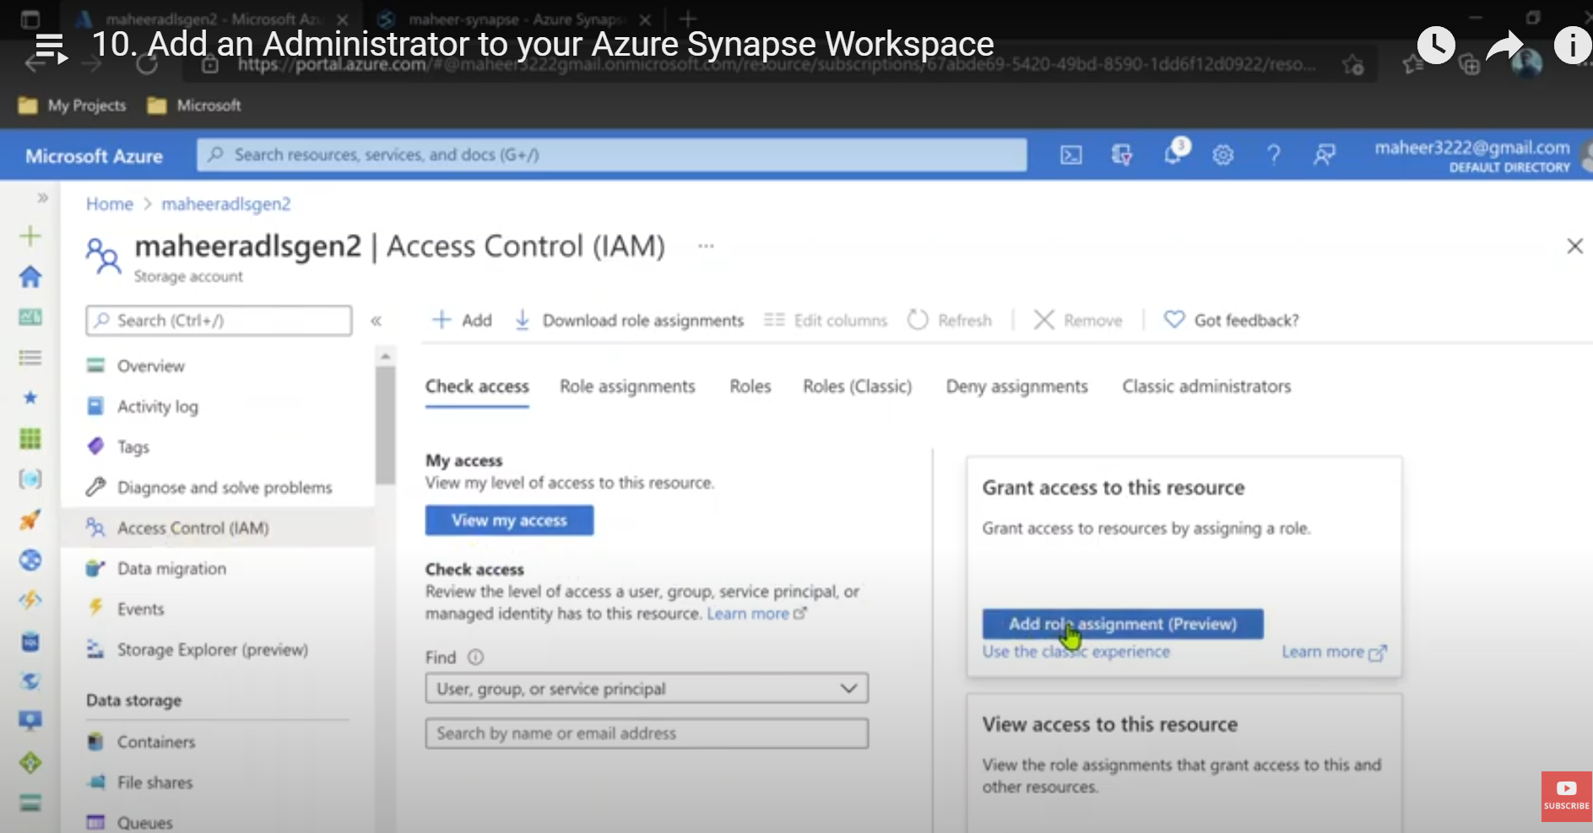

U NEED TO ADD 2 roles –

OWNER

STORAGE BLOB DATA CONTRIBUTOR

U need to do it one by one

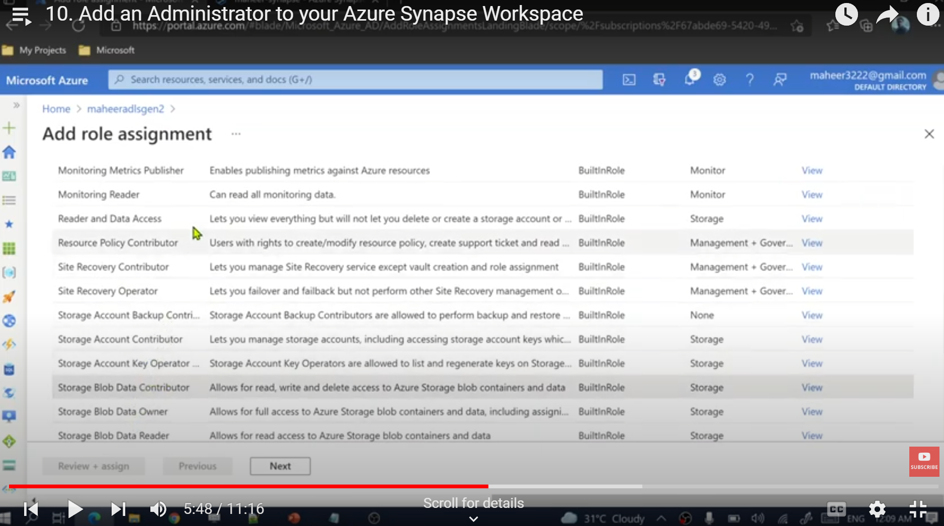

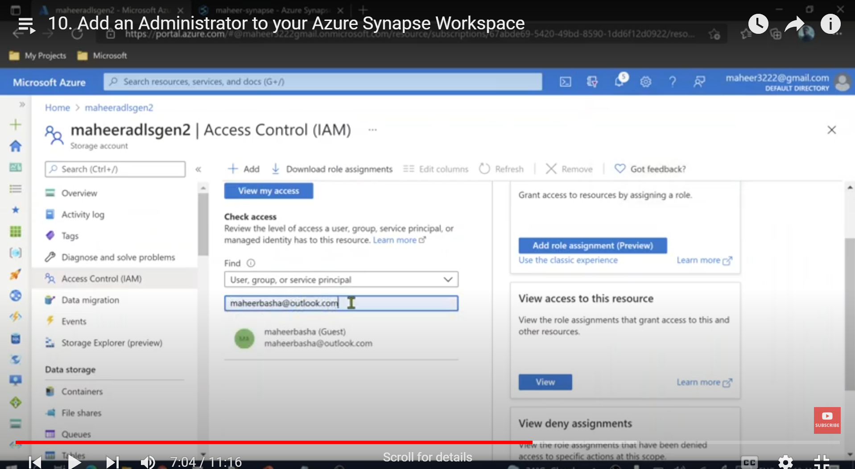

U can check the access of a user too

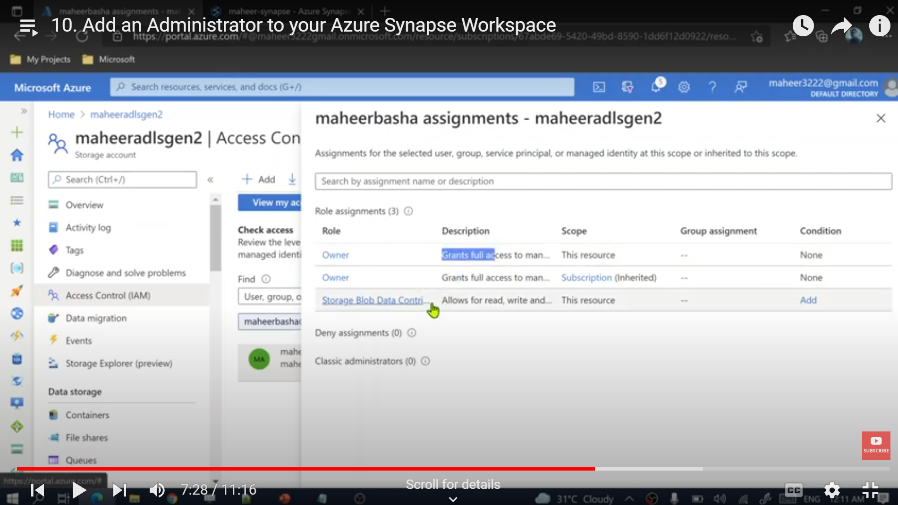

NEXT WE NEED TO ALSO ADD TO OUR DEDICATED SQL POOL

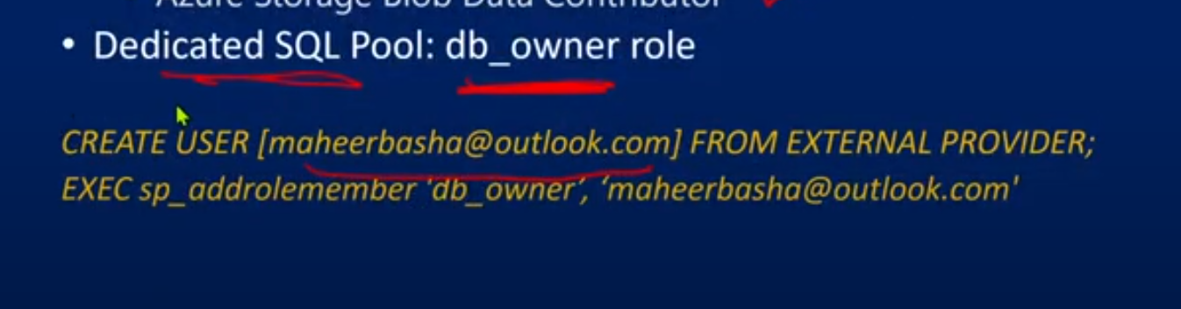

We create a user named [maherbasha@outlook.com](mailto:maherbasha@outlook.com) from an external provider and we are executing a stored procedure/function. And using that stored procedure, we r going to add this db_owner role for this user - [maherbasha@outlook.com](mailto:maherbasha@outlook.com)

So, this what we did

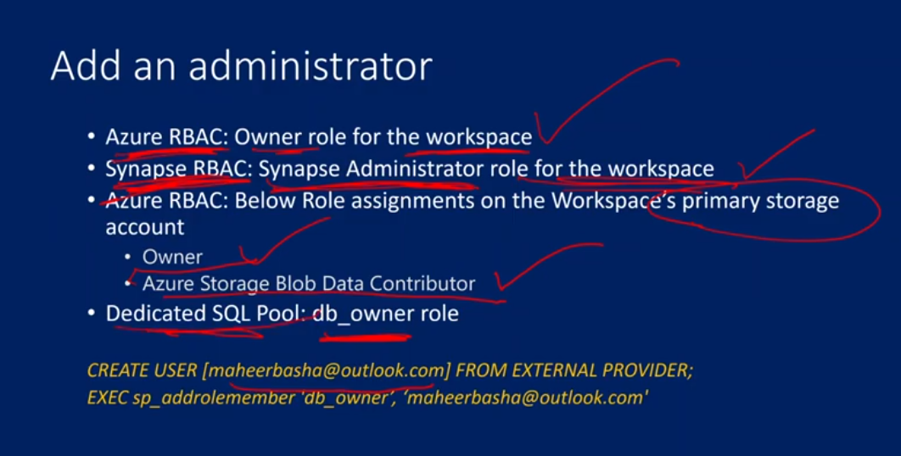

11. Azure Synapse SQL Architecture

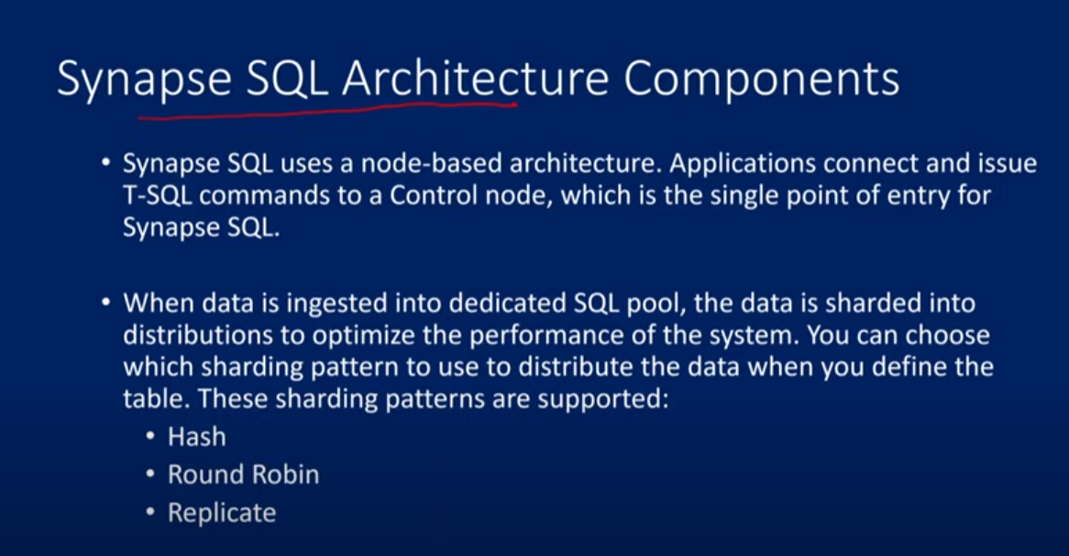



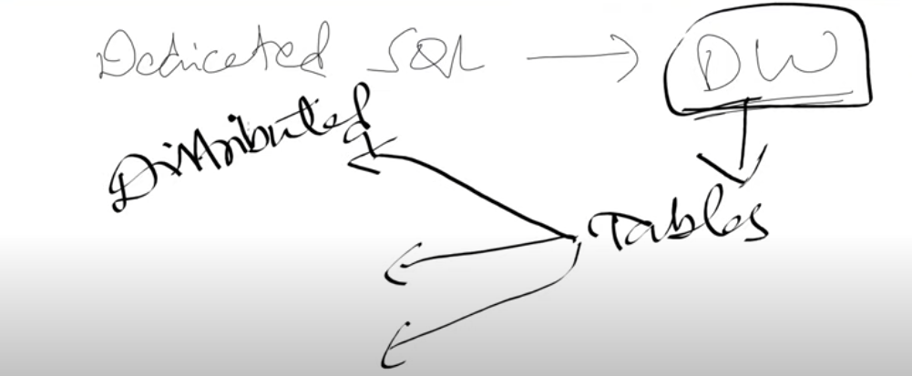

DEDICATED SQL POOL – Data is distributed in order to optimize the performance.

In this the data is stored in partitions or distributions

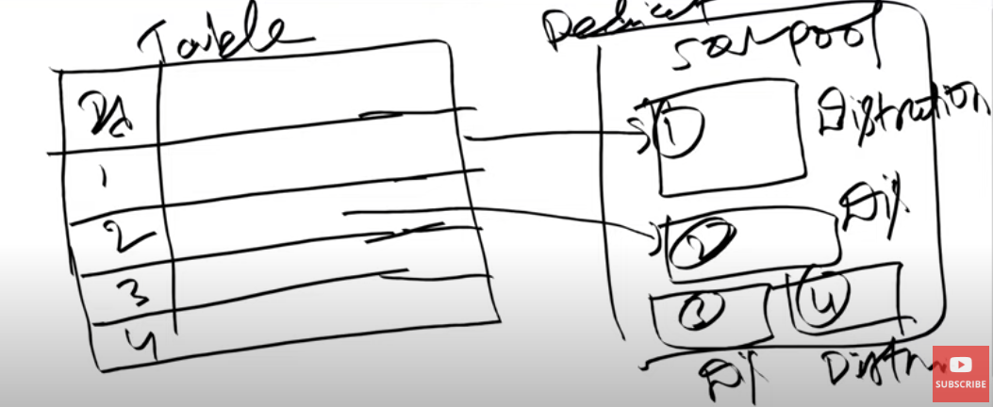

Synapse SQL uses node based architecture

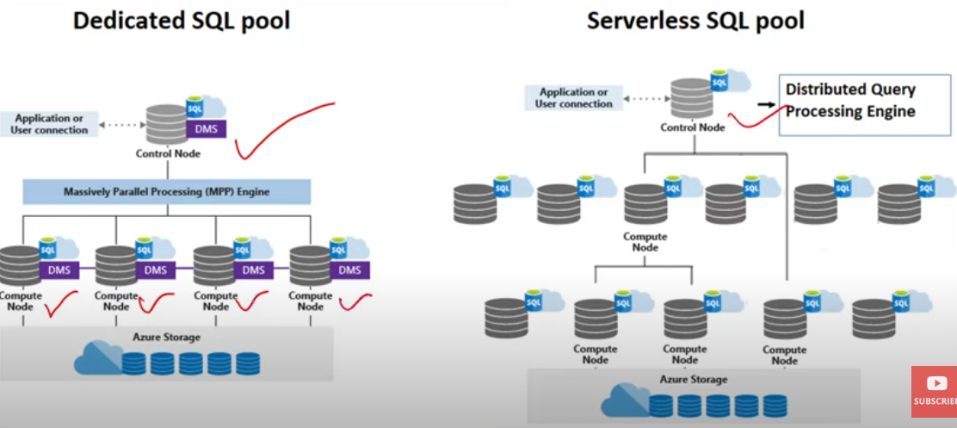

Control Node – Entry point and the Brain

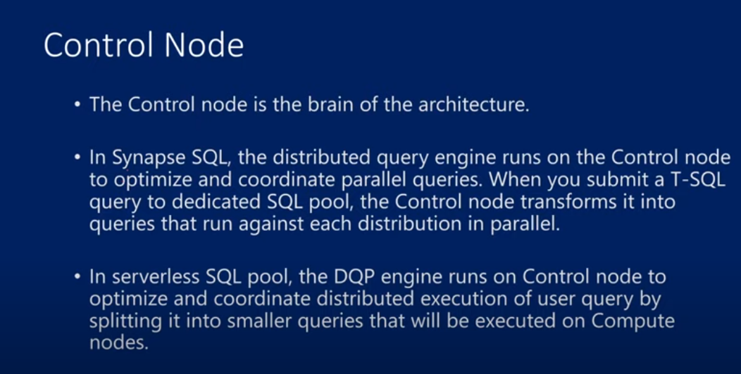

The SQL query gets transformed into parallel queries and each parallel query will land on the control node. SO, each data distribution parallel query is take care by a control node. i.e. each query is going to take each distribution and it will process the distribution

**DEDICATED SQL POOL**

Massively parallel processing engine (MPP)

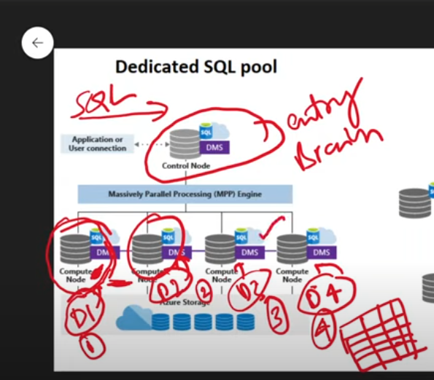

All this data has to clubbed in the end, so the data has to move in-between the compute nodes for which there is DMS(Data Movement Services)

Compute nodes are basically – processing engines / compute power

**SERVERLESS SQL POOL**

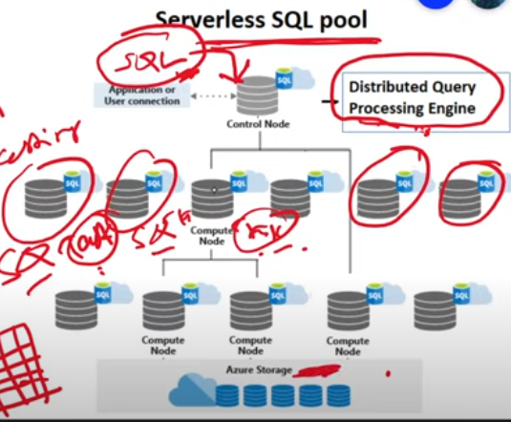

Sql query is passed to the control node and DISTRIBUTED QUERY PROCESSING ENGINE breaks it into small query/ small task. The data goes from our azure storage and it is processed. DISTRIBUTED QUERY PROCESSING ENGINE is responsible to optimize ur query and convert it into small small queries and assign the task to this compute nodes and these compute nodes will utilize azure storage to process the data

12. Distributions(Hash, Round Robbin & Replicate) in Azure Synapse Analytics

Distribution – basic unit of storage and processing

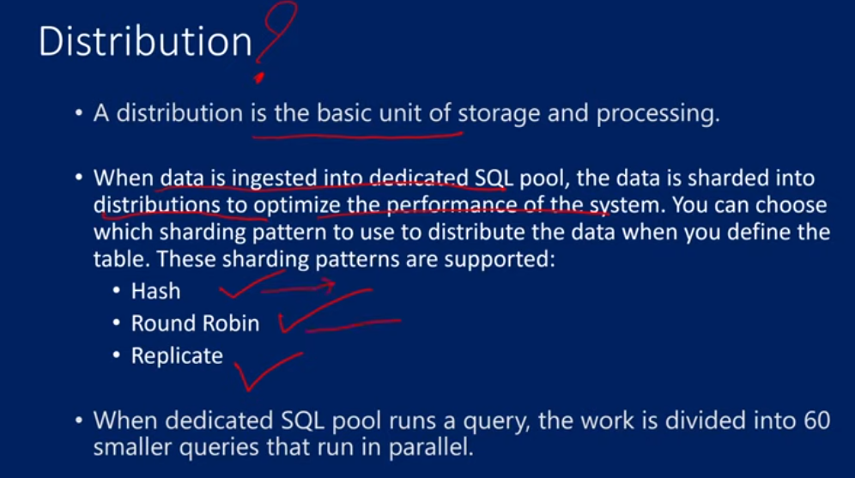

Hash distribution is used for huge data

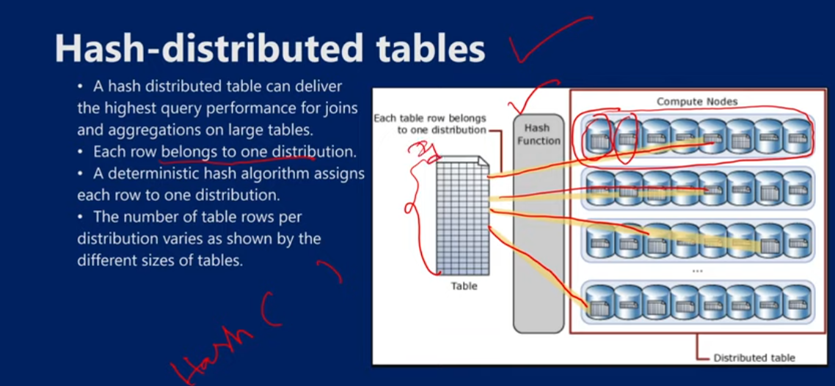

Round robin goes in circular sequence

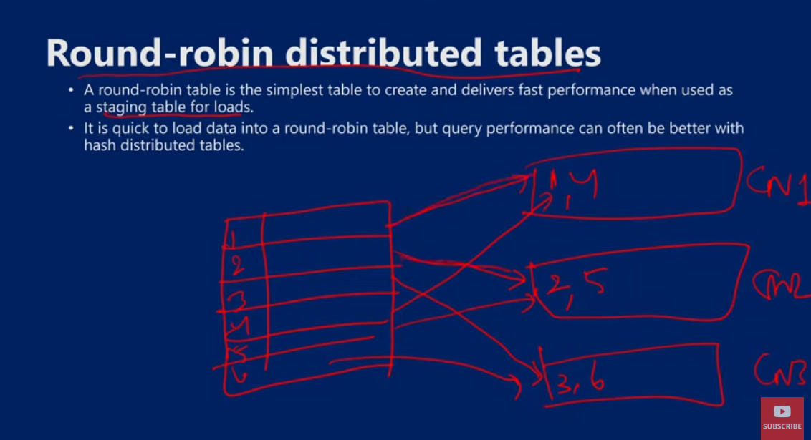

Replicated tables

When data is in small tables, entire table is added into all the compute nodes. As in single compute node u have all ur data, so it computes fast, ther would be no need of DMS to take data from each compute node etc, so it is fast

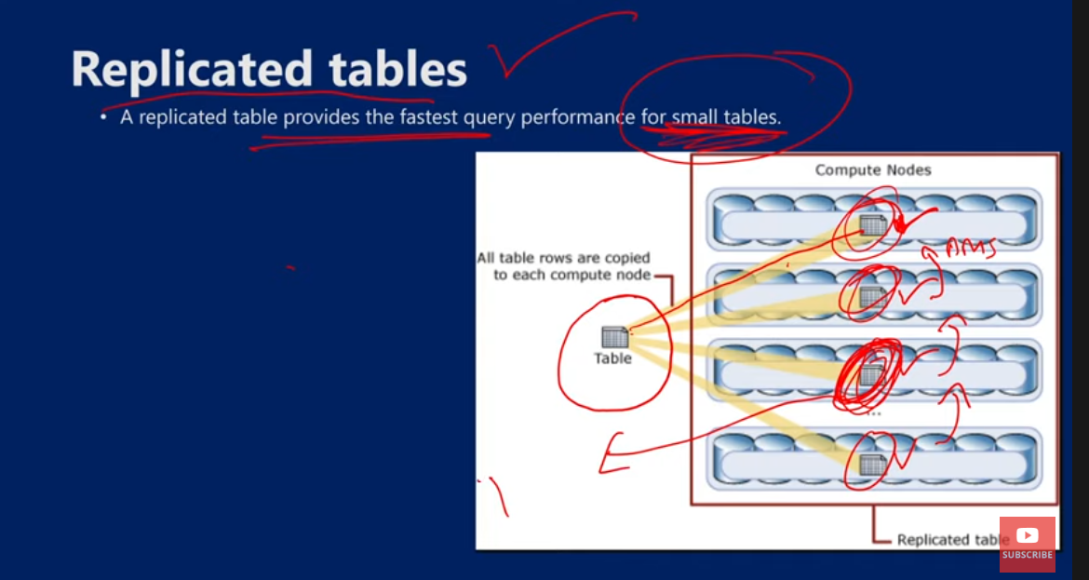

13. Server less SQL Pool Overview in Azure Synapse Analytics

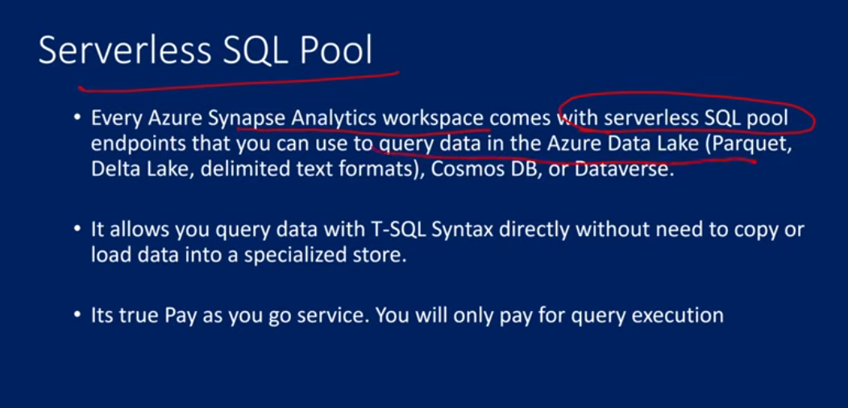

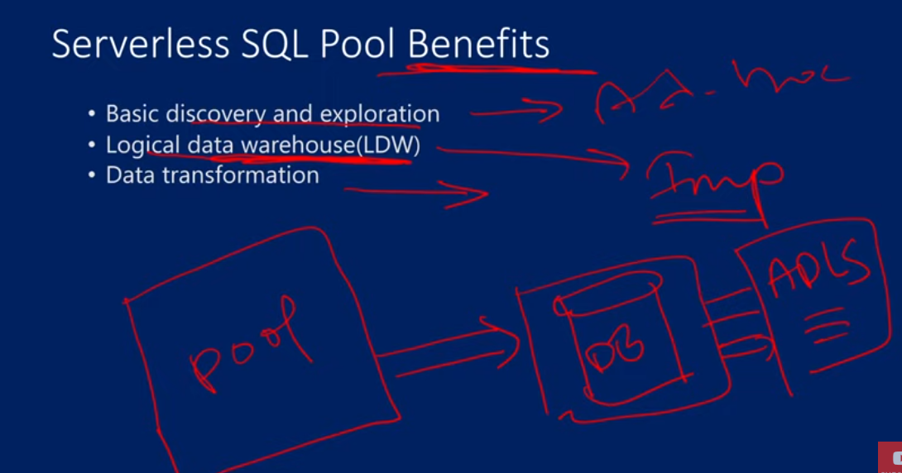

Serverless sql pool helps u to create a logical datawarehouse over the data lake etc db. It is just a layer on top of the data.

Databse has a power symbol, as it is just a layer, like it has no data , that is y there is external

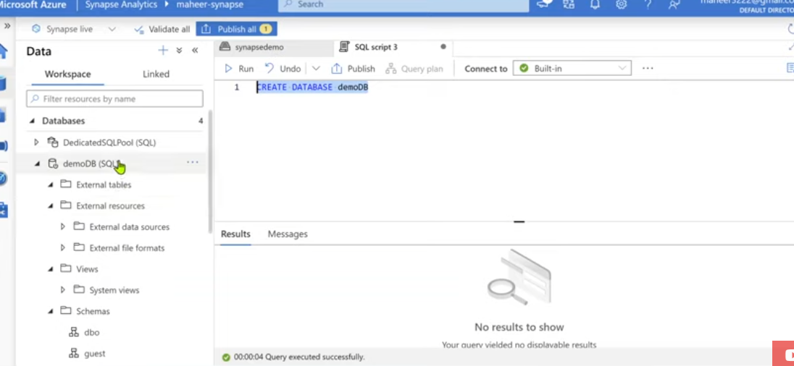

Using server less sql pool we build the LDW(LOGICAL DATA WAREHOUSE)

Whatever query we write for the data in azure datalake storage, those are used to store data in the external tables

LDW is a relational layer built on top of Azure data sources such as Azure Data Lake storage (ADLS), Azure Cosmos DB analytical storage, or Azure Blob storage.

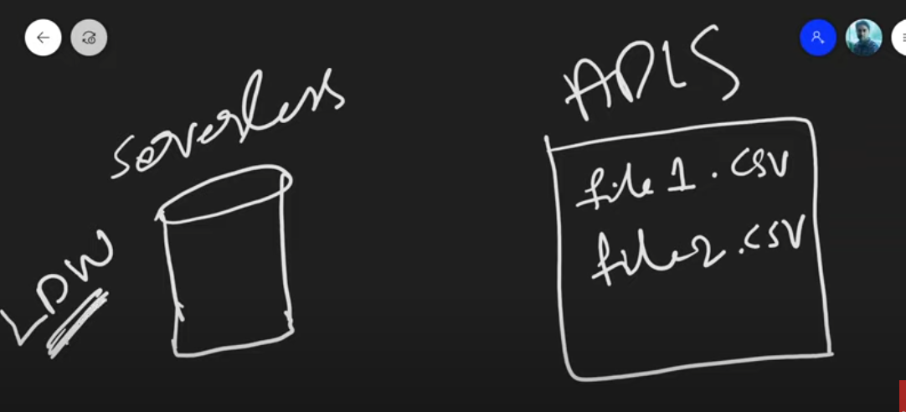

Data will always come from the files only(adls) not on the LDW,

In ldw, we only store the metadata of particular external table

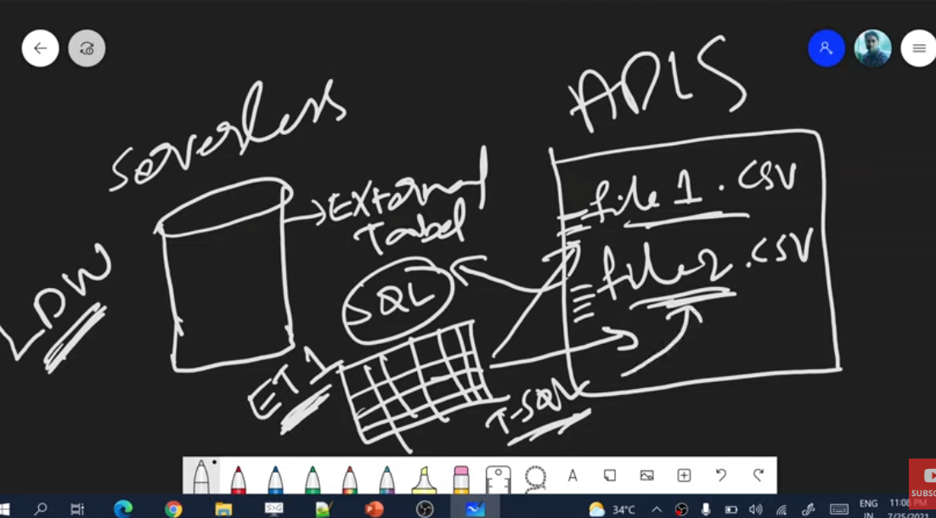

T-SQL support

It just offers querying surface area(LDW).

Schema is a group in which u have all the table and procedures etc but inside the schema u can only have external tables views etc

We can create views, stored procedures, inline table value functions, external resouces such as data sources, file formats and tables

Everything is external, nothing is stored. There iss no local storage for ldw. Only a metadata is there about table or view etc u created is there

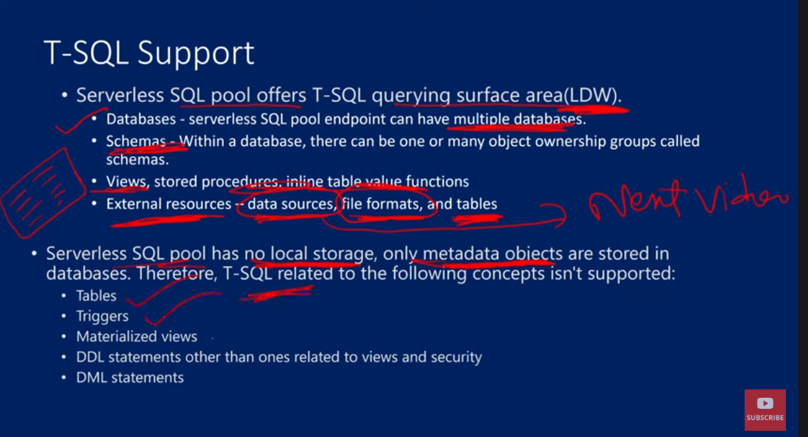

View – it will have sql query only

Materialized views – it will store the data by their own and has own memory alloacation which has data also.

Data definition statements other than views isn’t supported and so is Data manipulation statements

14. Create External Data source in Azure Synapse Analytics

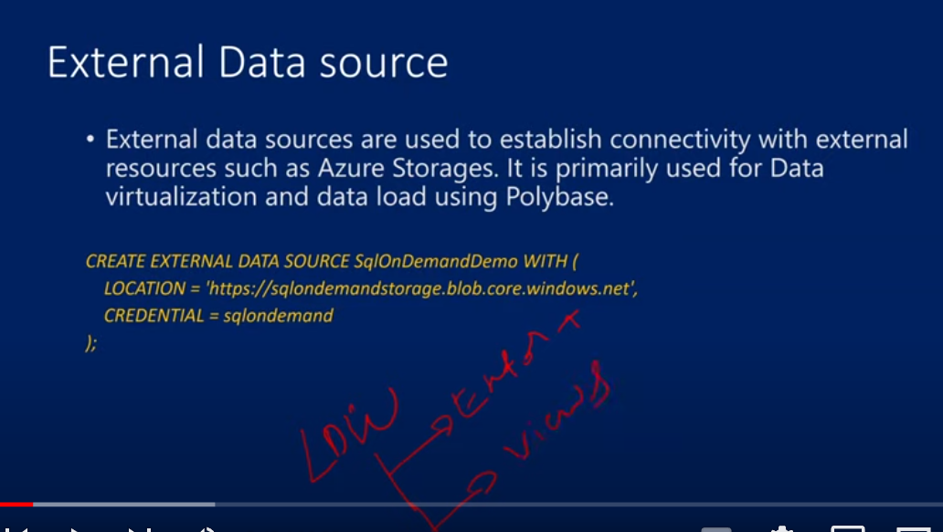

On top of the data lake storage data, we can create external table that is stored in ldw

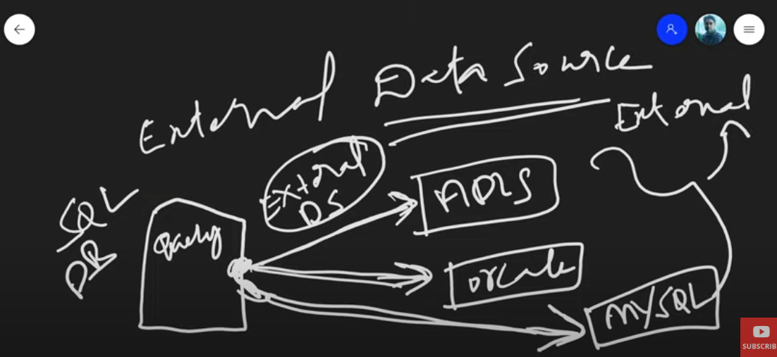

If we have some data in various locations in adls or oracle or mysql etc etc, we write a query to create a sql db and to get the access from those adls, oracle, mysql etc external data, we need to have external data source to get from external storages. They r like connection streams

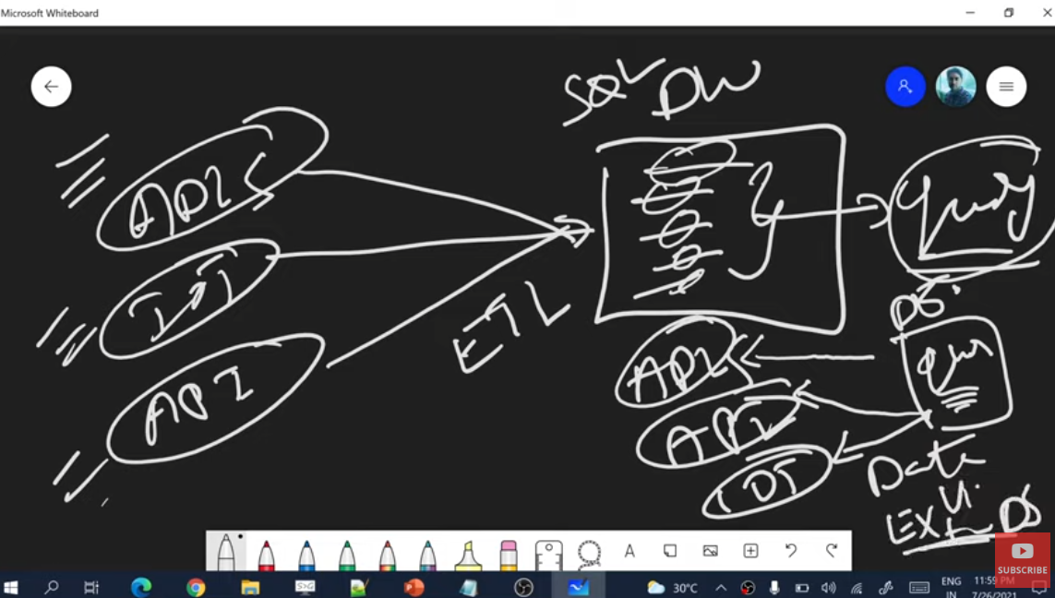

We take the data and create a data ware house, then we run a query on the data warehouse data, That query is a local query, this is not data virtualization.

If write a query to interact with the other storages without moving the data from external storage, then, that is data virtualization, for which we need an external data sources

SYNTAX

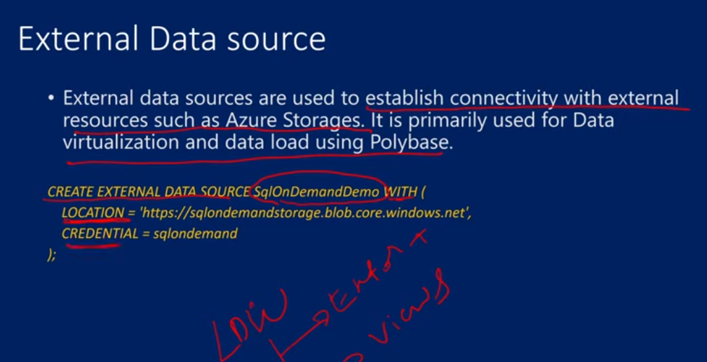

We need to CREATE the data source using WITH keyword with location of external storage and credential of the external storage.

For creating external data source for the maheer synapse data lake storage gen2

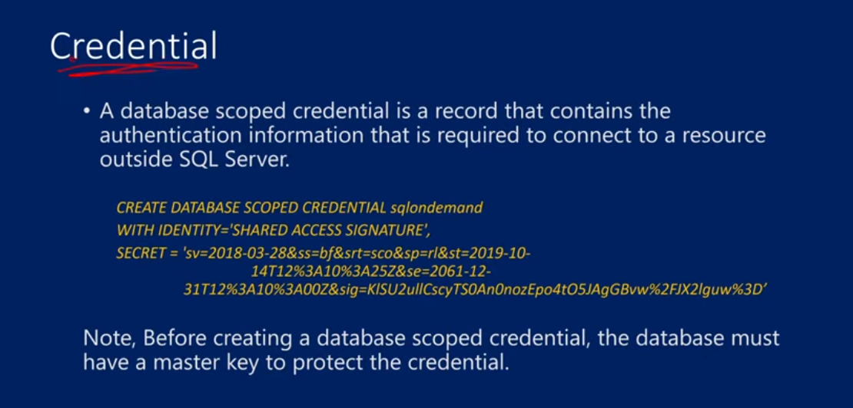

Use demoDB

GO

-- create master key that will protect the credentials:

CREATE MASTER KEY ENCRYPTION BY PASSWORD = 'Abhishek@2000'

CREATE DATABASE SCOPED CREDENTIAL demoCredential

WITH IDENTITY = 'SHARED ACCESS SIGNATURE',

SECRET = 'sv=2021-06-08&ss=bfqt&srt=sco&sp=rwdlacupyx&se=2022-09-15T23:48:38Z&st=2022-09-15T15:48:38Z&spr=https&sig=csqEBAdKEWBk6OCbVYYpCCfF26lrtvonTvWKVkYaFYw%3D',

GO

CREATE EXTERNAL DATA SOURCE demoDataSource WITH(

    LOCATION = "https://maheeradlsgen2.dfs.core.windows.net",

    CREDENTIAL = demoCredential

);

To get the shared access signature, go to

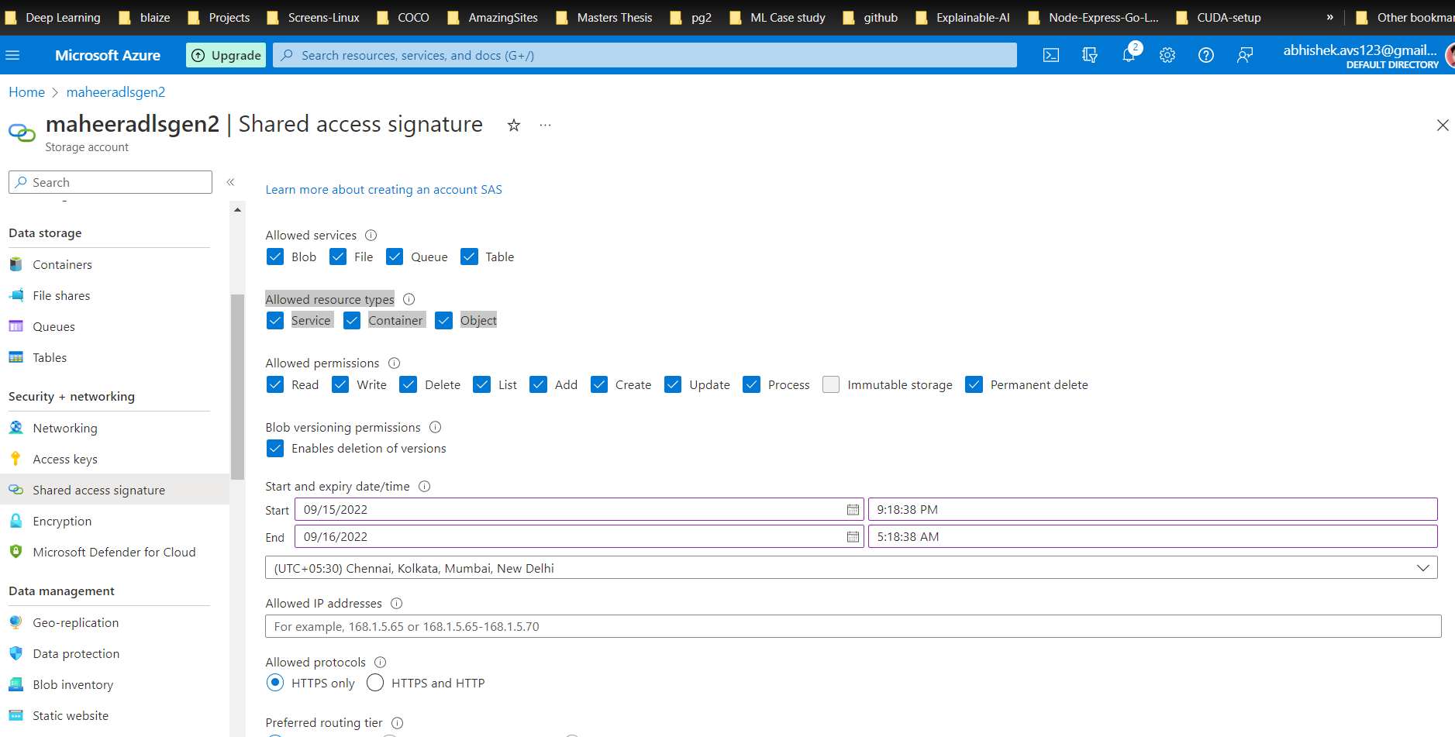

Tick the allowed resources types all 3 boxes- service, container, object> click on Generate SAS and connection string> then copy the SAS token and remove “?” and put it in the SECRET in above code

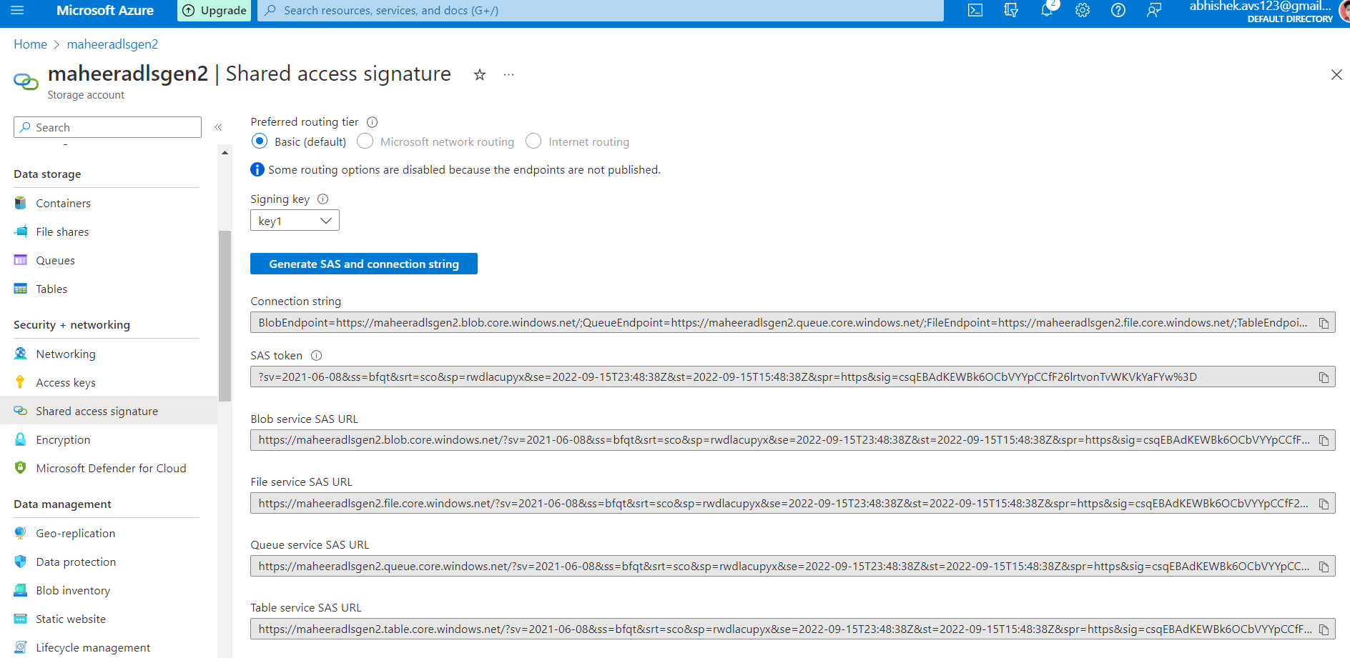

Once master key is created, then we create credentials in the database which will have authentication information of the ADLS. And once the authentication info is stored in the credential object called demoCredentials, we are creating external data source as demoDataSource, using the respective credential I want to access the location of the external data source as the credential that was created was the credential of this particular data lake storage.

15. Create External File Format in Azure Synapse Analytics

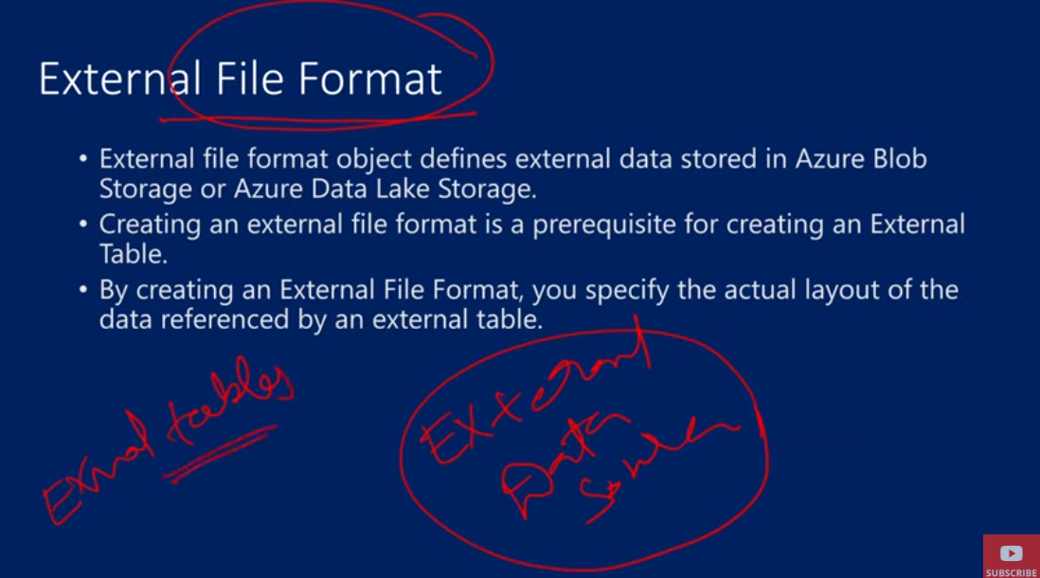

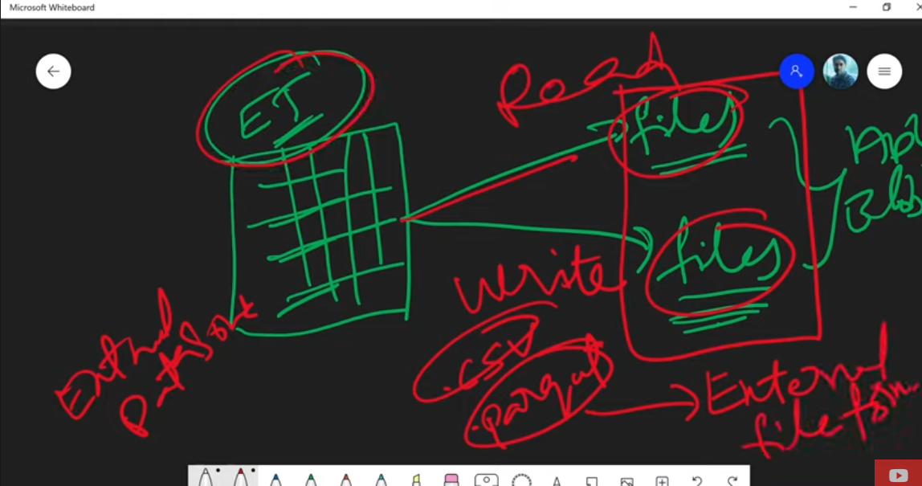

External data source is used to access the files in external storages, to read or write data in that storage. The files in the external storage will have some certain file formats like csv, parquet etc, for them we need to define the external file format object

Entire layout of external table is defined in this file format object like

first row i.e starts from first row or some gap is there and from 3rd row the header starts,

field i.e our data is separated by something like , or | etc

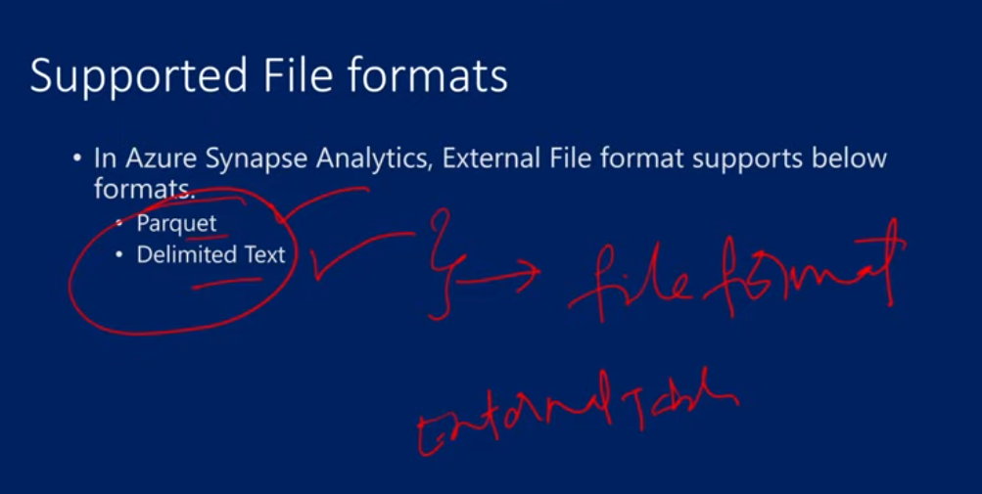

Syntax for creating the external file format

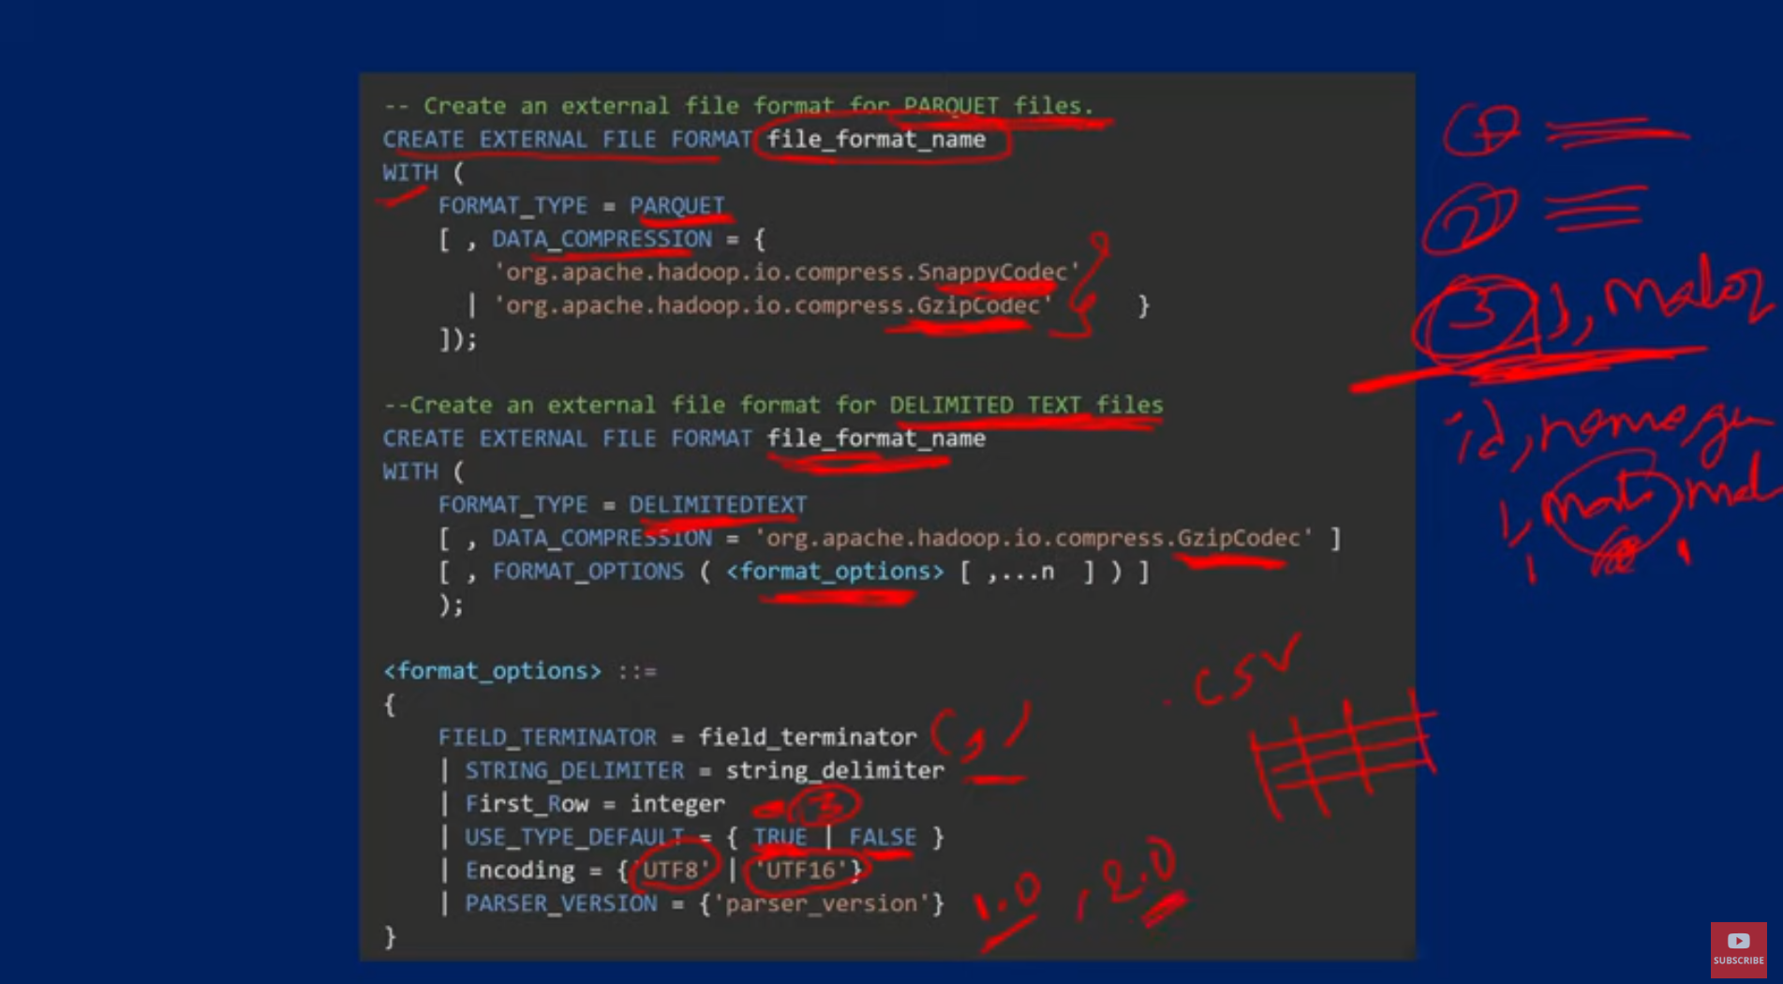

File compression format – SnappyCoded and GzipCodec for parquet file and for delimited text file only GzipCodec is there and we need to define a format options also



16. CETAS with Synapse SQL in Azure Synapse Analytics

CETAS – create external table as SELECT – this is an external table that is generate based on the output of the SELECT query

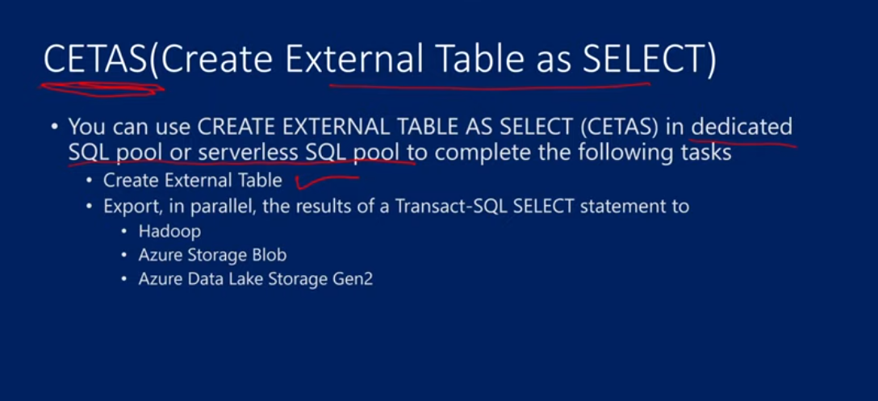

CREATE EXTERNAL TABLE [ [database_name . [ schema_name ] . ] | schema_name . ] table_name

WITH (

LOCATION = 'path_to_folder',

DATA_SOURCE = external_data_source_name,

FILE_FORMAT = external_file_format_name

)

AS <select_statement>

[;]

<select_statement> ::=

[ WITH <common_table_expression> [ ,...n ] ]

SELECT <select_criteria>

LOCATION is of the external storage and give the data source and file format name

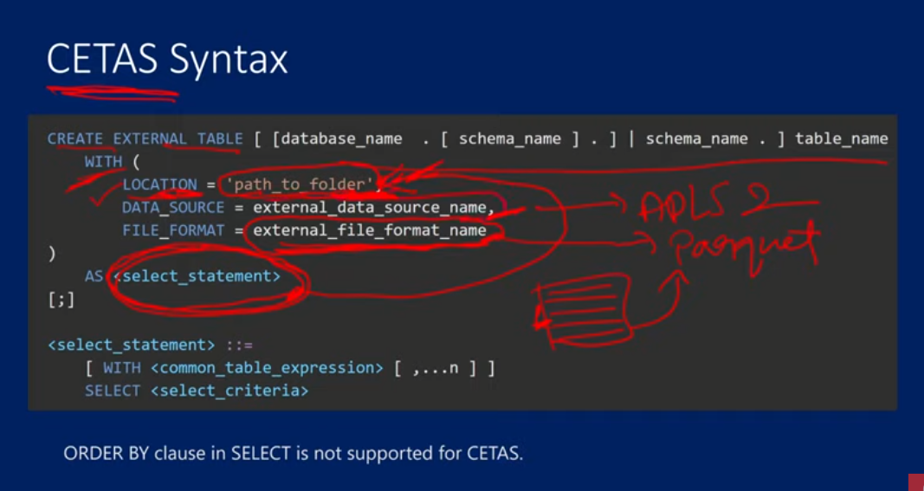

CTE – common table expressions which are temporary datasets

CREATE DATABASE demoDB

      COLLATE Latin1_General_100_BIN2_UTF8;

--inside the database if u have any string data and in which format they are - UTF8 or UTF 16 compression type

-- if u r trying to write a query to read or write data from external table, u will see an error that to add this collate in the db

-- to prevent this error use this collate

Use demo_db

GO

-- create master key that will protect the credentials:

CREATE MASTER KEY ENCRYPTION BY PASSWORD = 'Abhishek@2000'

-- CREATE DATABASE SCOPED CREDENTIAL demoCredential

-- WITH

--      IDENTITY = 'SHARED ACCESS SIGNATURE',

--      SECRET = 'sv=2021-06-08&ss=bfqt&srt=sco&sp=rwdlacupyx&se=2022-09-15T23:48:38Z&st=2022-09-15T15:48:38Z&spr=https&sig=csqEBAdKEWBk6OCbVYYpCCfF26lrtvonTvWKVkYaFYw%3D'

-- GO

CREATE DATABASE SCOPED CREDENTIAL ManagedIdentity

WITH

    IDENTITY = 'Managed Identity'

GO

CREATE EXTERNAL DATA SOURCE demoDataSource

WITH(

    LOCATION = 'https://maheeradlsgen2.dfs.core.windows.net',

    CREDENTIAL = ManagedIdentity

);

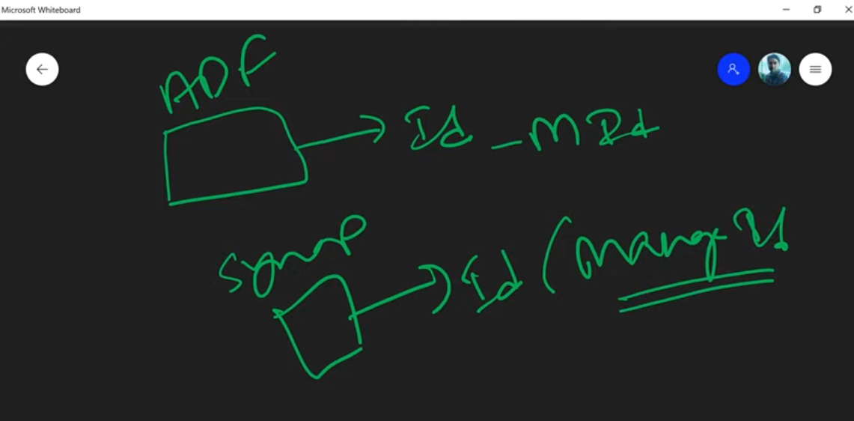

Managed identity – it Is same as the workspace name. in our case the workspace name is maheer-synapse, so this name is my managed identity. For that ID we are creating the credential object here

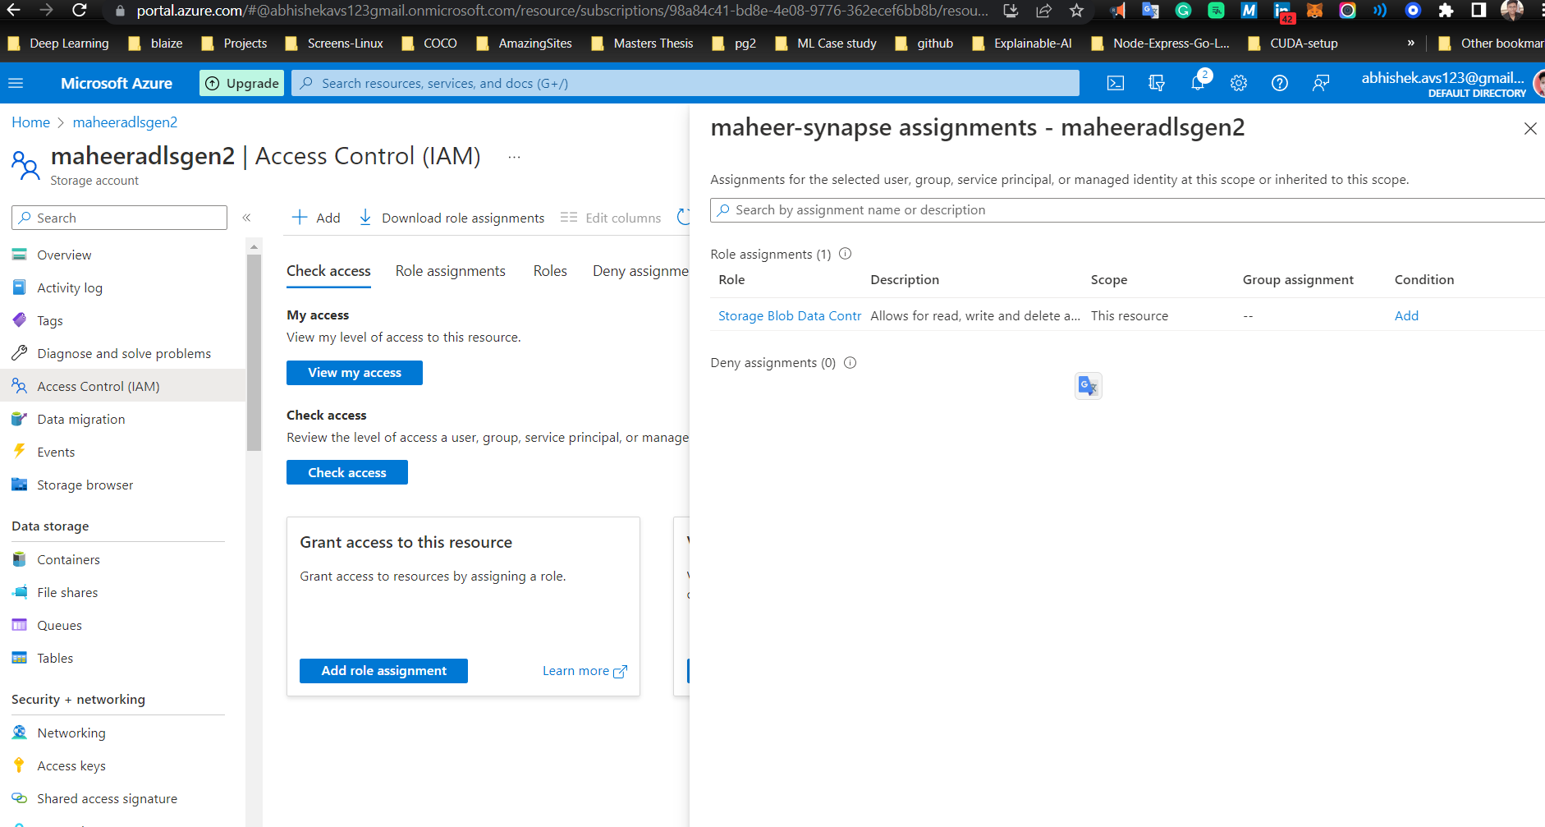

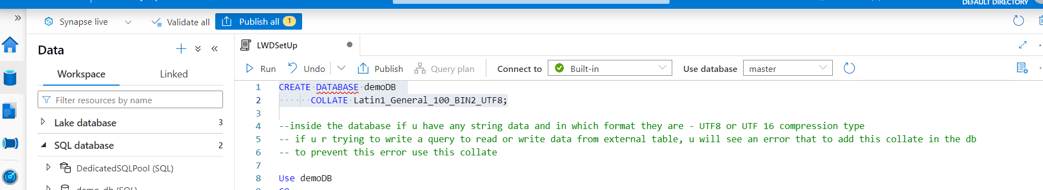

Initially use the master database to create demoDB, then run the rest of the lines with demoDB database

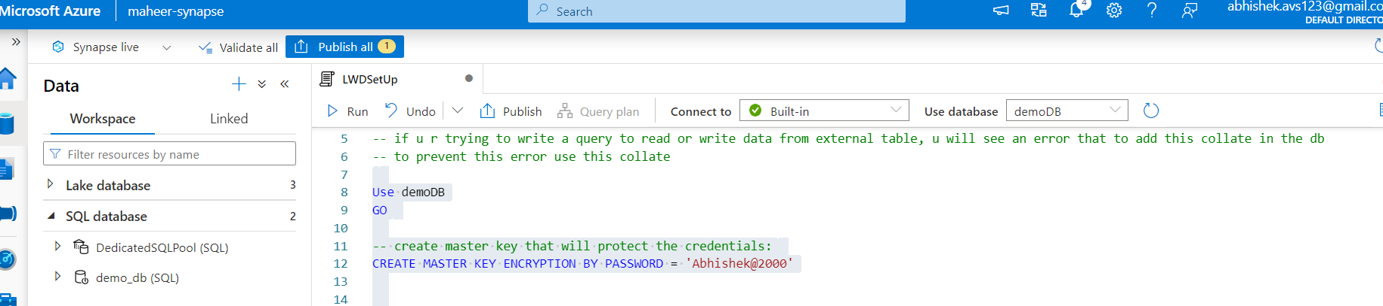

-- CREATE SCHEMA NYCTaxi

CREATE EXTERNAL TABLE NYCTaxi.PassengersCountStats

WITH (

    LOCATION = 'synapsedemo/NYCTaxi/Aggdata/',

    DATA_SOURCE = demoDataSource,

    FILE_FORMAT = ParquetFileFormat

)

AS

SELECT PassengerCount,

    SUM(TripDistanceMiles) AS SumTripDistance,

    AVG(TripDistanceMiles) AS AvgTripDistance

FROM

    OPENROWSET

    (

        BULK 'https://maheeradlsgen2.dfs.core.windows.net/synapsedemo/data/NYCTripSmall.parquet',

        FORMAT='PARQUET'

    )

AS [rows]

    WHERE TripDistanceMiles > 0 AND PassengerCount > 0

    GROUP BY PassengerCount

GO

-- you can query the newly created external table

SELECT * FROM NYCTaxi.PassengersCountStats

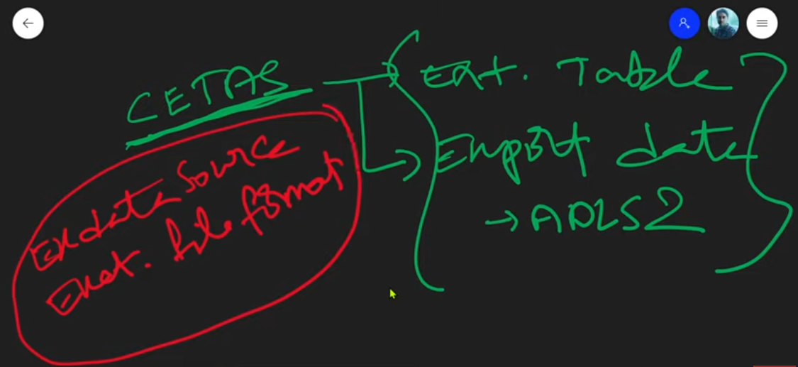

17. CTAS with Synapse SQL in Azure Synapse Analytics

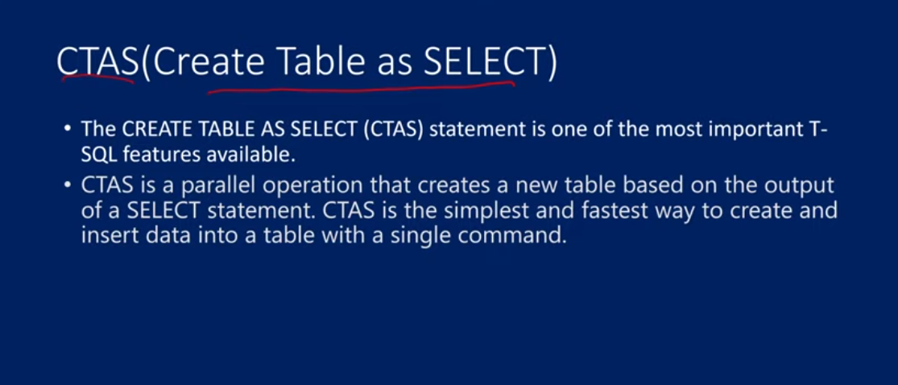

CTAS can be created only in dedicated table

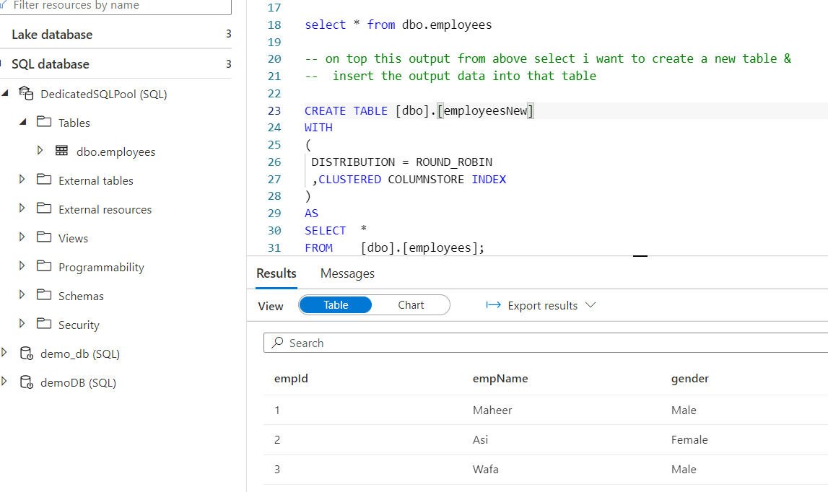

To see the distribution of the table, right click on dbo.employees and new script and click on CREATE

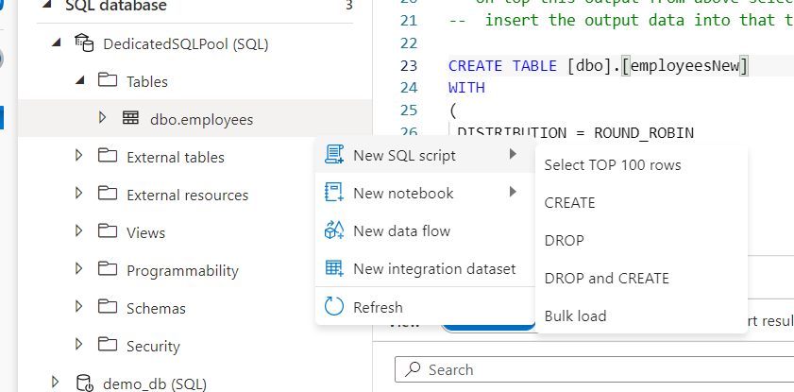

Type of distribution is shown here

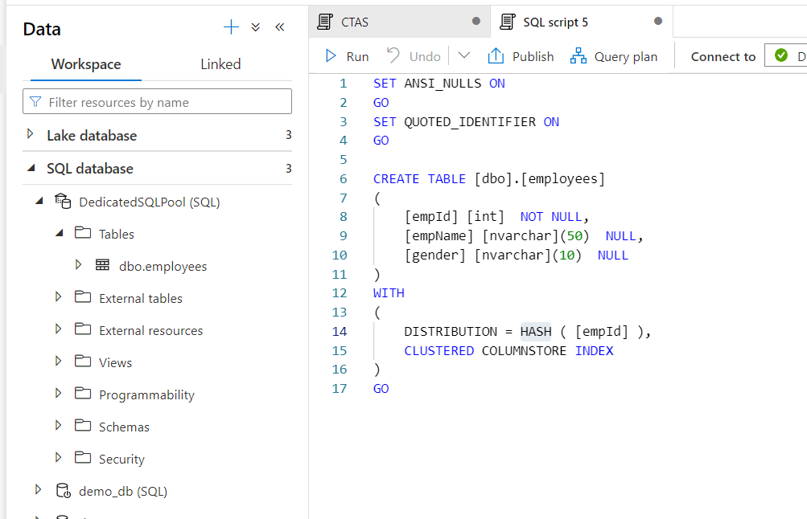

Hash with emoname instead if emid

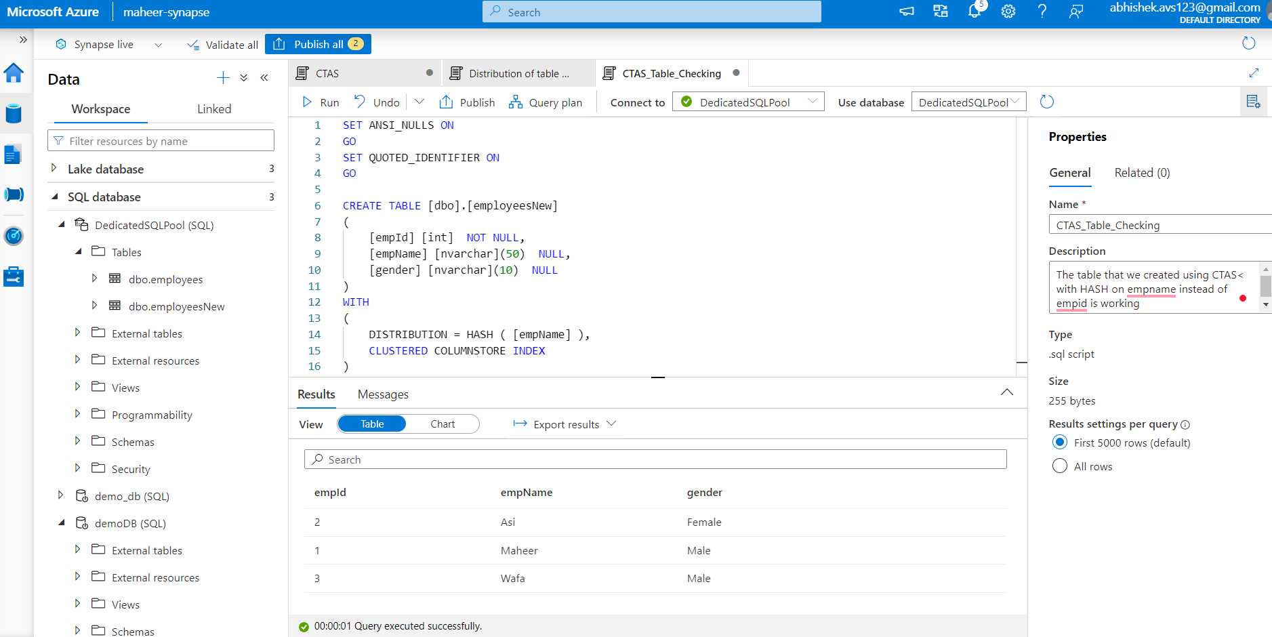

Round robin

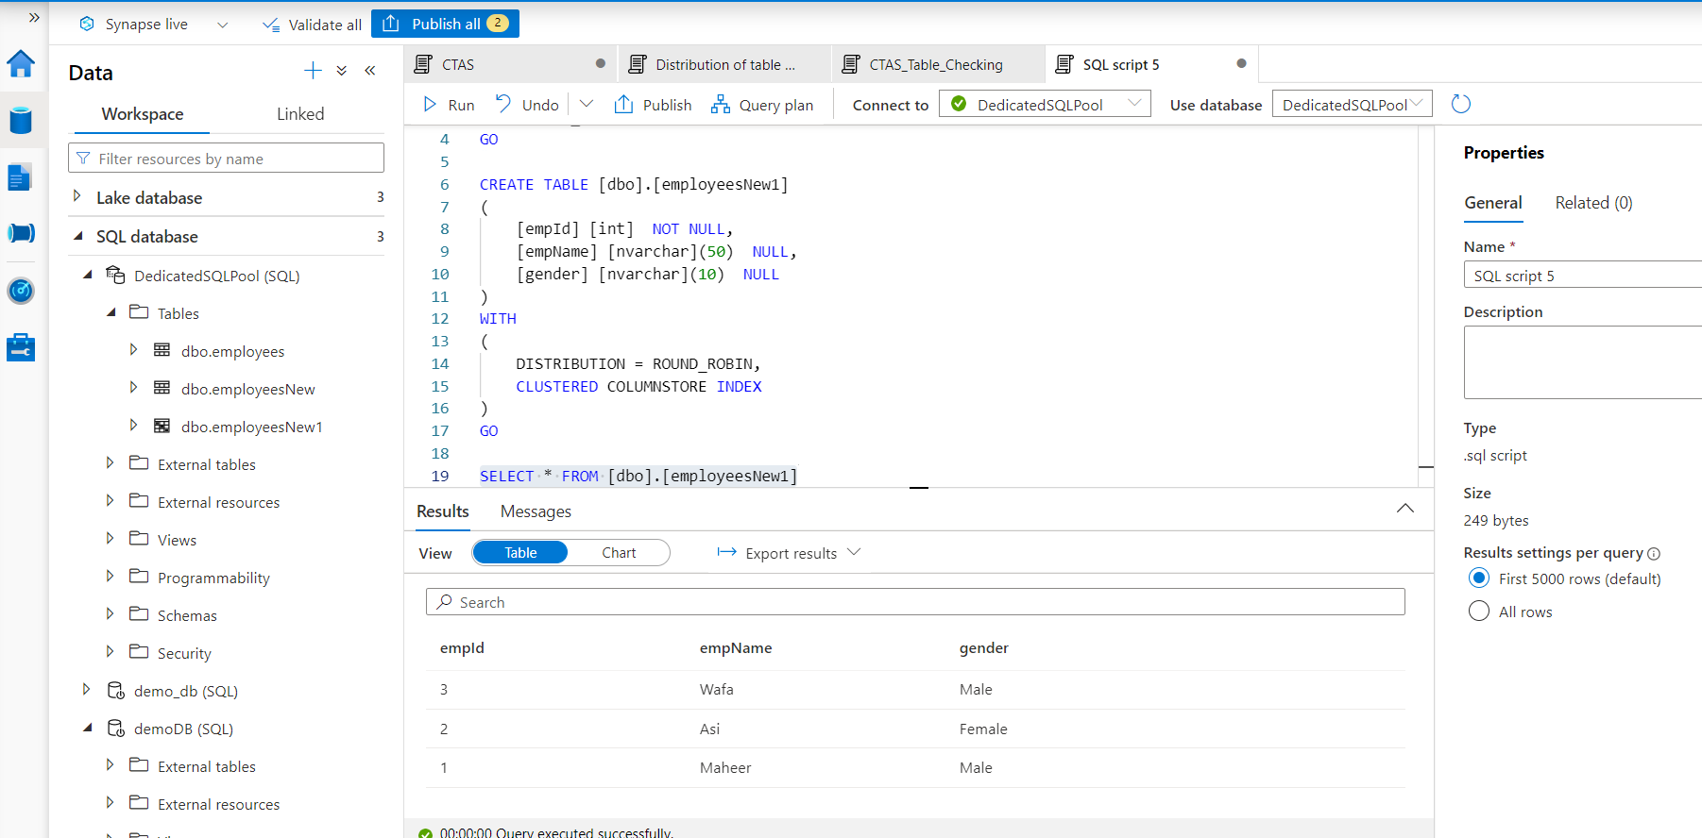

18. External Tables with Synapse SQL in Azure Synapse Analytics

CTAS only in Dedicated sql pool

But, External Table is in both

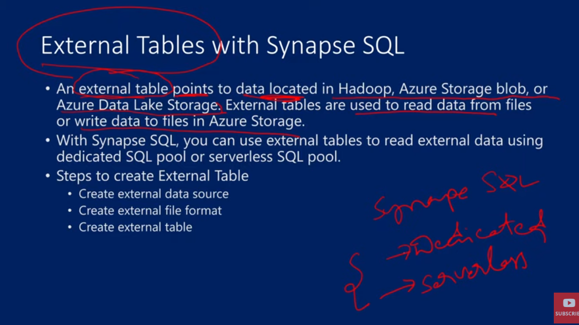

CREATE EXTERNAL DATA SOURCE maheeradlsgen2

WITH(

    LOCATION = 'abfss://synapsedemo@maheeradlsgen2.dfs.core.windows.net',

    CREDENTIAL = MSI_maheeradlsgen2,

    TYPE = HADOOP

);

-- We use ABFSS as we are creating data source

-- 1st we create credential object, once we create it, we use the object in data source and create our external data source

-- We define TYPE as HADOOP. It is datalake gen2 but y am I mentioning as Hadoop, u would be confused, right!

-- Using this external data source, u will query the data inside the data lake gen 2 using the Hadoop technology. Hadoop -> Java based technology which has a agility to query the data inside datalake storage gen 2 coz the data lake gen2 is built over Hadoop ecosystem only

DROP EXTERNAL DATA SOURCE maheeradlsgen2

CREATE DATABASE SCOPED CREDENTIAL MSI_maheeradlsgen2

WITH

    IDENTITY = 'Managed Identity'

GO

DROP DATABASE SCOPED CREDENTIAL MSI_maheeradlsgen2

CREATE MASTER KEY ENCRYPTION BY PASSWORD = 'Abhishek@2000'

CREATE EXTERNAL FILE FORMAT SynapseParquet

WITH (

    FORMAT_TYPE = PARQUET,

    DATA_COMPRESSION = 'org.apache.hadoop.io.compress.SnappyCodec'

)

DROP EXTERNAL FILE FORMAT SynapseParquet

CREATE EXTERNAL TABLE dbo.NYCTaxi

    (

     [DateID] int,

     [MedallionID] int,

     [HackneyLicenseID] int,

     [PickupTimeID] int,

     [DropoffTimeID] int,

     [PickupGeographyID] int,

     [DropoffGeographyID] int,

     [PickupLatitude] float,

     [PickupLongitude] float,

     [PickupLatLong] nvarchar(4000),

     [DropoffLatitude] float,

     [DropoffLongitude] float,

     [DropoffLatLong] nvarchar(4000),

     [PassengerCount] int,

     [TripDurationSeconds] int,

     [TripDistanceMiles] float,

     [PaymentType] nvarchar(4000),

     [FareAmount] numeric(19,4),

     [SurchargeAmount] numeric(19,4),

     [TaxAmount] numeric(19,4),

     [TipAmount] numeric(19,4),

     [TollsAmount] numeric(19,4),

     [TotalAmount] numeric(19,4)

    )

WITH

    (

        LOCATION = '/data/NYCTripSmall.parquet',

        DATA_SOURCE = maheeradlsgen2,

        FILE_FORMAT = SynapseParquet

    )

SELECT top 100 * FROM dbo.NYCTaxi

We use ABFSS as we are creating data source

1st we create credential object, once we create it, we use the object in data source and create our external data source

We define TYPE as HADOOP. It is datalake gen2 but y am I mentioning as Hadoop, u would be confused, right!

Using this external data source, u will query the data inside the data lake gen 2 using the Hadoop technology. Hadoop -> Java based technology which has a agility to query the data inside datalake storage gen 2 coz the data lake gen2 is built over Hadoop ecosystem only

**USES of External Table**

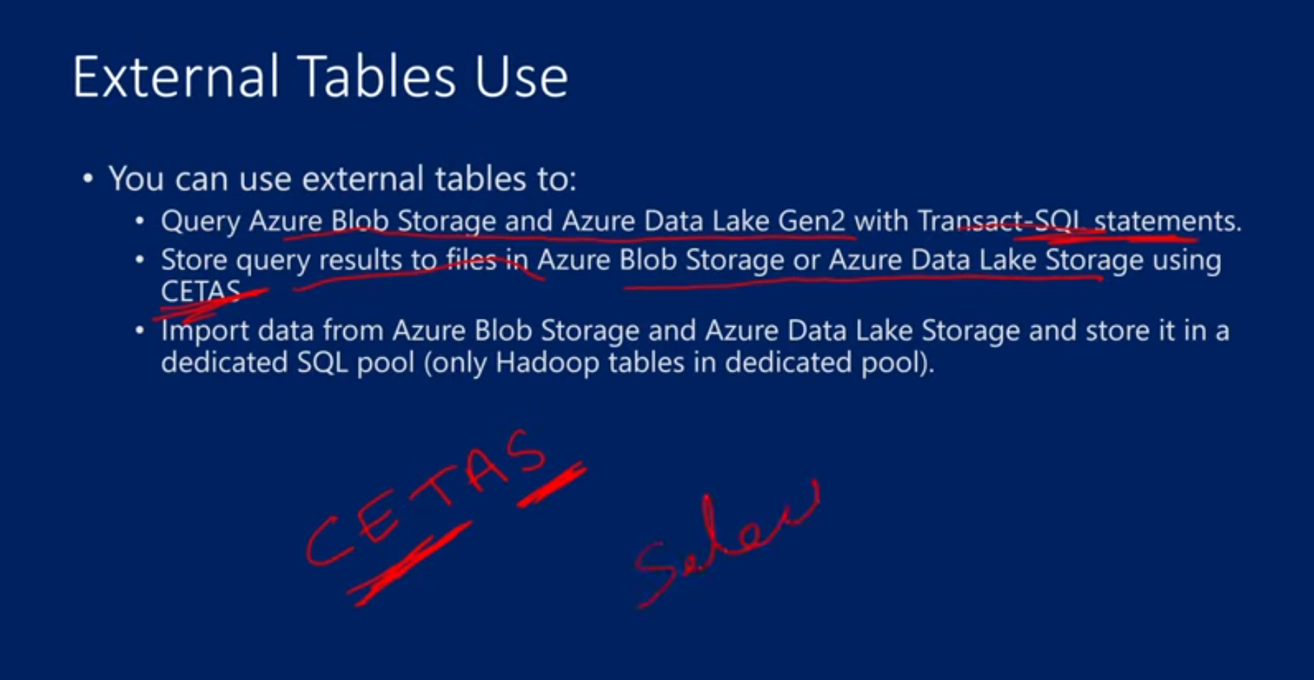

Using CETAS the select query output is stored in the ADLS

Like we can just import data of top 100 rows in table etc

-- We create a CTAS using the output of above select query

CREATE TABLE dbo.NYCPhysicalTable

WITH

(

DISTRIBUTION = HASH(DateID),

CLUSTERED COLUMNSTORE INDEX

)

AS

SELECT top 100 * FROM dbo.NYCTaxi

SELECT top 100 * FROM dbo.NYCPhysicalTable

19. Create and query external tables from a file in ADLS in Azure Synapse Analytics

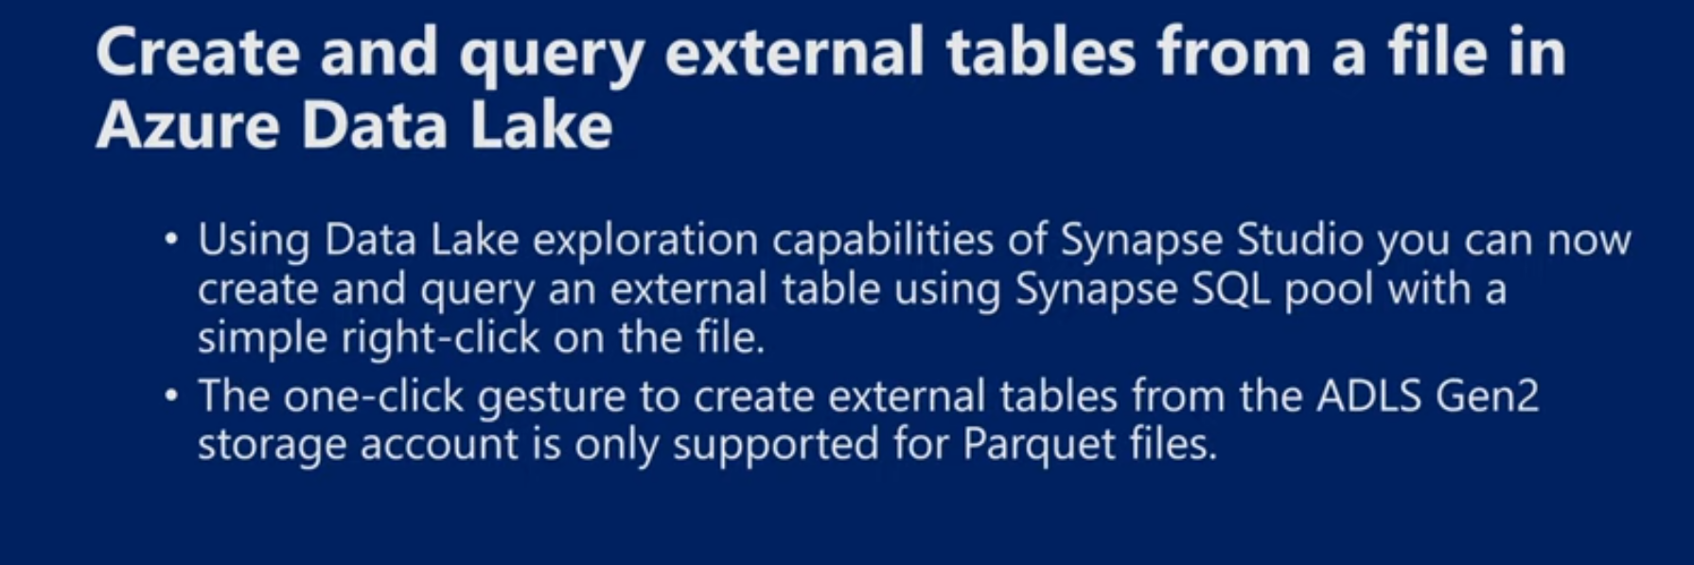

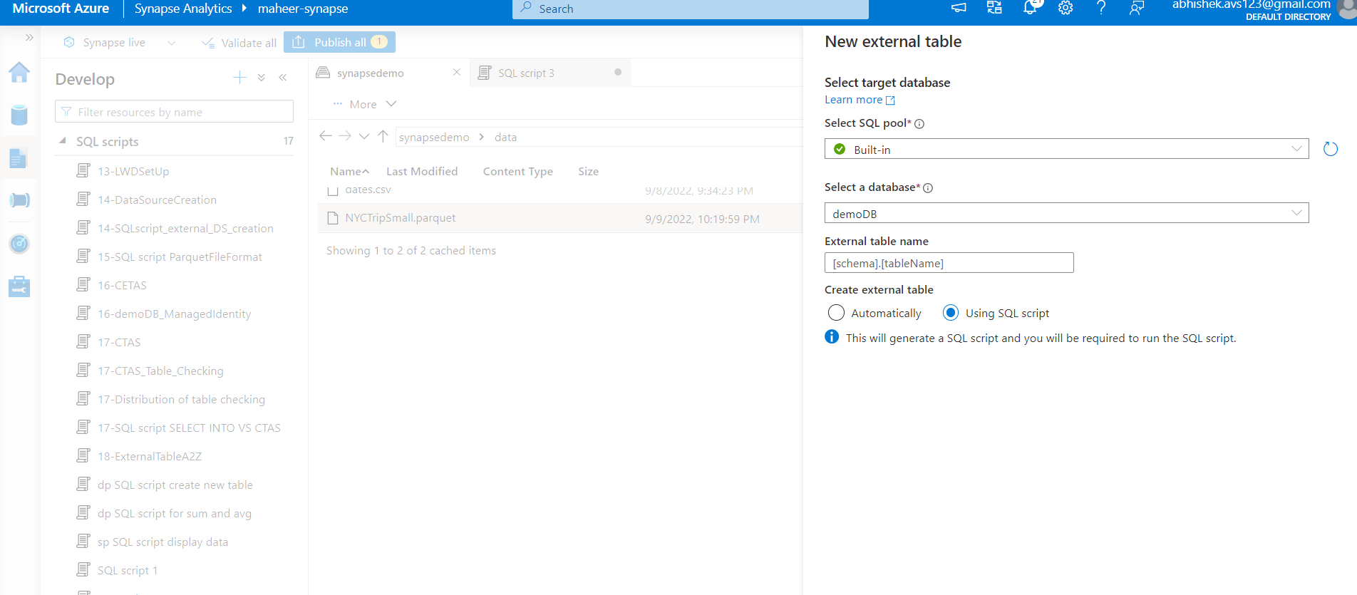

For csv file it don’t work

20. Types of External Tables (Hadoop & Native) in Synapse SQL in Azure Synapse Analytics

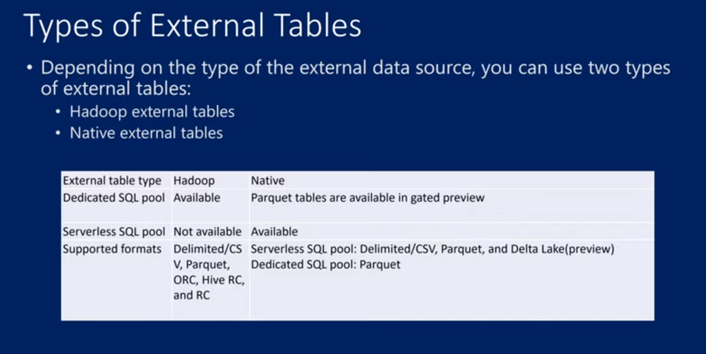

* Hadoop External Tables - TYPE = HADOOP
  + It is an external table that uses JAVA technology to read the data from external files
  + It is available in dedicated sql pool, not available in serverless
  + 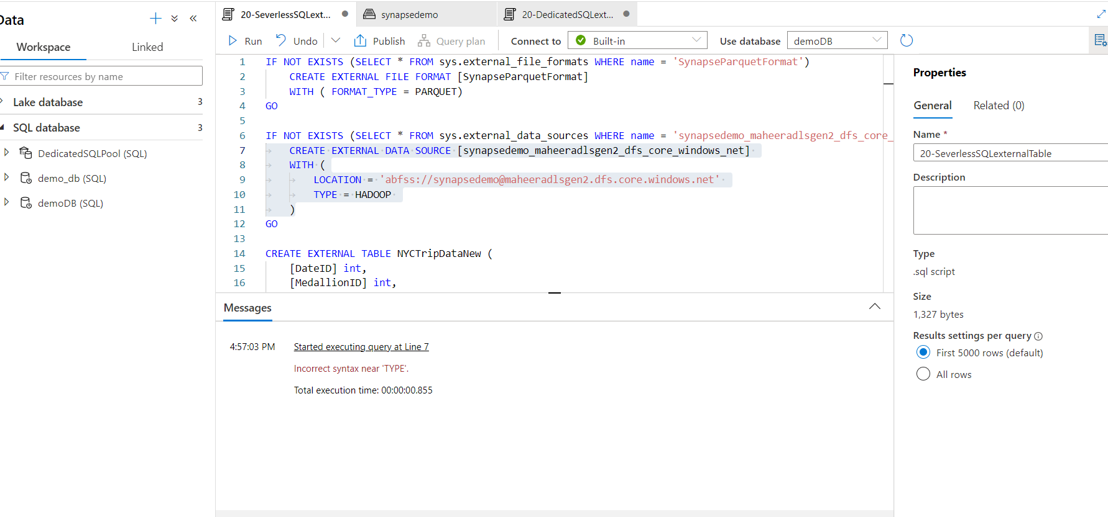
  + 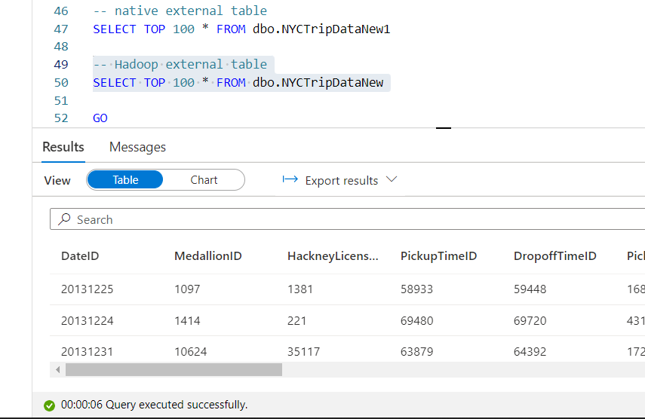
* Native External Tables - if u don’t mention TYPE = HADOOP
  + Better than Hadoop ones in performance
  + Azure native technology is in C++ technology for reading the data from external storage
  + 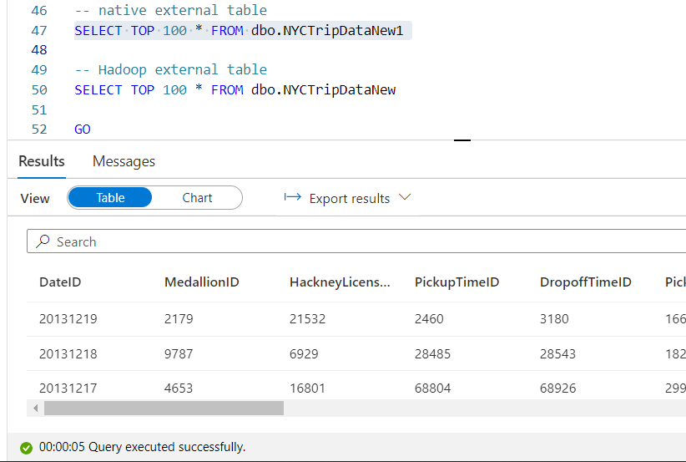

21. Administrative accounts in Synapse SQL in Azure Synapse Analytics

Maheer-synapse work space > properties> there are 2 things in it – sql admin nusername and SQL Active Directory Admin

* Server Admin –
  + u can give any name in this
  + created automatically
  + uses SQL Authentication, can change by clicking on reset admin password etc
  + 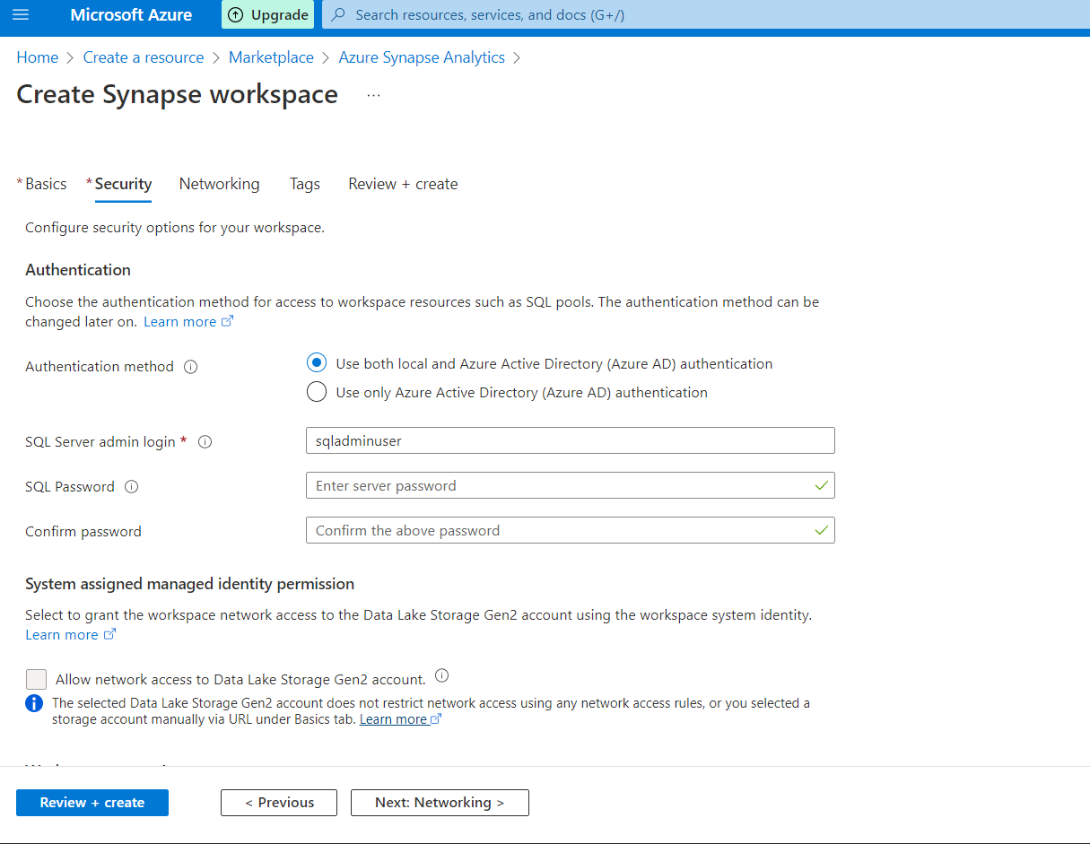
* Active Directory Admin –
  + ur own id will be added to the active directory admin
  + u can change it in settings> sql active directory admin>SET ADMIN> enter the search box
  + u can also create sql directory admin group also

These can be used to connect to any database i.e. serveless and dedicated sql pool an du can do anything u want.

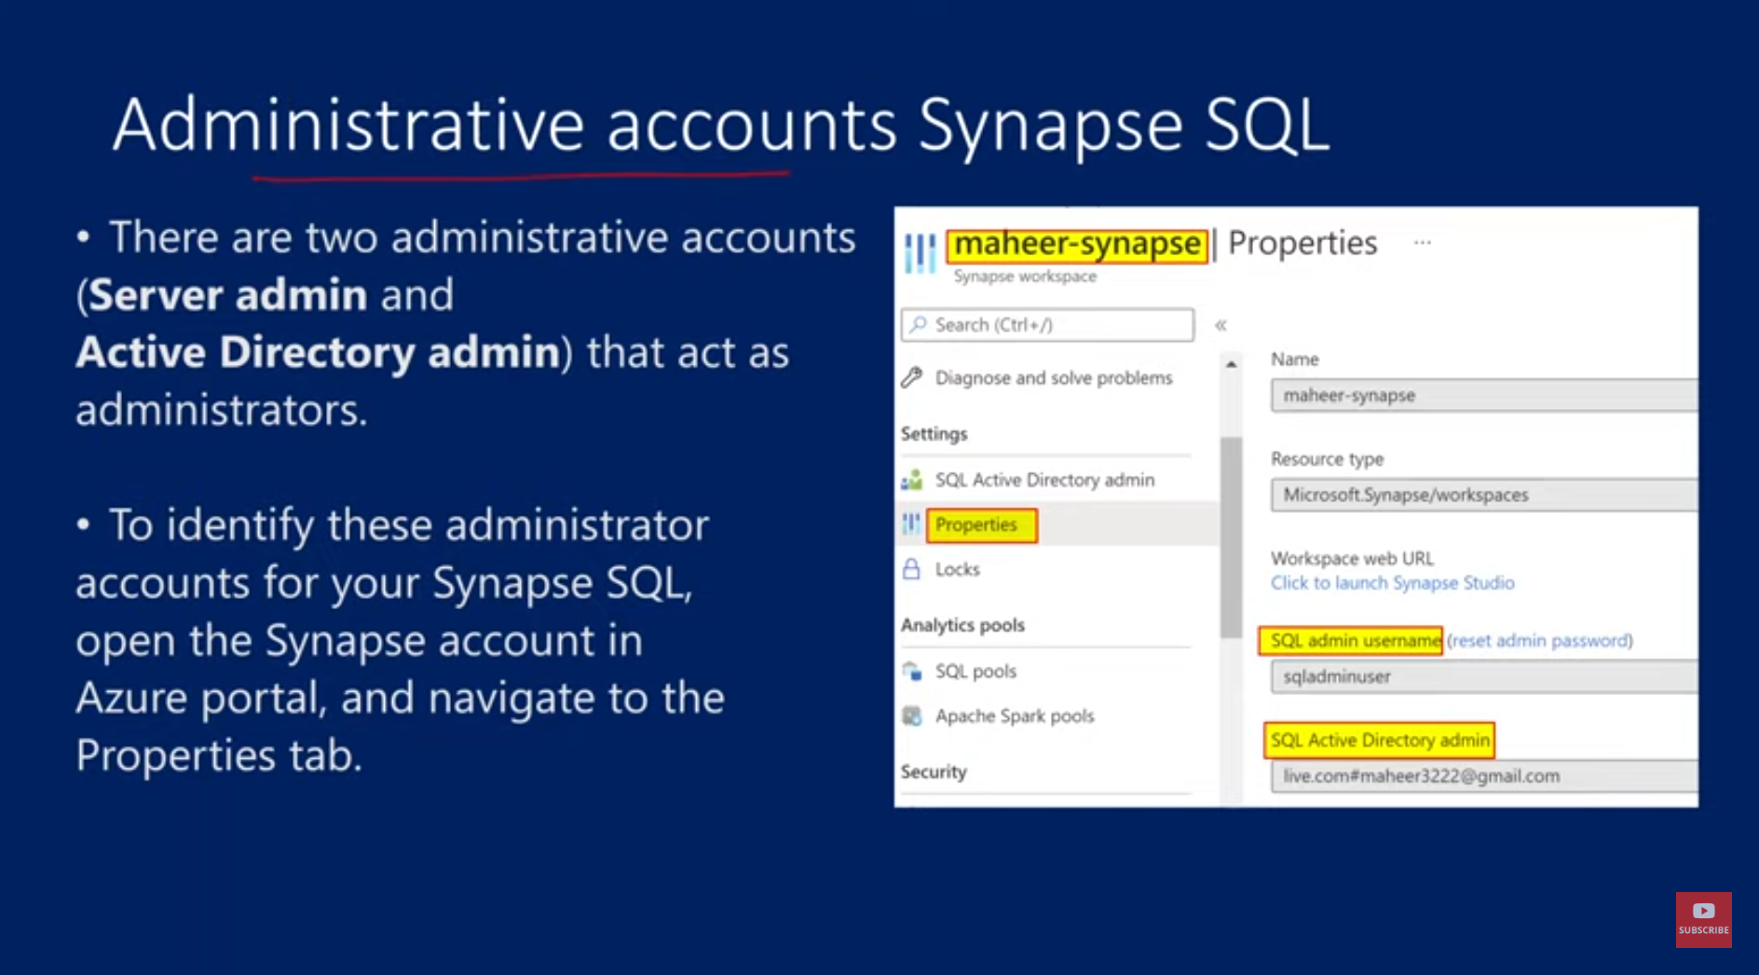

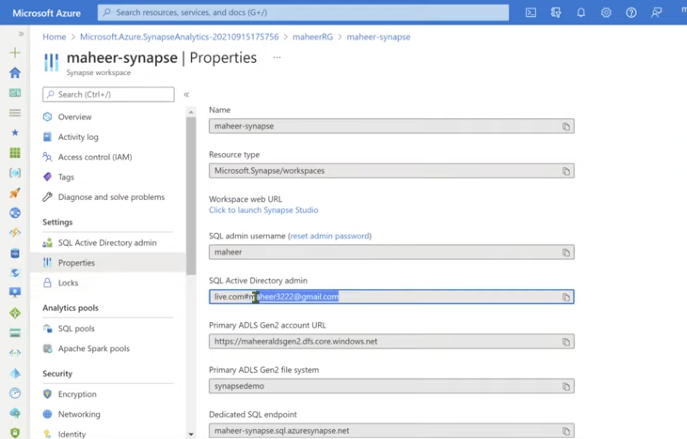

SQL Server Management Studio (SSMS)

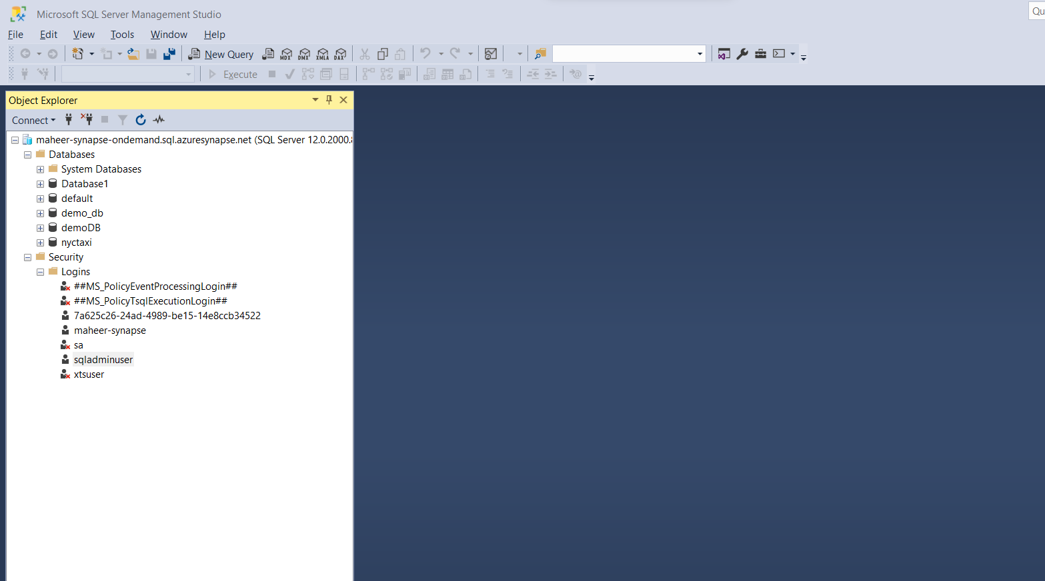

2nd icon beside connect in this pic, u can click on it and disconnect

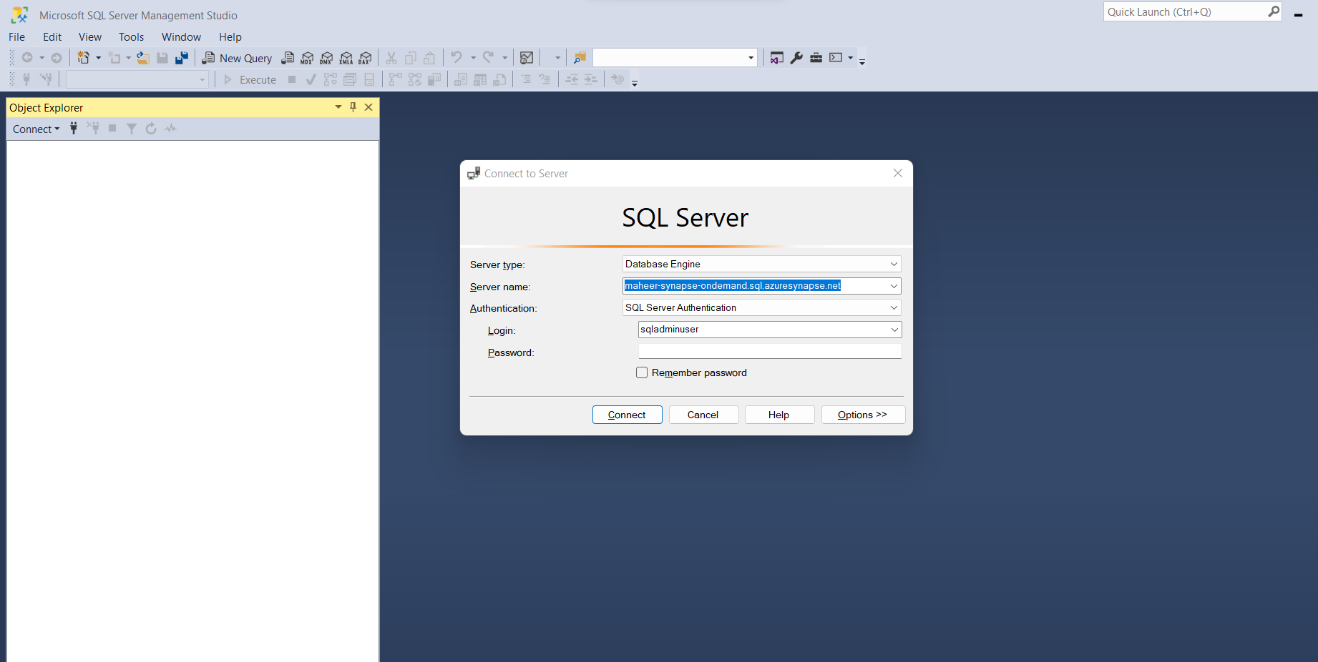

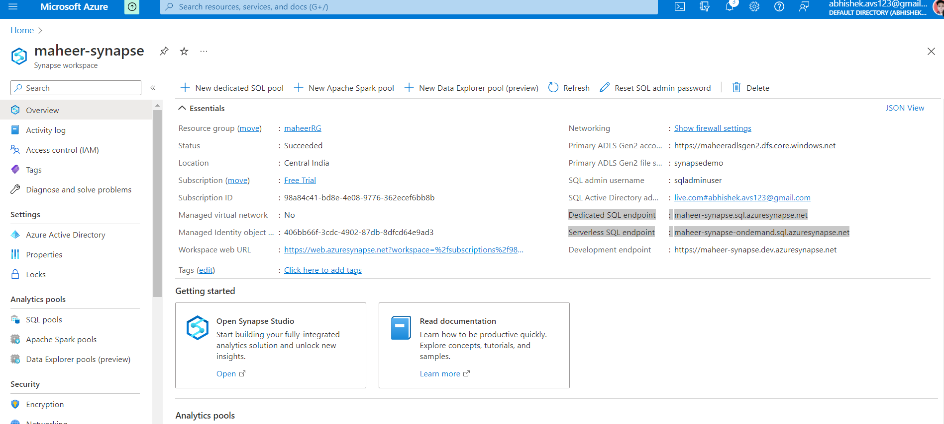

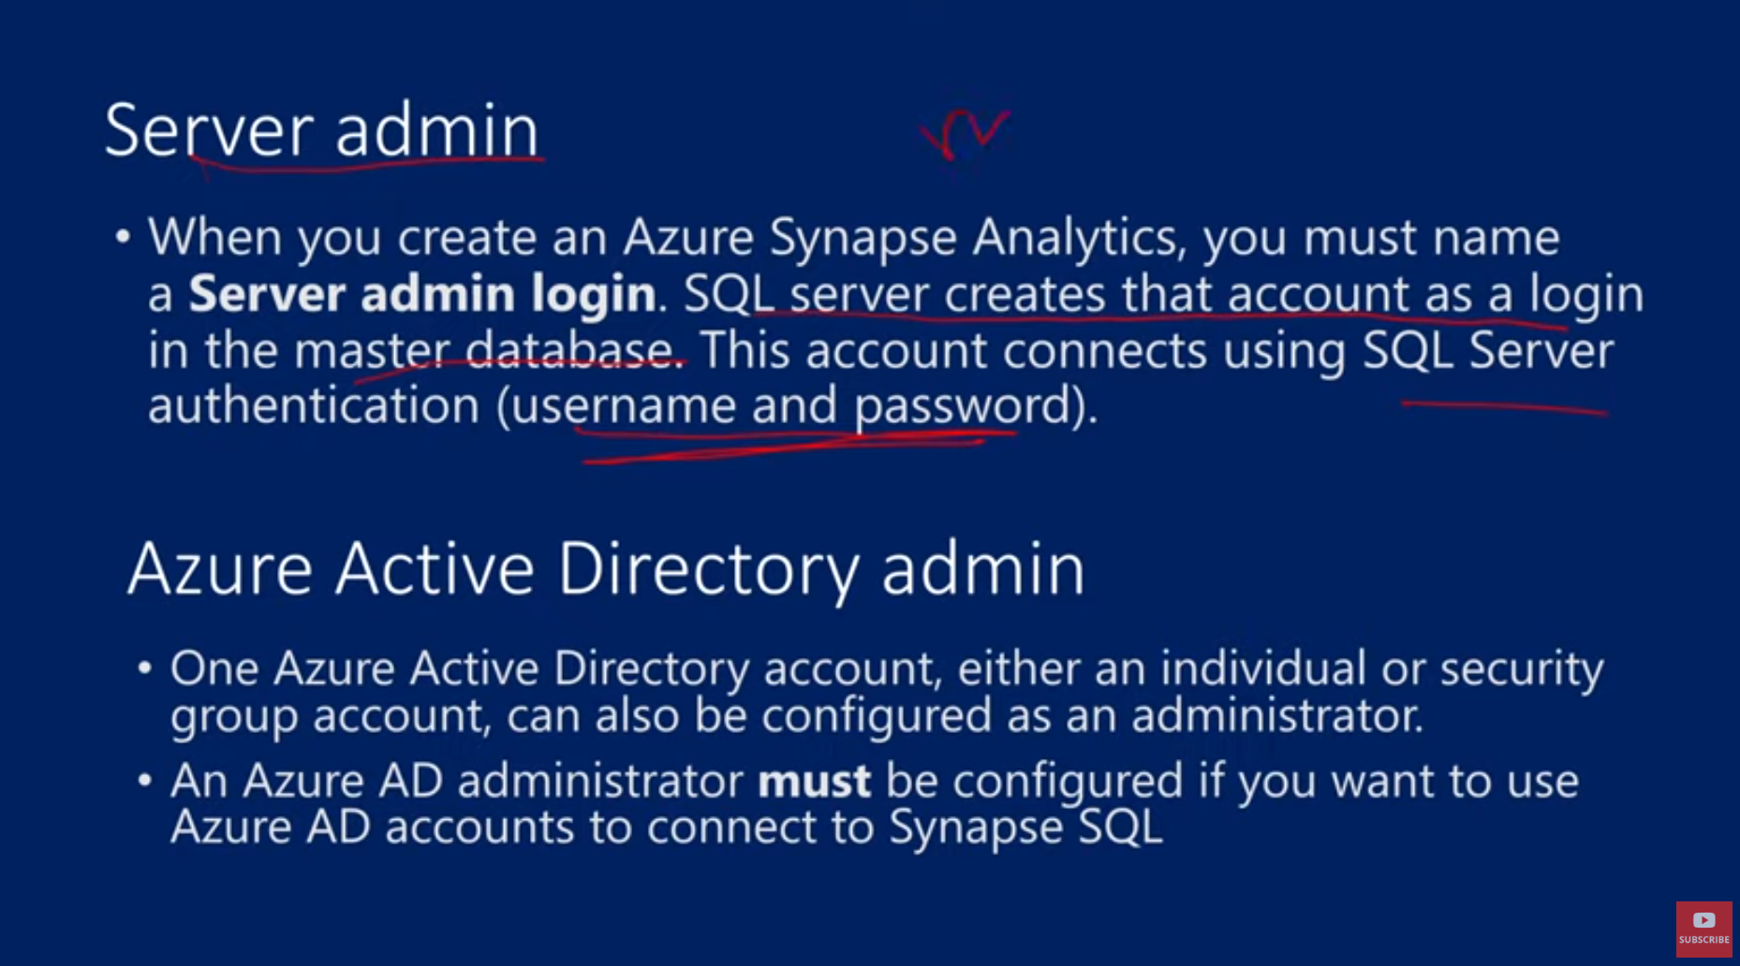

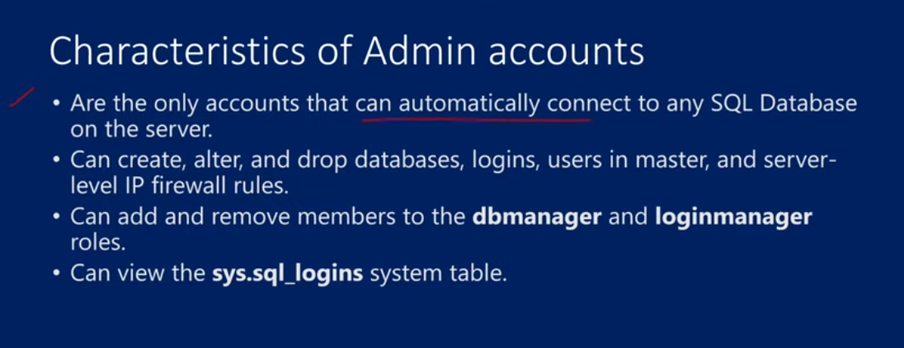



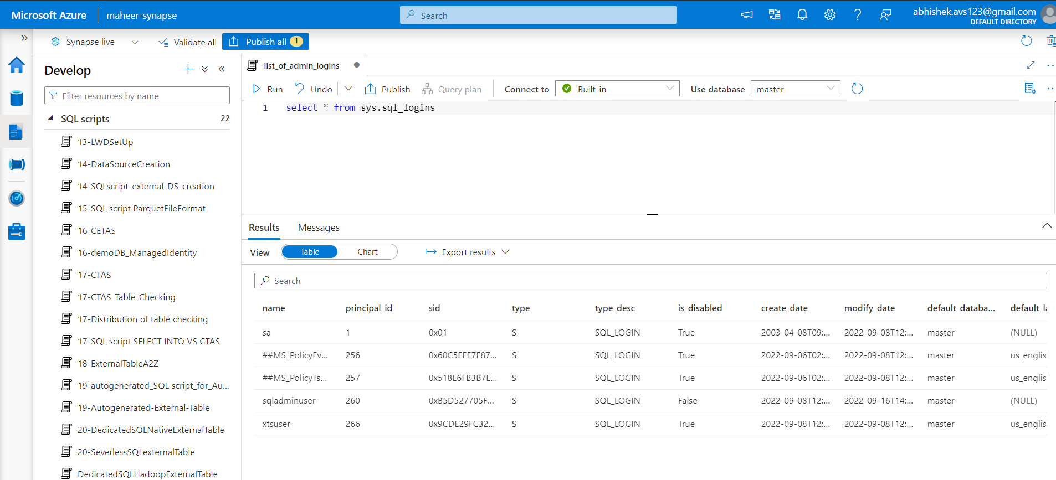

22. Create Login and User for Server less SQL Pool in Azure Synapse Analytics

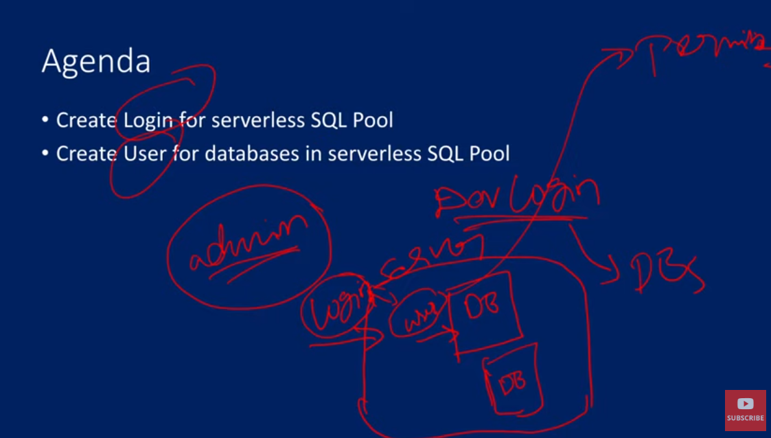

To get into the sever, we need login credentials, then to access certain DB, we need a certain username access for each database

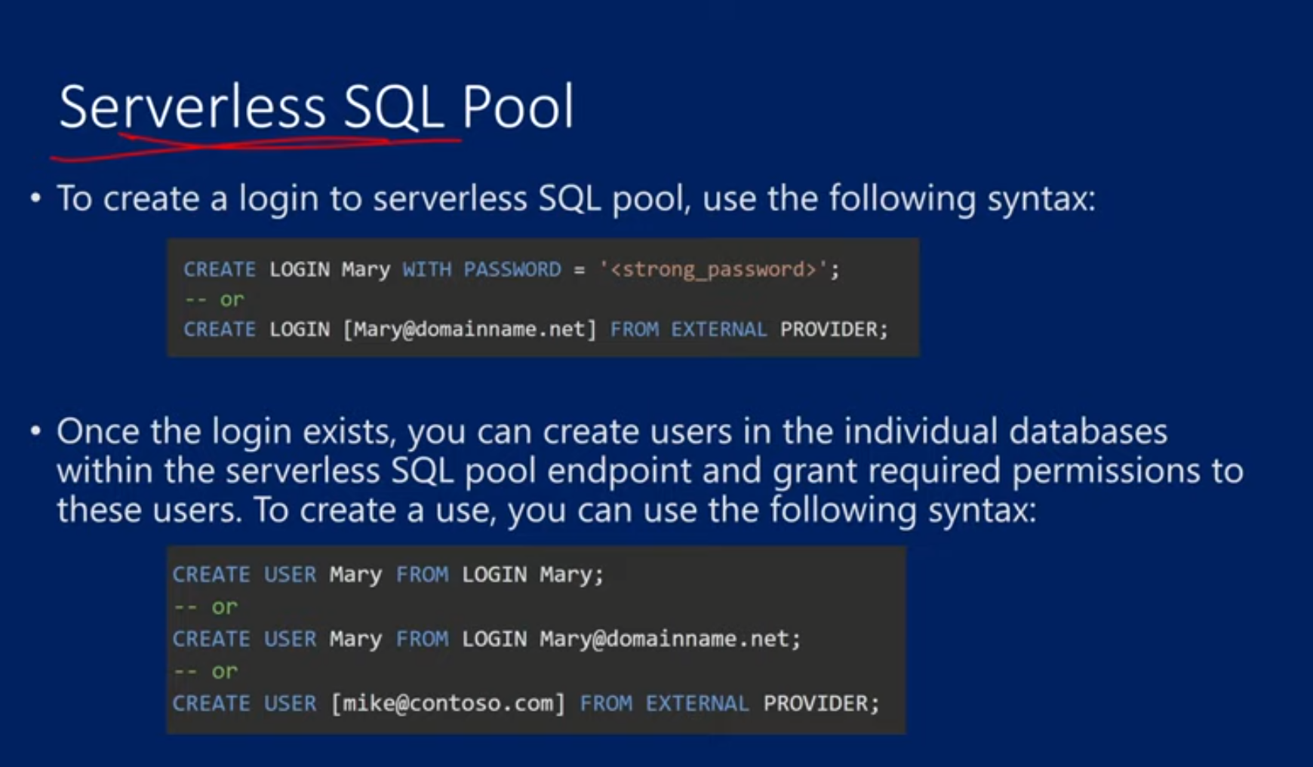

LOGINS are created at server level and USER are created at database level

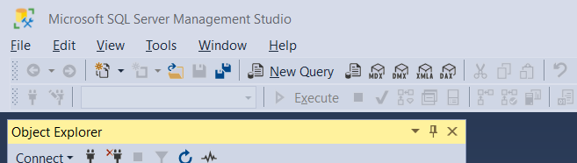

Click on new query window to write the query

We can login through the new login id that we created

create login abhi with password = 'Welcome@1123'

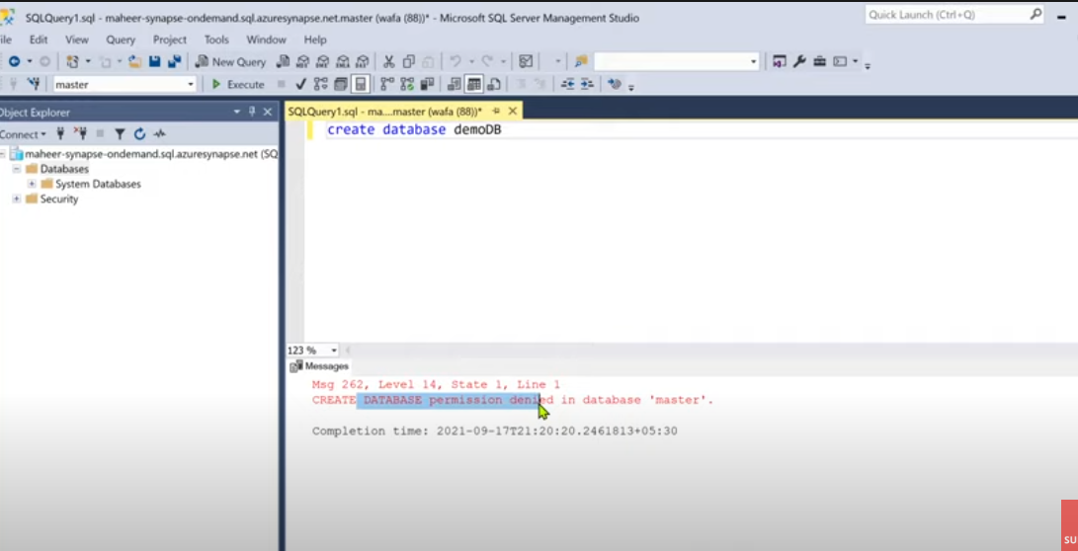

It is denied coz it don’t have permission to do that

We only have login, dv access etc not given yet

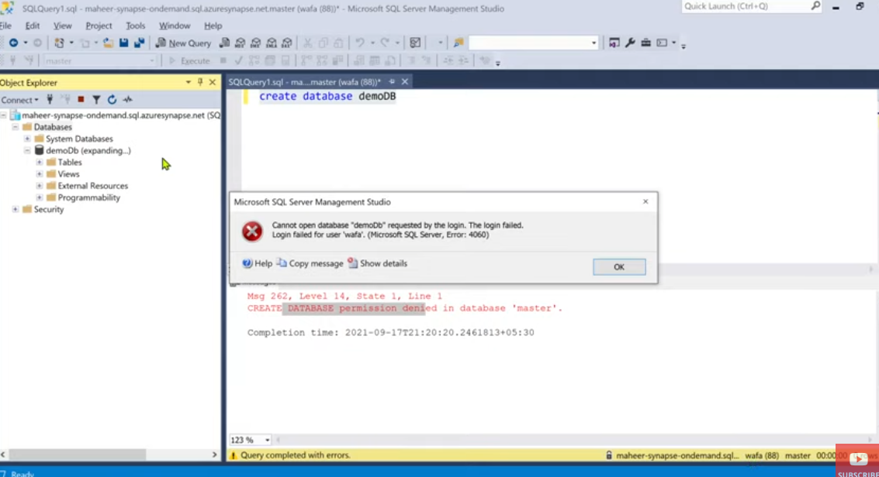

We create a database

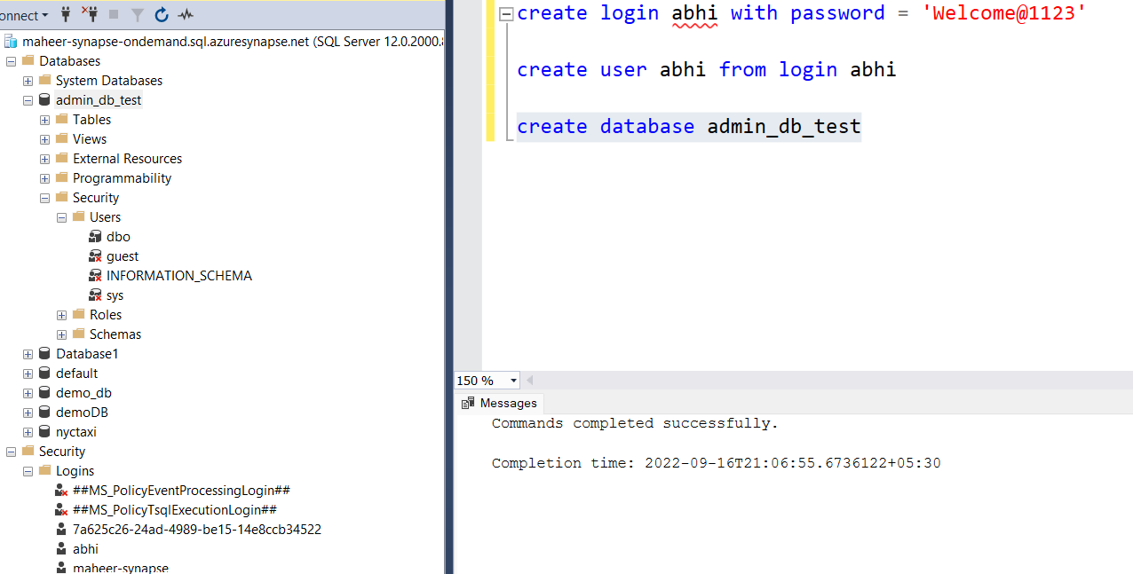

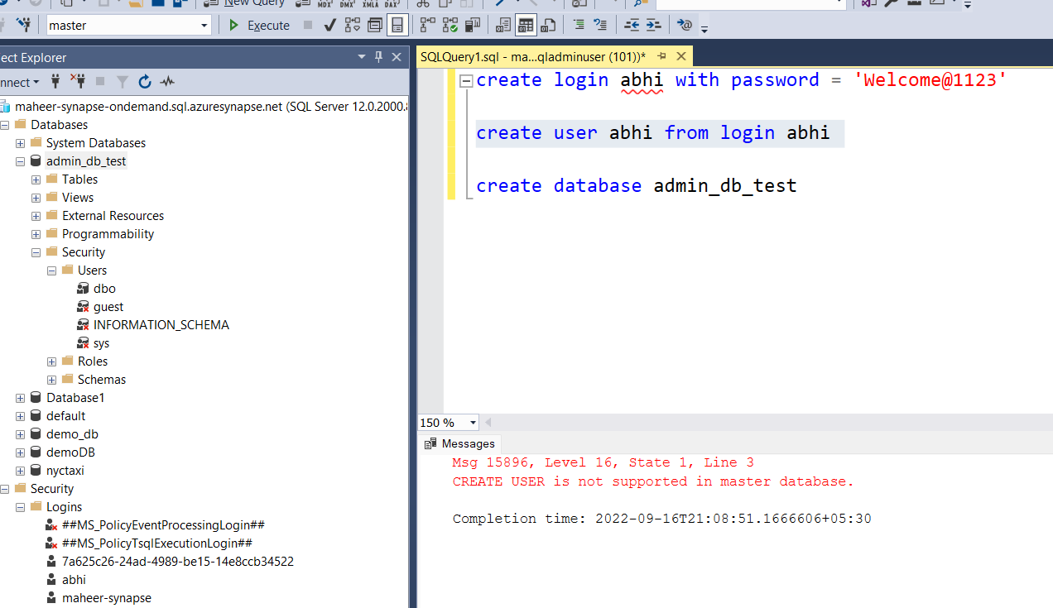

We need to go to the database in which we want to create the user, then we can run that anad the user abhi will be created

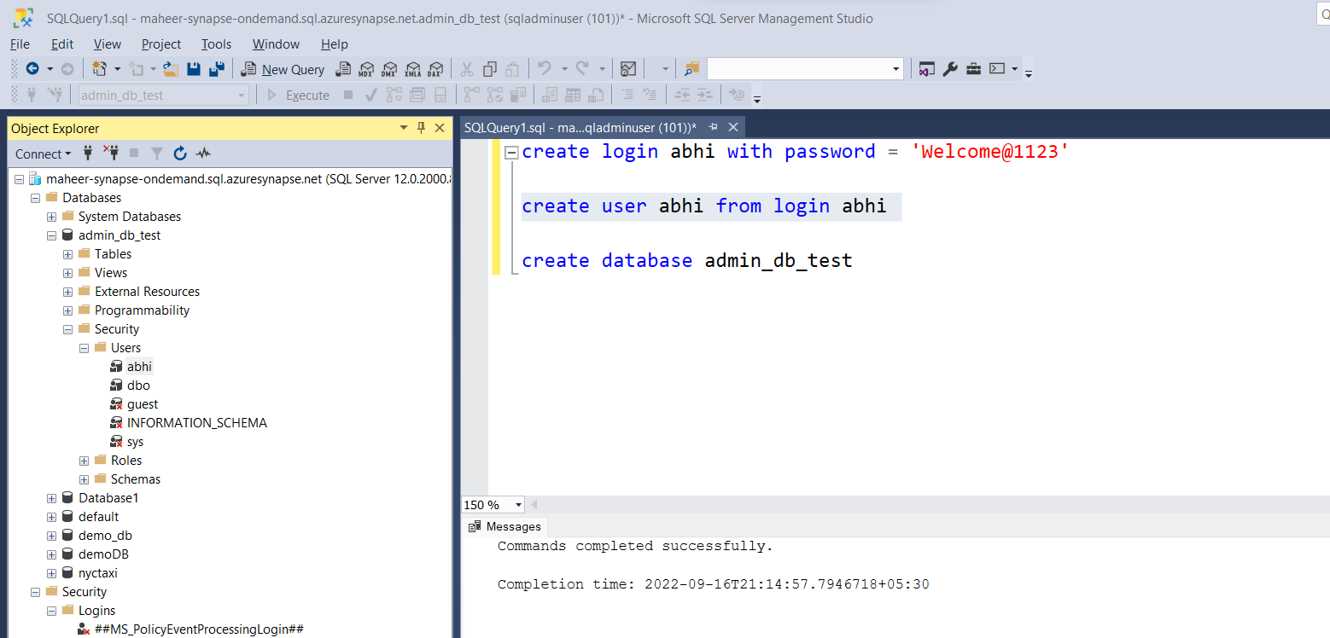

After creating the user, we need to also grant the permission etc

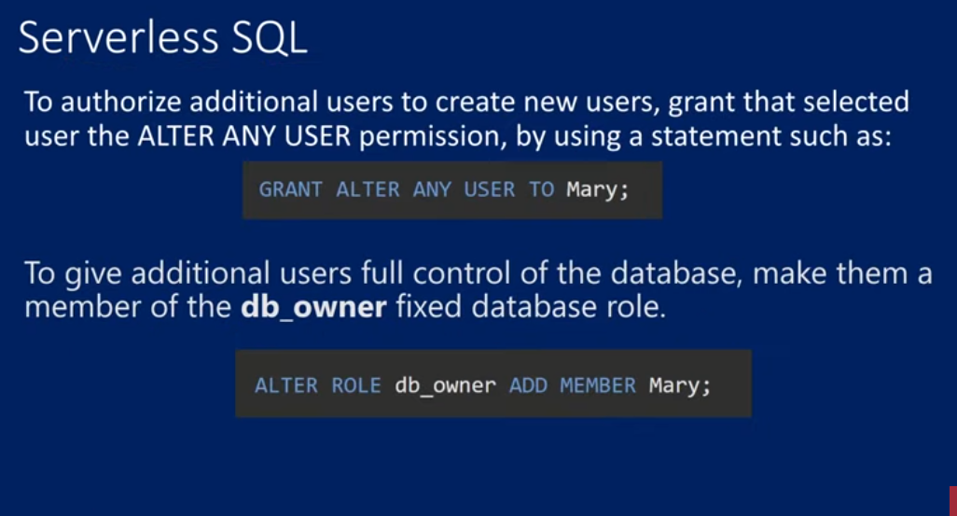

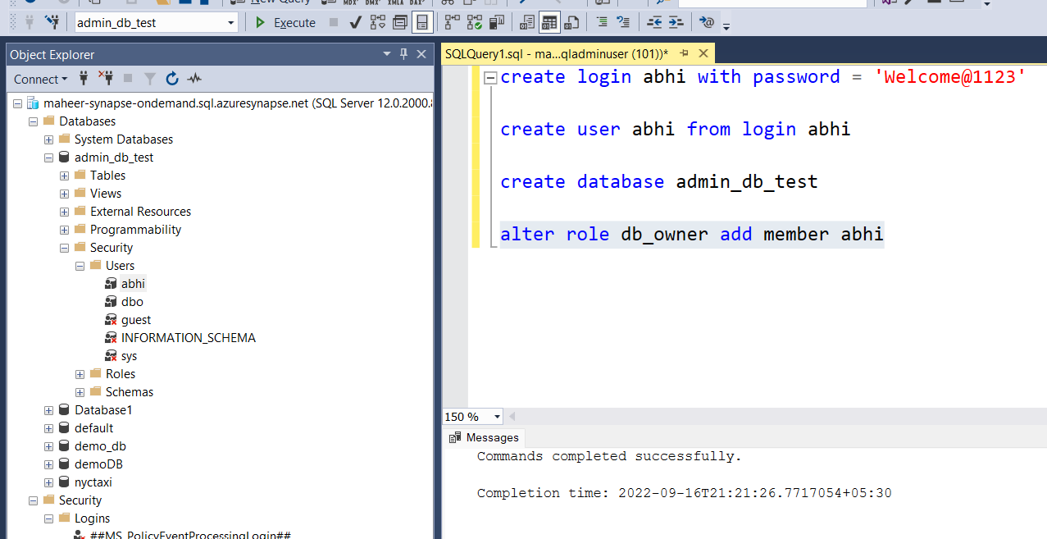

create login abhi with password = 'Welcome@1123'

create user abhi from login abhi

create database admin_db_test

alter role db_owner add member abhi

ALL this will work with sql authentication

In azure active directory admin case

For them the syntax is this

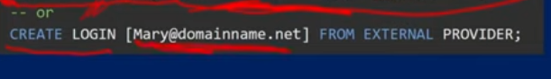

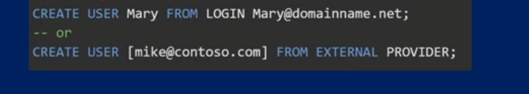

Instead of Mary, use ur login

23. Create Login and User for Dedicated SQL Pool in Azure Synapse Analytics

Contained DB user – where u wont create login, only user will be there

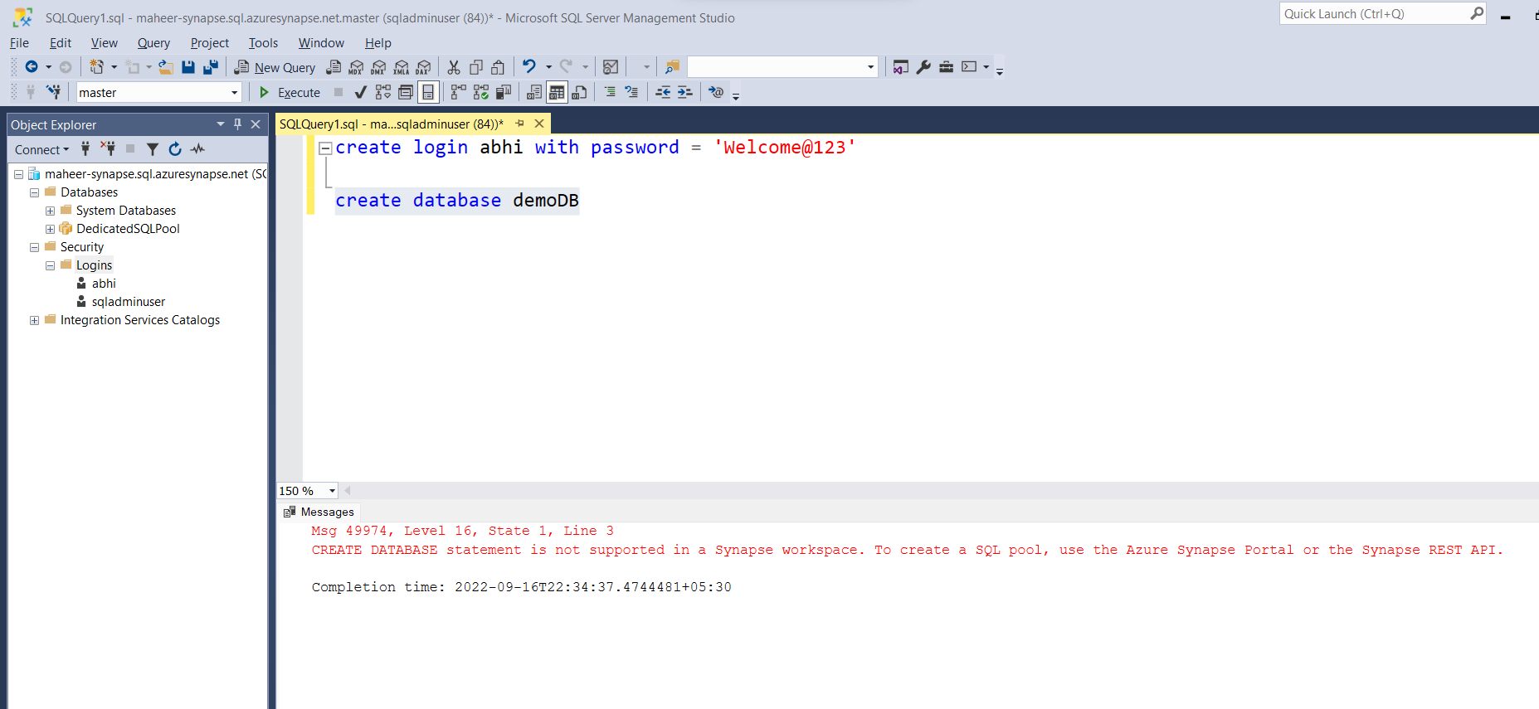

We cant create database from here in case of dedicated sql pool

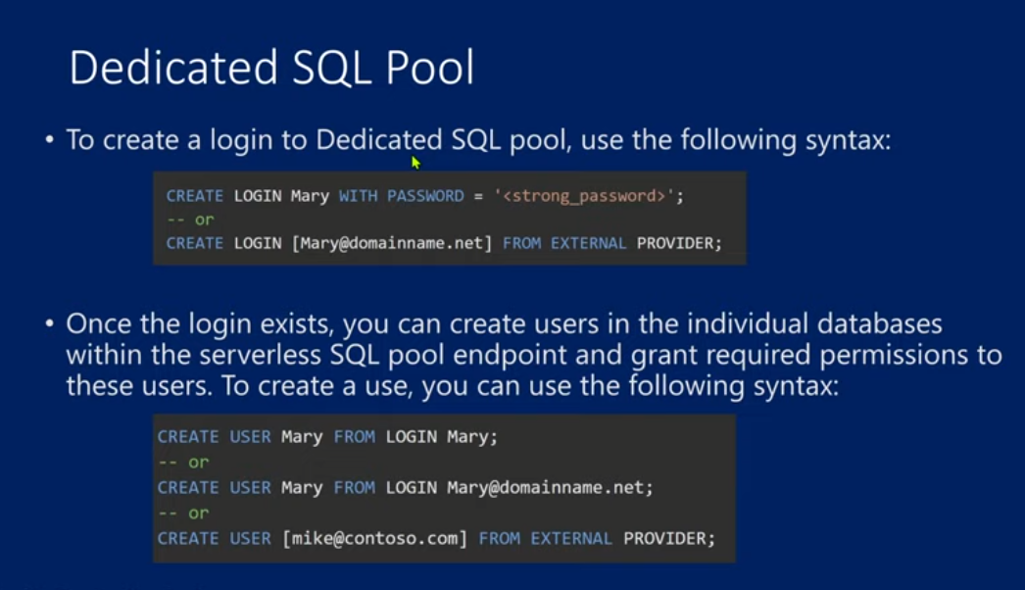

After making the login Still error comes, coz the login is inside the demoDB that we created, not in master

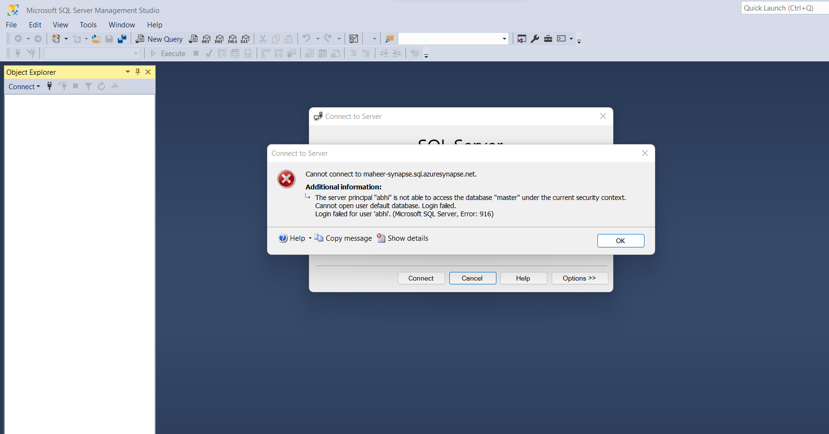

SO, we need to go the options> then click on connect to database, it will take a moment to search(b4 that try to connect with sqladmin then try going to options)

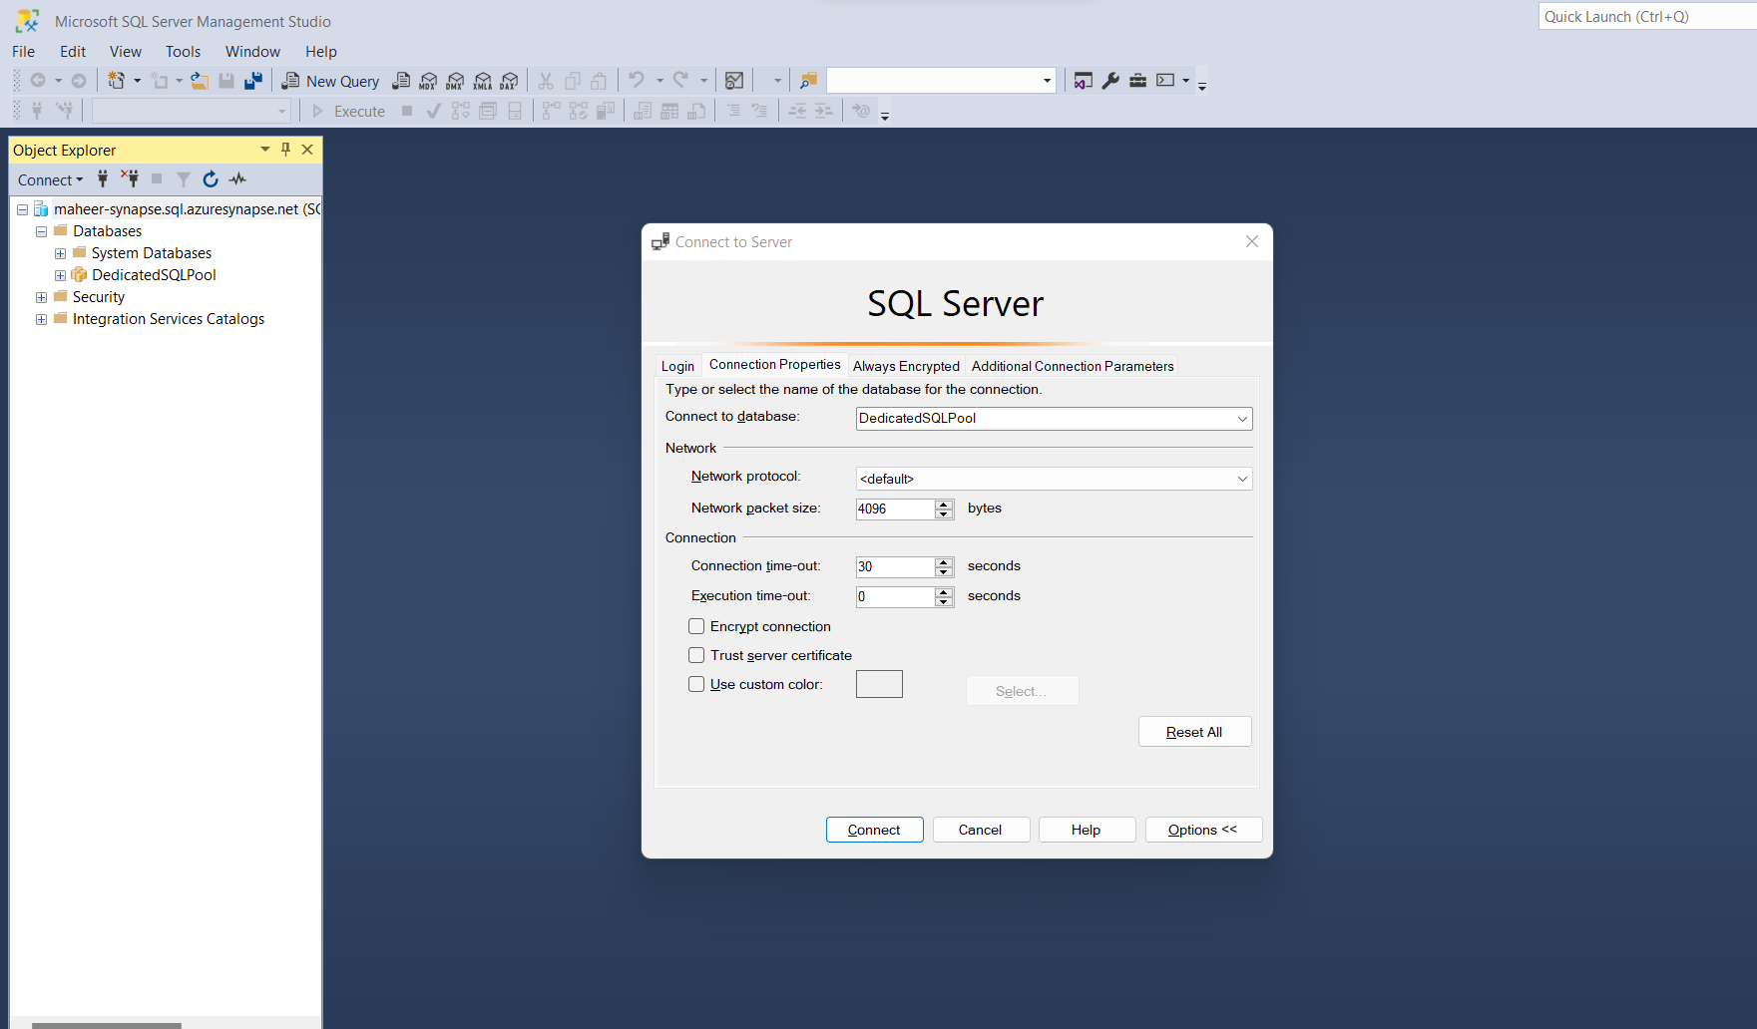

create login abhi with password = 'Welcome@123'

-- create database demoDB

create user abhi from login abhi

exec sp_addrolemember 'db_owner','abhi'

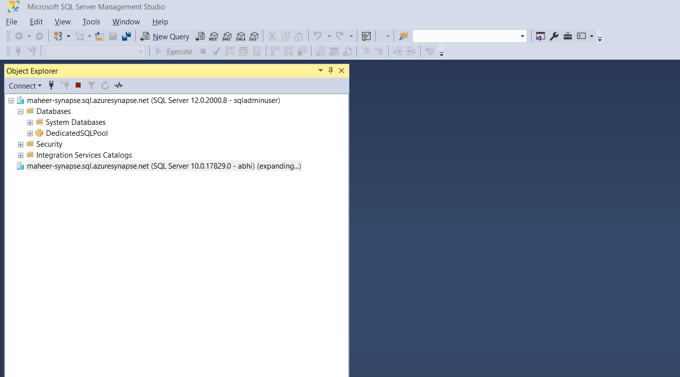

After connecting, we try to create table from abhi login, but error comes

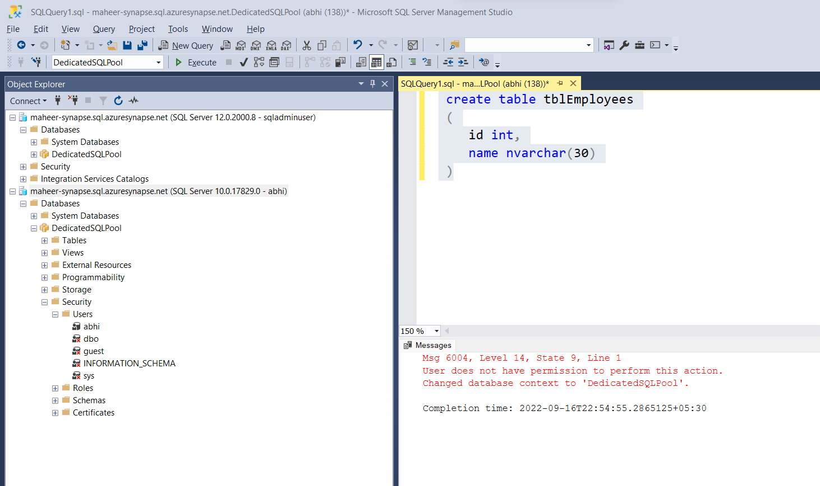

We add the role now

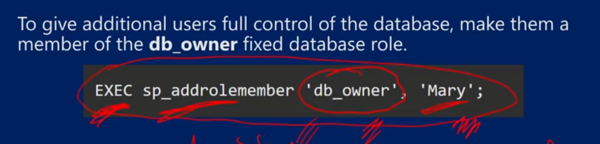

exec sp_addrolemember 'db_owner','abhi'

after running this from sql admin login, we can now create table in abhi login

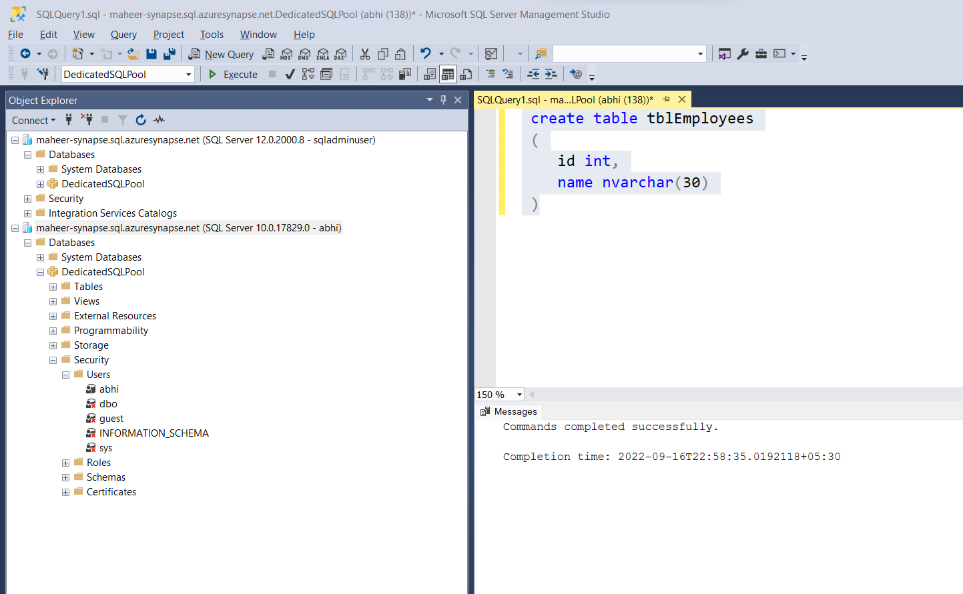

Alter permission for other users also

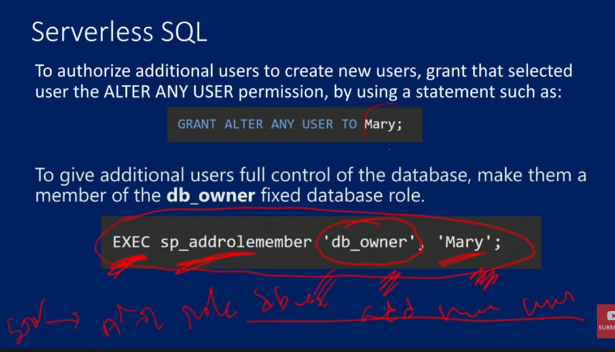

24. Temporary Tables in Synapse SQL in Azure Synapse Analytics

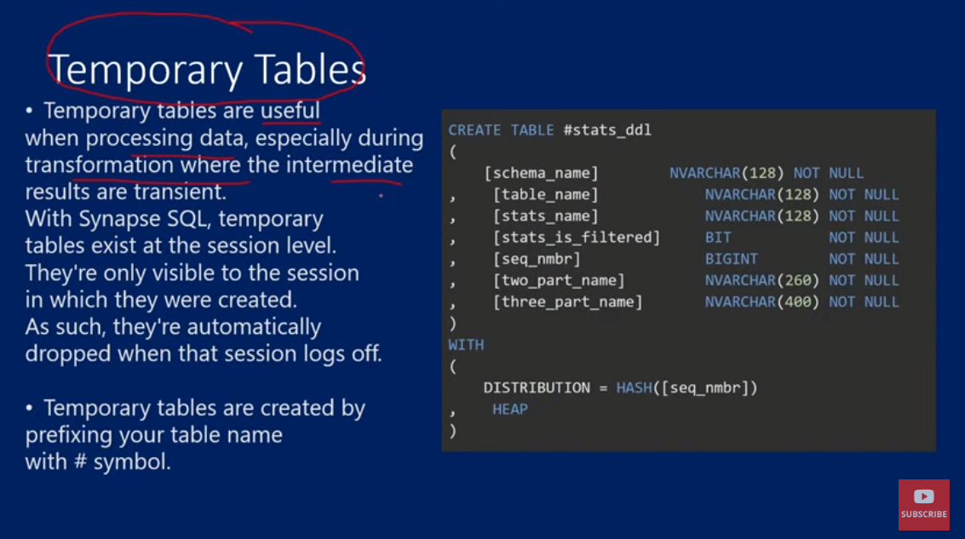

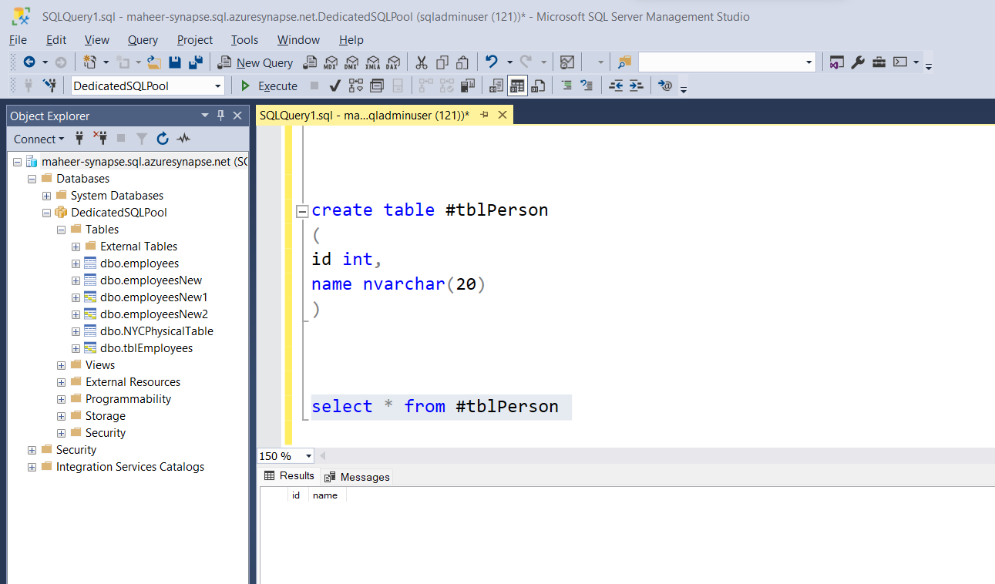

In dedicated sql pool, the temporary table doesn’t show up

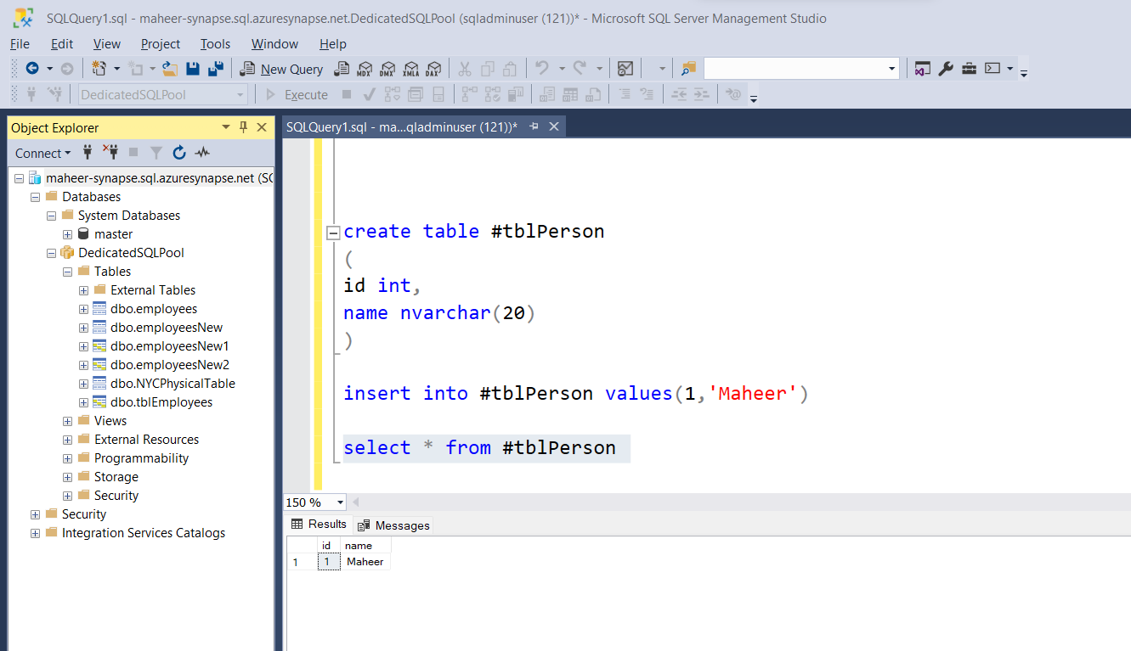

Within the session only the temporary will be available

Session -> new query window opening

Temp table with CTAS

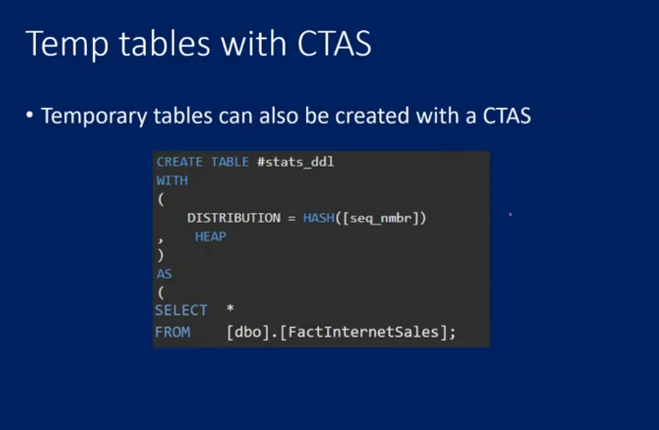

Drop temptable

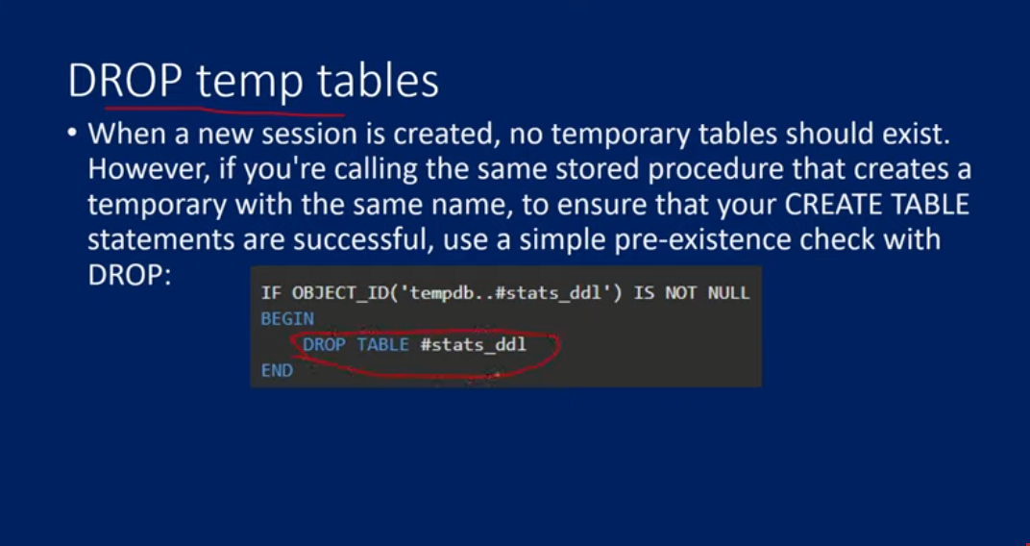

Limitation of temp tables

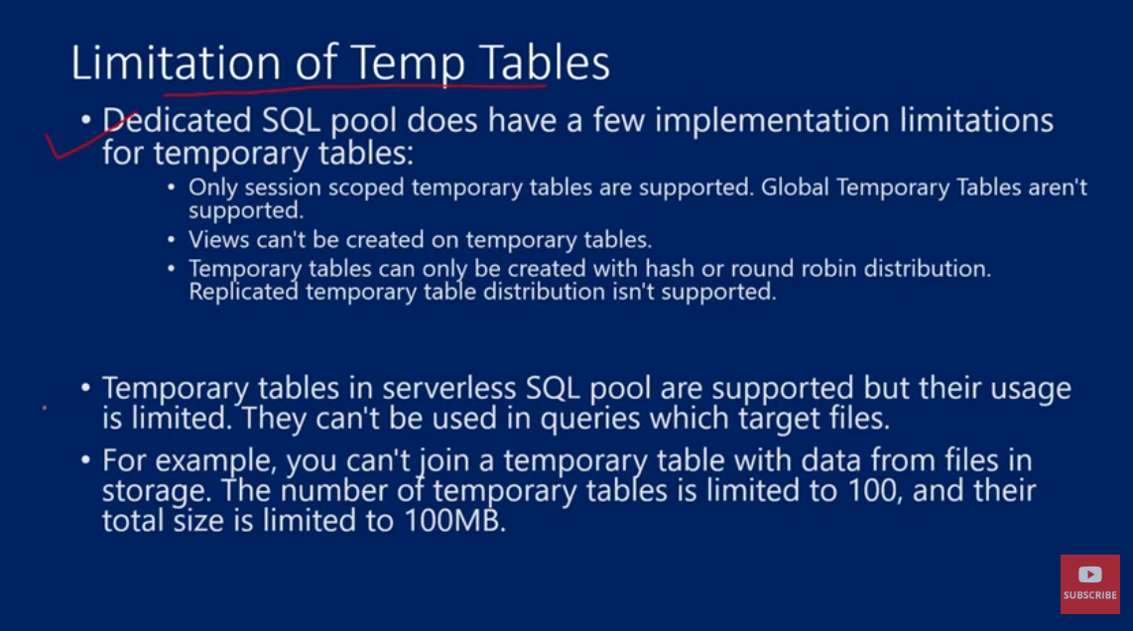

In serverless sql pool we cant take the data from the files to make the temp table

25. Using IDENTITY to create surrogate keys using dedicated SQL pool in Azure Synapse Analytics

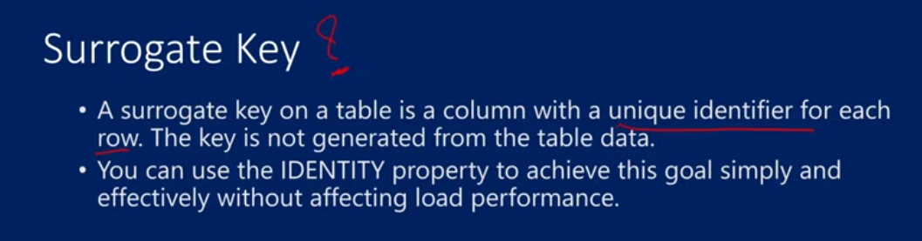



Identity means – if u put (10,1) then table will start from 10th identifier and with increament of 1

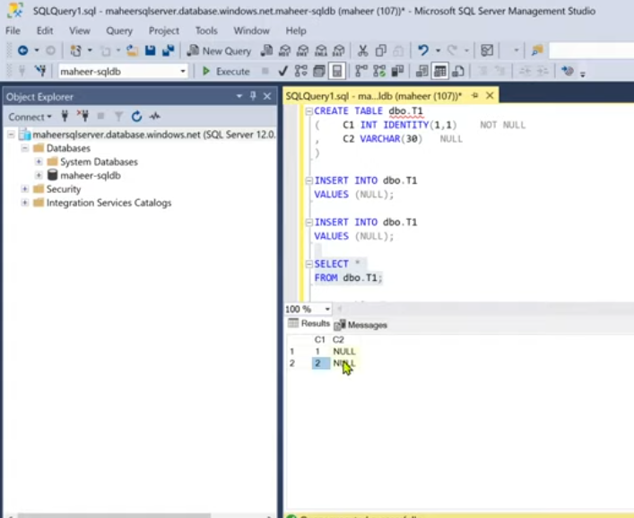

As serverless sql pool don’t have tables, hence identity don’t work in serverless

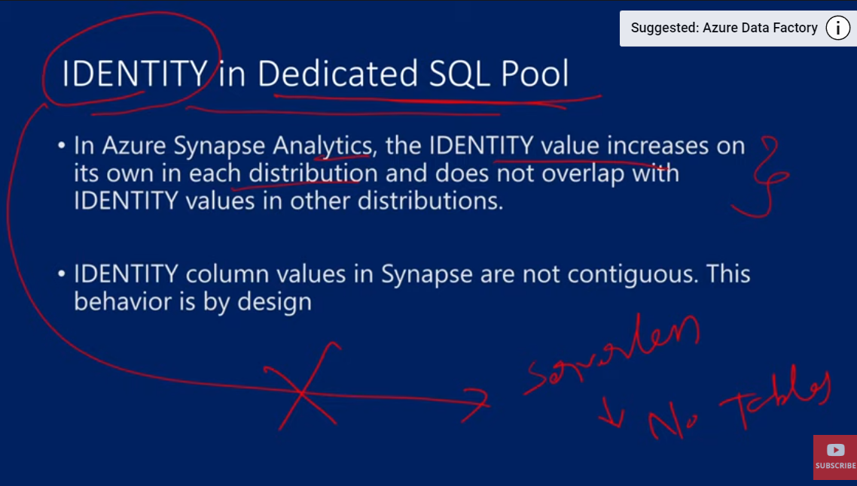

Each compute node we have 60 distributions

So the each column value will have a key and a hash value is calculated, and based on that it is sent to the distribution. If hash value is same, then it will be sent to the same distribution

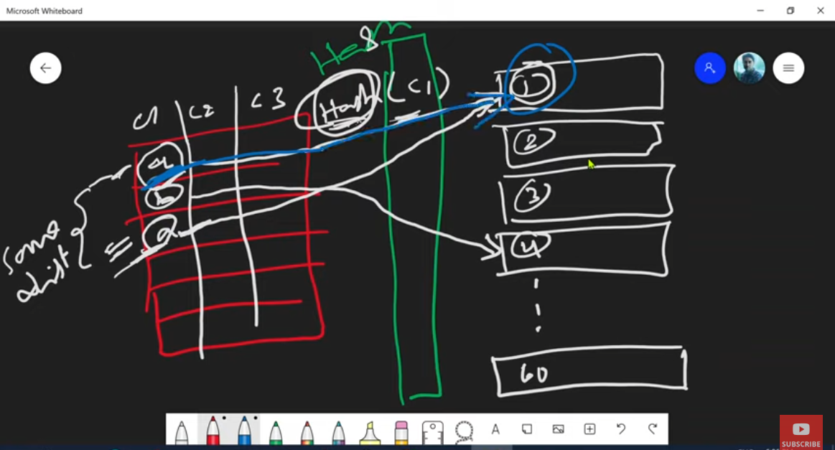

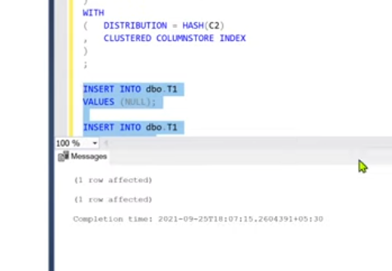 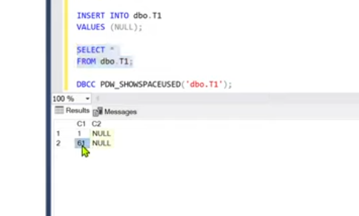

Both are NULL inserted, as they are same, so both hash value would be same. And 60 distributions are there, so as has values same, so both are in same, so it is 1 & 61

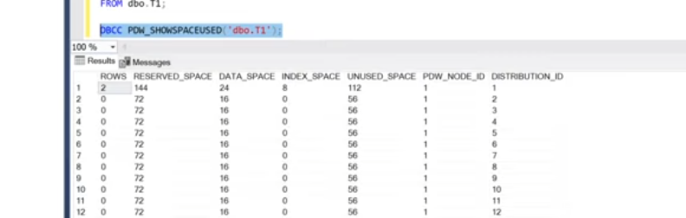

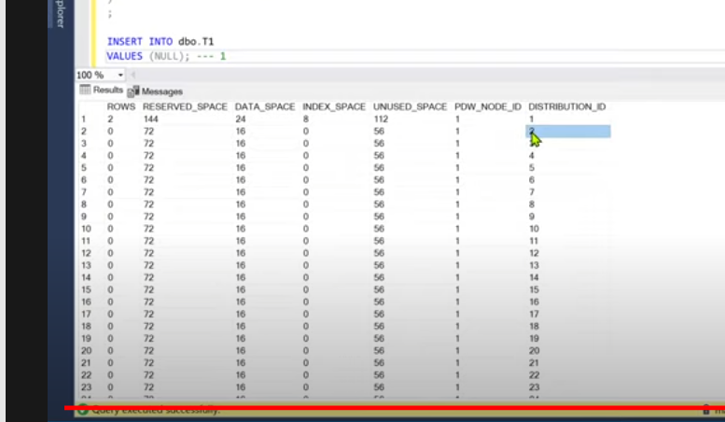

That is 1 & 61 bcoz 60 are already reserved to the distribution and in case of identity, after 1 , then 61 will come

Suppose we insert another value

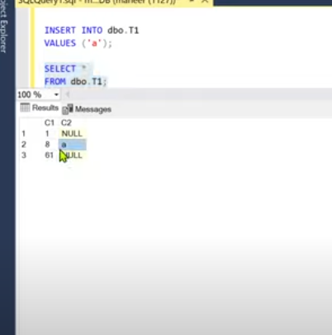

The hash value will be calculated and sent to respective distribution

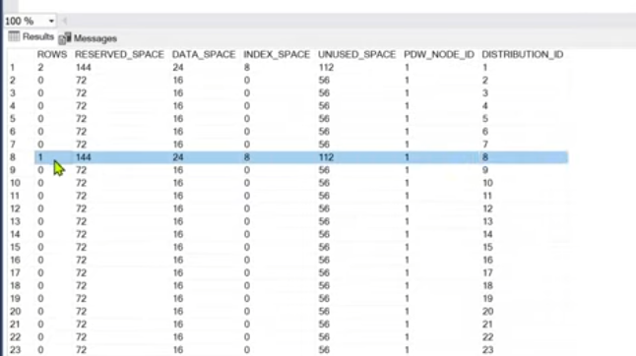

**IMP for interview - IDENTITY PROPERTY DON’T GUARANTEE ORDER**

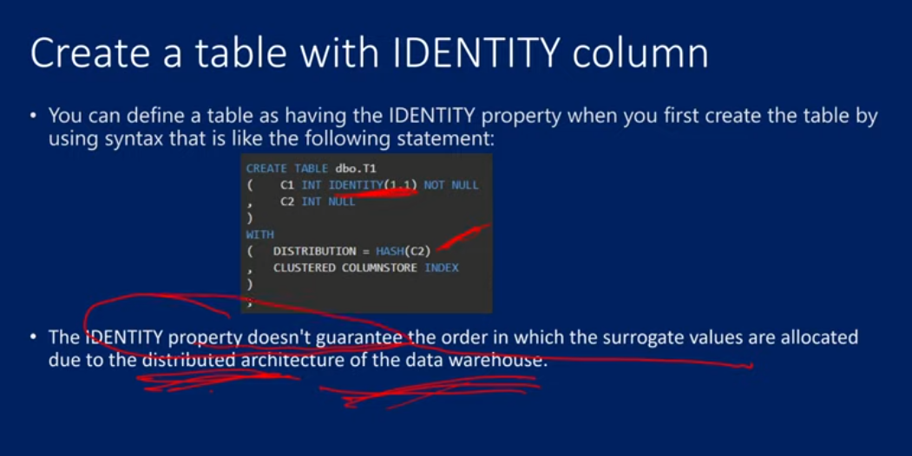

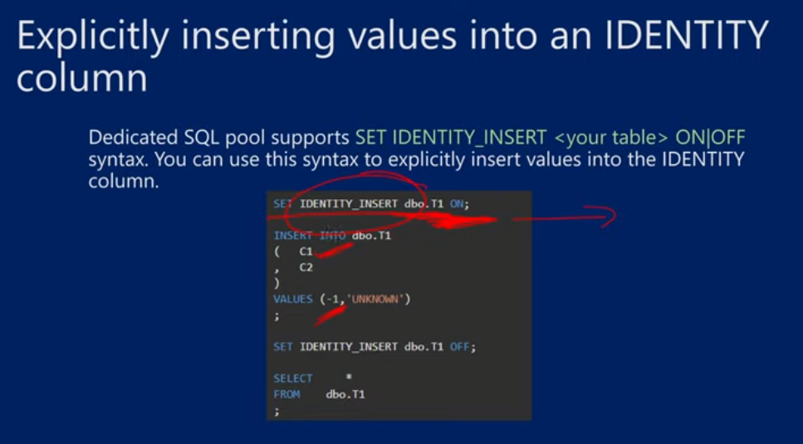

Limitation of identity coloumn



26. OPENROWSET() function in Synapse SQL in Azure Synapse Analytics

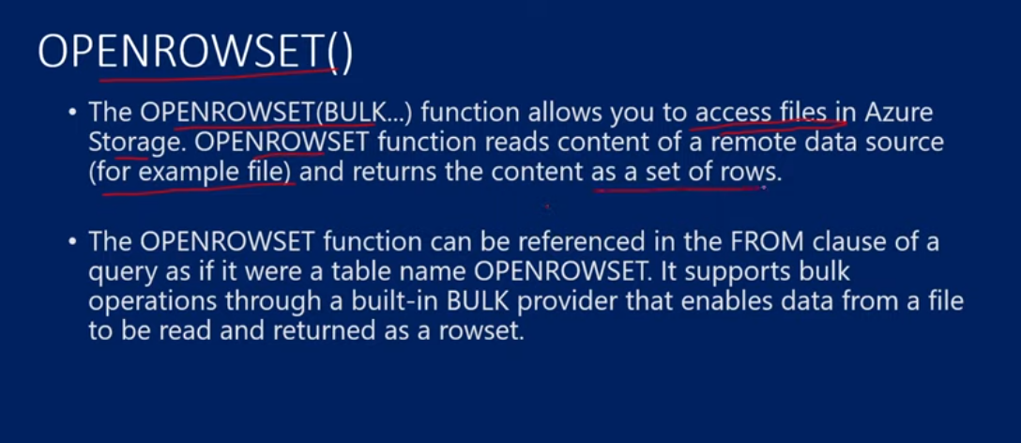

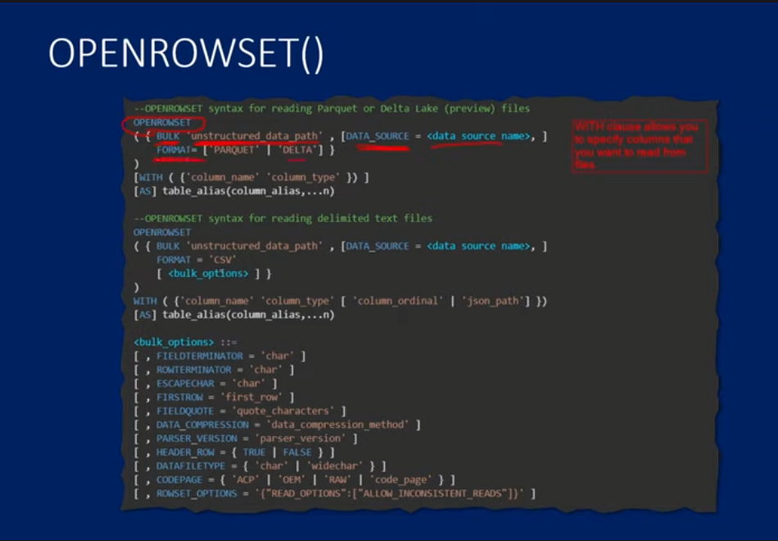

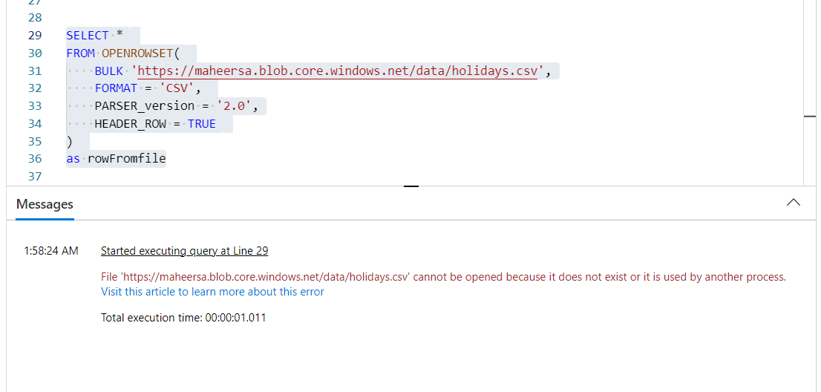

. The easiest way is to grant yourself a Storage Blob Data Contributor role on the storage account you're trying to query.

SELECT *

FROM OPENROWSET(

    BULK 'https://maheeradlsgen2.dfs.core.windows.net/synapsedemo/data/dates.csv',

    FORMAT = 'CSV',

    PARSER_version = '2.0',

    HEADER_ROW = TRUE

)

WITH

(

    term_id int,

    term_name NVARCHAR(20)

)

as rowFromfile

SELECT TOP 10 *

FROM OPENROWSET(

    BULK 'https://maheeradlsgen2.dfs.core.windows.net/synapsedemo/data/NYCTripSmall.parquet',

    FORMAT = 'PARQUET'

)

WITH

(

    DateID BIGINT,

    MedallionID INT

)

as rowFromfile

SELECT *

FROM OPENROWSET(

    BULK 'https://maheersa.blob.core.windows.net/data/holidays.csv',

    FORMAT = 'CSV',

    PARSER_version = '2.0',

    HEADER_ROW = TRUE

)

as rowFromfile

-- The easiest way is to grant yourself a Storage Blob Data Contributor role on the storage account you're trying to query.

-- if u dont wanna do all that, u can make external data source and use it

27. Apache Spark in Azure Synapse Analytics

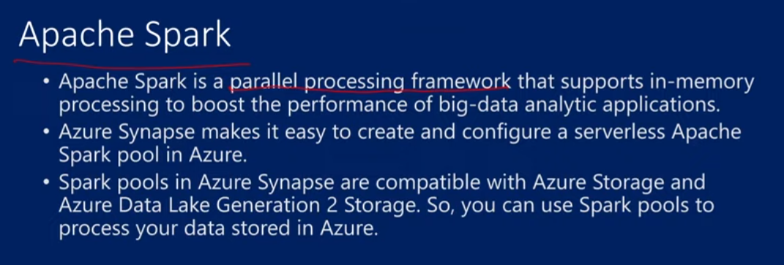

Transformations upon big data, it will take data, partition it, and process parallel and it happens within the memory

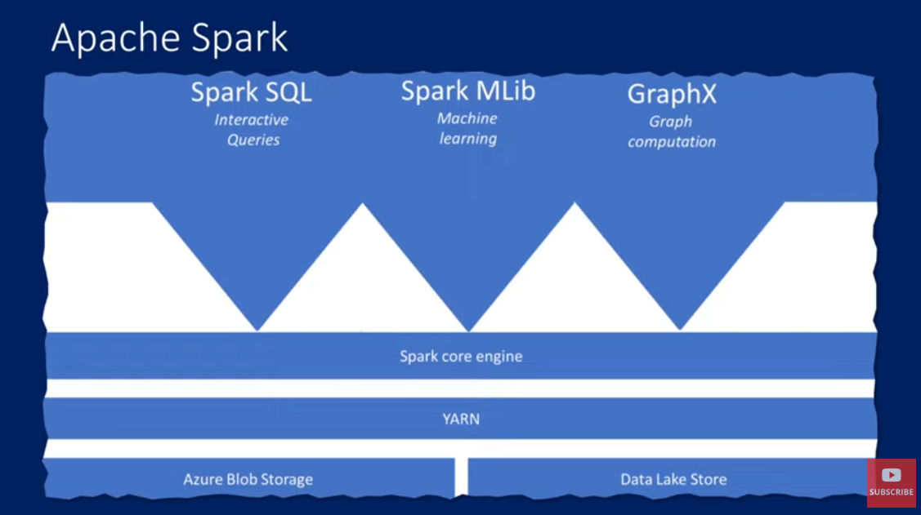

Cluster manager is there, master node and worker node is there, the cluster manger ensure that there is proper communication b/w master and worker nodes to make the transformation work.

APACHE YARN is the Cluster manager in case of Azure Synapse. Upon which apache spark engine is built. This engine has – spark sql for intertactive queries, spark MLib for machine learning libraries and Graph X for graph computation

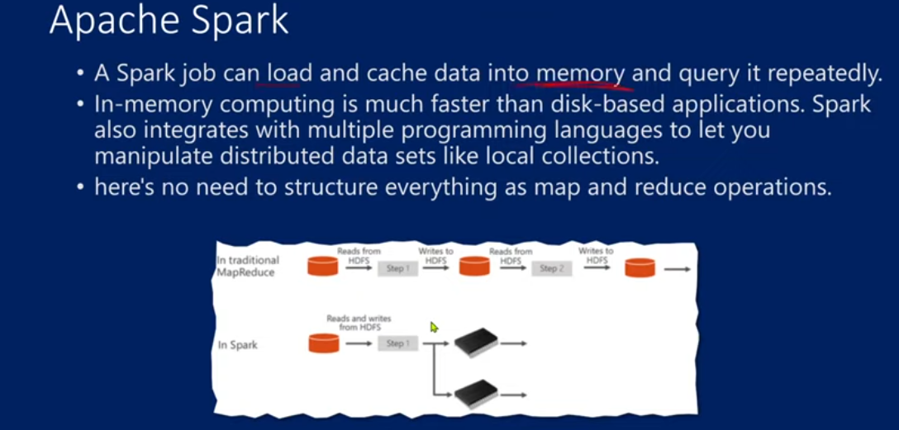

The query execution happens inside the memory no the architecture, that is why it is very much faster than the traditional map reduce technology that helps in data transformation of big data

In MAP REDUCE, there will a data inside the disk(HDFS), reads the data from hdfs, then it performs logical exectution, once the logical execution completes, it writes back into the disk. And again we read, apply logic and write into the disk, so this continues. This is much slower.

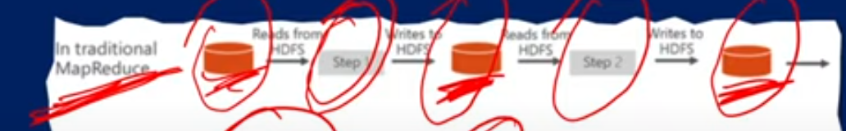

In spark, the data will be taken for the first time from the disk into the memory. And all the logic is executed in the memory

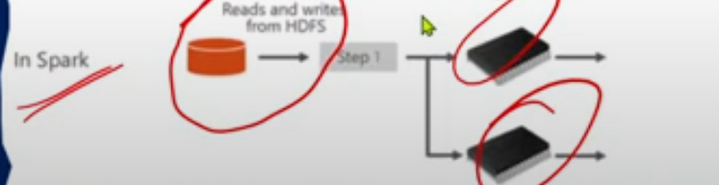

Benefits of spark pool

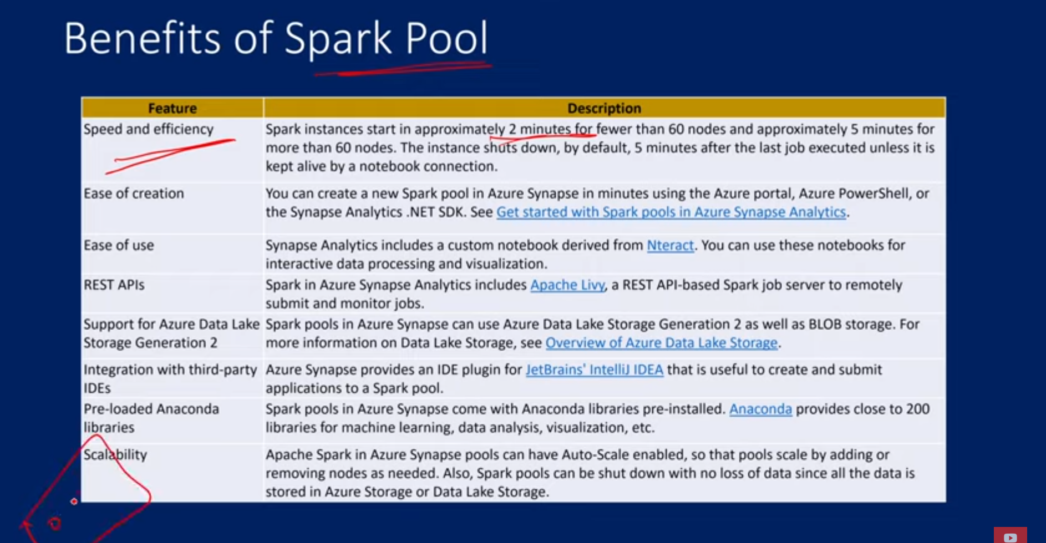

Nodes are like machines

Rest API is supported in Apache Livy.

SPARK POOL ARCHITECTURE

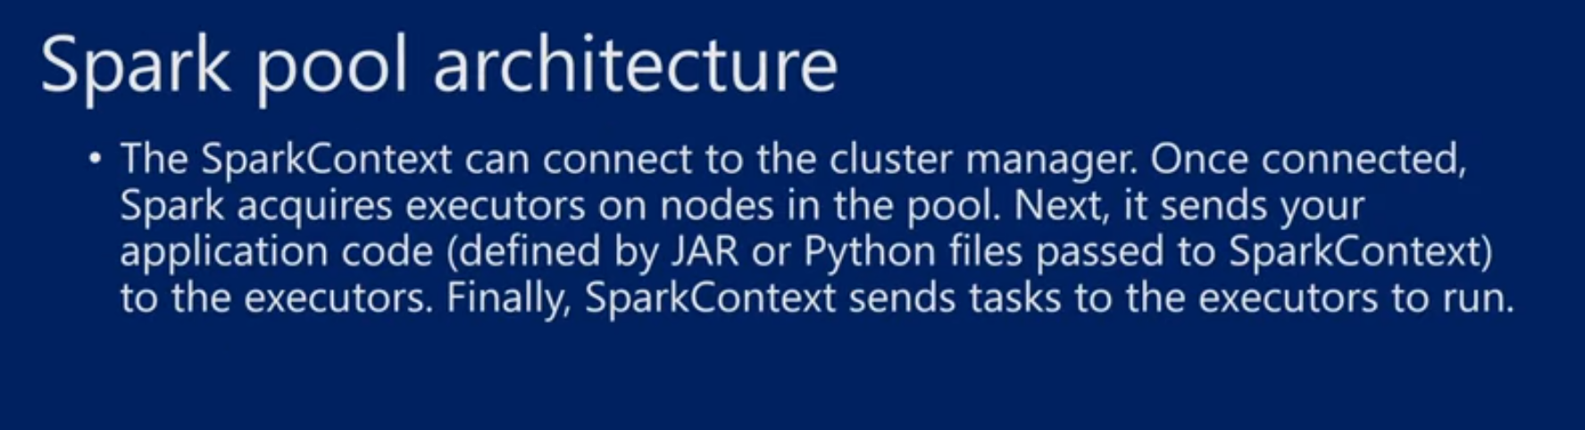

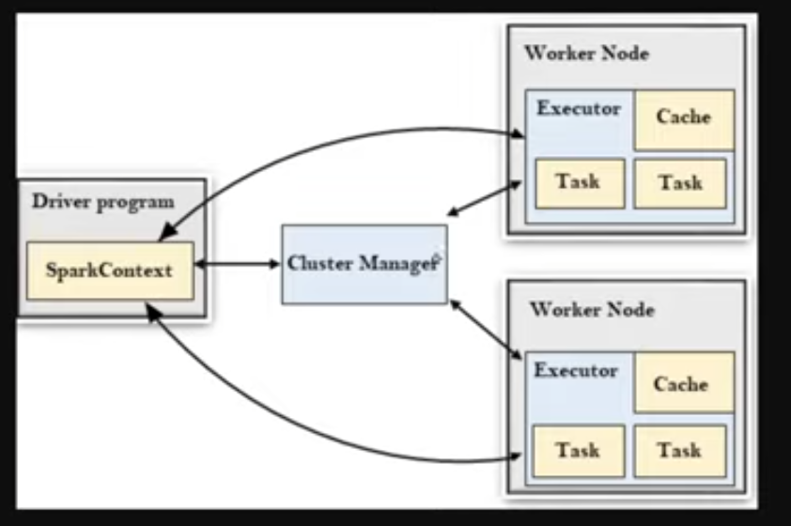

Master node/ Driver program is like a lead and worker nodes are like a teammates. So the lead assign the work to teammates by coordinating with the cluster manager.

So the driver program contains the spark context, i.e. all the transformation logic. This is going to connect with the cluster manager, and the cluster manager will identify the executor(It performs the tasks) in worker node. Cluster manager takes the entire logic and distributes into the tasks, and the tasks are distributed among the multiple worker nodes

The executor execute the task, that means it applies transformation logic on the data and the output is stored in cache, we r not writing data into harddisk. The output is call RDD objects.

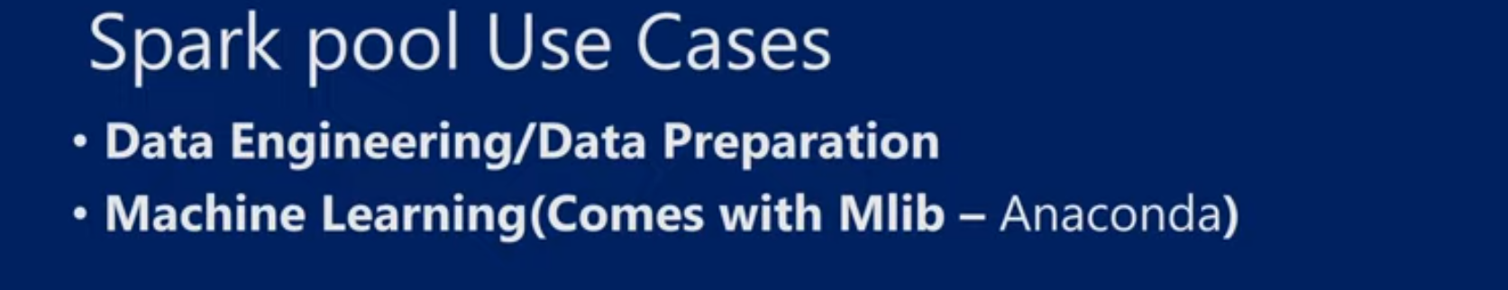

28. Create a Spark Pool with Azure Portal

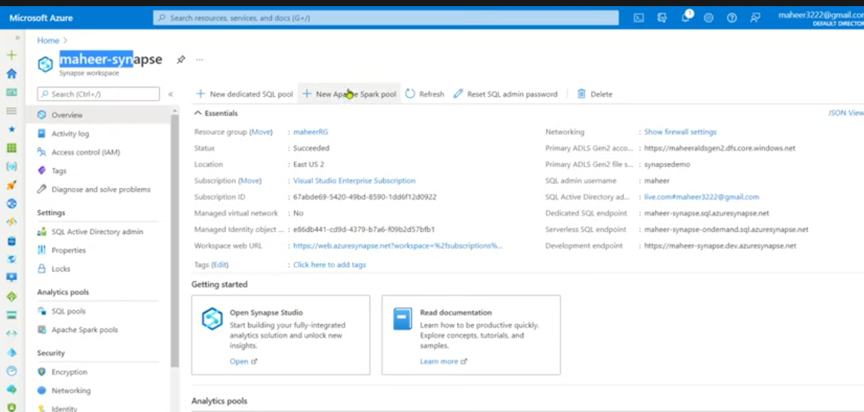

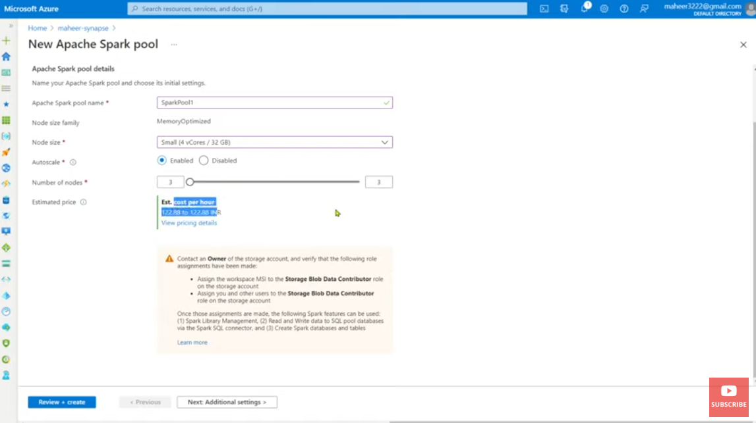

29. Create a Notebook in Azure Synapse Analytics

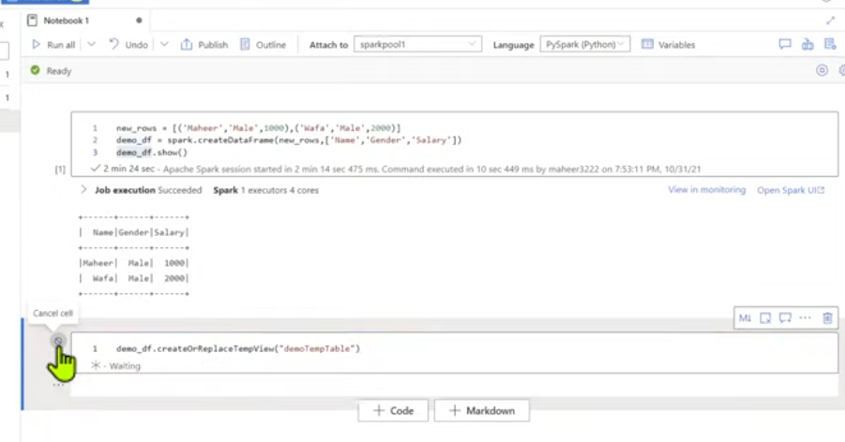

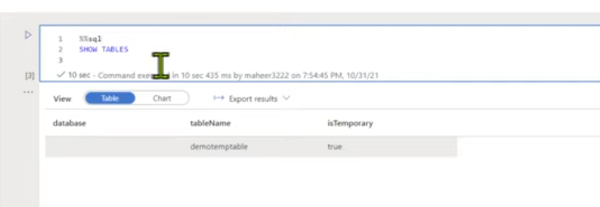

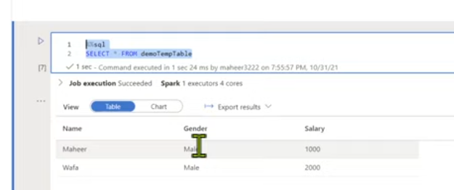

30. Pandas to read/write Azure Data Lake Storage Gen2 data in Apache Spark pool in Synapse Analytics